Name | Area | Email | Phone | Mobile
Evelyn Gloyn | North | gloyne@ealing.gov.uk | 8825 8021 | 07525 893579
Tan Afzal | South | afzalt@ealing.gov.uk | 8825 6426 | 07525 893580
Dennis Frost | West | frostd@ealing.gov.uk | 8825 5453 | 07525 893581
Kofi Nyamah | East | nyamahk@ealing.gov.uk | 8825 5818 | 07525 893582

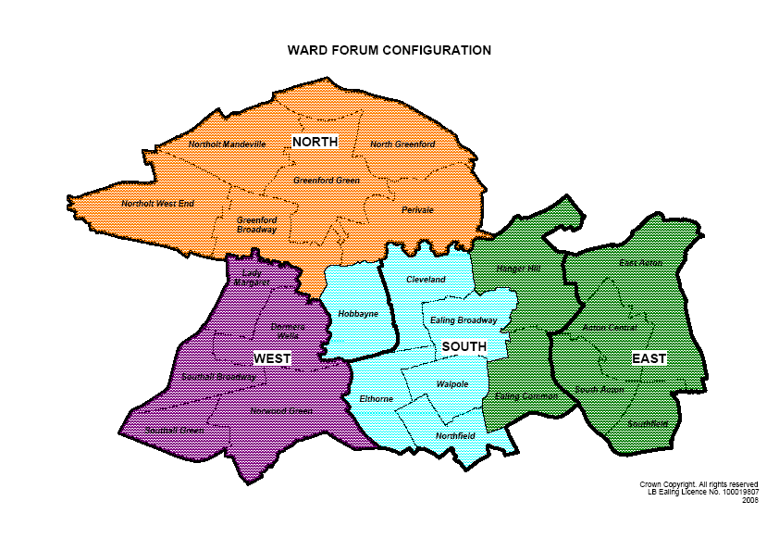
North Area | East Area | South Area | West Area
Evelyn Gloyn | Kofi Nyamah | Tan Afzal | Dennis Frost
Northolt West End  Northolt Mandeville  North Greenford  Greenford Green  Greenford Broadway  Perivale | Acton Central Ealing Common  East Acton  Hanger Hill  South Acton  Southfield | Cleveland  Ealing Broadway  Elthorne  Hobbayne  Northfield  Walpole | Dormers Wells  Lady Margaret  Norwood Green  Southall Broadway Southall Green

