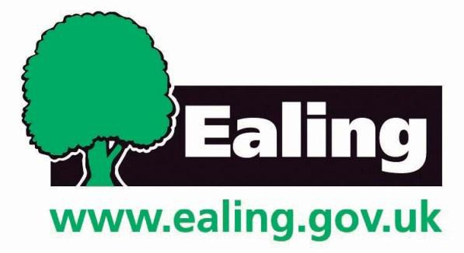

COMMUNITY RIGHT TO BID NOMINATION FORM

Once completed please return the application form to:

Strategic Property & Investment
London Borough of Ealing
Perceval House
14-16 Uxbridge Road
Ealing W5 2HL

E-mail: LBEStrategicProperty@ealing.gov.uk

Please Note: The information you provide on this form will be the basis upon which the council decides whether or not to list the asset.

Section 1: About the property to be nominated

Name of Property
Address of Property
Postcode
Name(s) of current property owner(s)
Address
Postcode
Name(s) of current property occupier(s)
Name

Section 2: About your Community Organisation

Name of Organisation
Contact Name (Lead Nominator)

Position in Organisation
Email Address
Address
Postcode
Telephone: |  | Mobile:

Section 3: What is your Organisation Type?

 | Constituted  Community/Voluntary Group |  | Parish/Town Council
 | Neighbourhood Forum |  | Un-constituted Community  Group
 | Industrial & Provident Society |  | Community Interest Company
 | Company Limited by Guarantee |  | Charity
How many members do you have?

Section 4: Supporting Information for Nomination
Why do you feel the property is an asset of community value? Please give as much information as possible.

Section 5: Boundary of Property
What do you consider to be the boundary of the property: Please provide as detailed a description as possible, including a plan if possible.

Section 6: Attachment Checklist

Evidence to support your eligibility to nominate
Information to support your application
A site plan (where available)

Section 7: Declaration

I confirm that I have authority to submit this nomination of behalf of the
relevant body and that to the best of my knowledge the information contained in this nomination form is complete and accurate.
Signed
Position in organisation
Dated

Please note that your nomination form, including map, will be published and may be supplied, on request, to the owner or occupier. Personal details will be omitted.

