
COMMUNITY SCRUTINY COMMITTEE 2003/2004

HEALTH SCRUTINY TASK GROUP III

SMOKING CESSATION IN EALING

Task Group Members:
Councillor Virendra Sharma (Chair)
Councillor Kate Crawford
Councillor Mrs Susan Emment
Councillor Sophie Hosking
Councillor Ram Perdesi
Councillor Harvey Rose
Councillor Gurdip Sahota
Councillor Simon Woodroofe
Mrs Jean Humphries
Mrs Pat Seers

March 2004

CONTENTS

 |  | PAGE
INTRODUCTION |  | 3
BACKGROUND |  | 4
Health Scrutiny |  | 4
Smoking Cessation – National Context |  | 4
Smoking Cessation – Local Context: |  | 6
Ealing’s Smoking Cessation Targets and Allocations |  | 6
Current Smoking Cessation Provision in Ealing |  | 7
Ealing, Hammersmith & Hounslow Smoking Cessation Treatment Services |  | 8
Core Treatment Programme |  | 8
Group Motivational Clinics |  | 9
Community Smoking Cessation Advisors and Drop In Clinics |  | 9
Smoking in Pregnancy Service |  | 9
WHAT DID THE TASK GROUP WANT TO ACHIEVE? – OUTCOMES AND TASKS |  | 10
HOW DID THE TASK GROUP ACHIEVE ITS AIMS? - METHOD |  | 11
CONSULTATION |  | 11
TASK GROUP MEETINGS |  | 12
Meeting One – 16 September 2003 |  | 12
Meeting Two – 13 October 2003 |  | 12
Meeting Three – 3 November 2003 |  | 12
Meeting Four – 16 December 2003 |  | 13
Meeting Five – 12 February 2004 |  | 13
EMERGING THEMES |  | 13
Theme 1: Increasing Take Up of Services |  | 13
Reaching Targets |  | 13
Encouraging Referrals by GPs |  | 13
Theme 2: Marketing Services Through Publicity |  | 15
Raising Awareness |  | 15
Improving Local Knowledge |  | 16
Theme 3: Approaching Target Groups |  | 17
Workforces |  | 17
Young People and Schools |  | 18
Theme 4: Work Within Ealing Council – Prioritising Smoking Cessation |  | 19
Smoking Policies |  | 19
Smoking Cessation Support for Staff |  | 21
Theme 5: Joint Working and Partnerships |  | 22
Sharing Information and Spreading the Smoking Cessation Message |  | 22
Broader Tobacco Control Policy |  | 23
RECOMMENDATIONS |  | 24
BACKGROUND READING |  | 27
USEFUL WEB ADDRESSES |  | 27

COMMUNITY SCRUTINY COMMITTEE 2003/04
HEALTH SCRUTINY (SMOKING CESSATION) TASK GROUP

COMMENT FROM THE TASK GROUP CHAIR

“I am delighted to present this report summarising the work and findings of the Smoking Cessation Task Group over the last six months. Smoking is an important topic that has recently dominated debates in society. Smoking cessation is a particular challenge for London and North West London especially, and the NHS is committed to supporting people to quit smoking through their smoking cessation services which offer a range of advice and treatment services.

There is a strong commitment in the borough to provide valuable information, support and guidance to those who want to quit smoking and the Task Group has brought together a number of agencies locally and from across London to develop ideas on how best to progress local services. I believe the Task Group has come up with a set of workable recommendations that entails genuine cross-agency working, keeps smoking cessation firmly on the local agenda and will progress service development for the future.

I would like to extend my thanks to all those who were involved in the Task Group and contributed to its work. I sincerely hope that the Task Group’s work and recommendations are taken forward by the various agencies in order to promote the important smoking cessation message for Ealing.”
Councillor Virendra Sharma

INTRODUCTION

- The Health Scrutiny Task Group for Smoking Cessation (“the Task Group”) has prepared this report for the Community Scrutiny Committee to summarise the work carried out during the past six months. The Task Group consists of the following members:
- Councillors: Sharma (Chair of Task Group), Crawford, Mrs Emment, Hosking, Perdesi, Rose, Sahota and Woodroofe.
- Advisors: David McArdle (Hounslow Primary Care Trust), Kate Lachowycz (North West London Strategic Health Authority), Lesley Owen (Health Development Agency), Nahreen Matlib (Ealing Council Scrutiny Unit), Jackie Chin (Ealing Primary Care Trust), Valerie Elliott (Ealing Council), Jean Humphries and Pat Seers (both from Ealing Community Health Council).

- The purpose of this report is to outline the work of the Task Group and highlight points for further consideration for the Committee and relevant agencies, as identified by the Task Group.

BACKGROUND

Health Scrutiny
- The formal power for local authorities to scrutinise local NHS bodies/services (‘health scrutiny’) came into effect in January 2003. In its commitment to its health scrutiny responsibilities and to progress its work in the scrutiny of local health services, the Community Scrutiny Committee commissioned its Health Scrutiny Task Group to review local smoking cessation services under powers set out in regulation 2(1) of the Local Authority (Overview and Scrutiny Committees Health Scrutiny Functions) Regulations 2002:
“An overview and scrutiny committee may review and scrutinise any matter relating to the planning provision and operation of health services in the area of its local authority.”
This report has been prepared under powers set out in regulation 3(1) of the same Regulations:
“An overview and scrutiny committee may make reports and recommendations to local NHS bodies and to its local authority on any matter reviewed or scrutinised by its pursuant to regulation 2.”

- At its meeting on 11 June 2003, the Community Scrutiny Committee considered a number of possible options for task group work and selected smoking cessation as the service area to further explore. The topic had been raised by both members and Ealing Primary Care Trust (PCT) as an area where the PCT recognises that it is not progressing very well, as is the scenario for the whole North West London sector. The Community Scrutiny Committee felt that local smoking cessation services face challenging targets from the government. Targets are unlikely to be met unless new approaches are suggested and tried in practice. Local smoking cessation services are not being ‘scrutinised’ in any other forum so scrutiny task group work is both welcomed and timely. It offers the opportunity to explore more in-depth issues relating to local smoking cessation services.

Smoking Cessation – National Context
- In 1999, the Government white paper on tobacco ‘Smoking Kills’ contained the Government’s new tobacco strategy which, backed by more than £100 million over the forthcoming three years:
“…puts money behind a concerted effort – in prevention, support in stopping, and help for the most affected. In doing so we are meeting our pledge, and our responsibility to protect young people and support those who want to stop, whilst respecting the free choice of those who wish to continue to smoke.”

- Smoking is the United Kingdom’s single greatest cause of preventable illness and early death. The British smoke more cigarettes per person than the European average and more deaths are caused by smoking in the UK than in other countries. It is estimated that smoking costs the NHS up to £1.7 billion each year. The NHS Cancer Plan sets a target of a 20% reduction in cancer mortality by 2010 – the largest area of work appears to be in the reduction of tobacco consumption. The downward trend in smoking could be now levelling out with increasing numbers of young people starting to smoke. Smoking also hits poorer people harder (the poor are five times more likely to smoke than the most well off), widening inequalities in health among social groups.

- 70% of adult smokers say that they would like to give up. However, due to the addictive nature of nicotine, most smokers find hard it to quit. There is a commitment in the NHS Plan (2000) to a world-leading smoking cessation service. The Priorities and Planning Framework for the NHS for 2003-2006 makes clear the role of the services in contributing to reducing cancer mortality and in tackling health inequalities, through helping smokers to quit. The national requirements, targets and priorities for smoking cessation treatment services are contained in a number of central government documents as demonstrated in Figure 1.

NHS Document | Target set | Local Monitoring
Smoking Kills  (Department of Health, 1998) | To reduce adult smoking in all social classes so that the overall rate falls from 28% to 24% or less by 2010: with a fall to 26% by the year 2005. | Contribute to a reduction in smokers through the cessation services.
National Plan  (DH 2000) | The NHS Plan states that the specialist smoking cessation services will focus on heavily dependent smokers needing intensive support, and on pregnant smokers as part of antenatal care. | Integrated into other key targets
National Cancer plan (DH 2000) | This concentrates on the need to focus smoking cessation on low-income smokers and ensuring this group is catered for. | Mapping of smokers entering the smoking cessation services with local authority post code
Coronary Heart Disease National Standards Framework  (DH 2000) | Reducing smoking is a key part to Standards 3 & 4 of the NSF (Chapter two CHD NSF). | Ongoing
Smoking and Pregnancy Smoking Kills (DH 1998) | To reduce the percentage of women who smoke during pregnancy from 23% to 15% by the year 2010: with a fall to 18% by the year 2005. | An 8% reduction by 2010  A 5% reduction by 2005
Sure Start  Smoking Targets | By 2004 produce a 10% reduction in the number of mothers currently smoking in sure start areas. | 10% Overall reduction in pregnant smokers
2003-6 Priorities and Planning guidance | Reduce the rate of smoking, contributing to the national target of reducing the rate in manual groups from 32% in 1998 to 26% by 2010.  Ealing PCT needs to achieve 5,414 smokers quit at 4 weeks between 2003 –2006. | SAFF monitoring returns. DoH monitoring returns
FIGURE 1: NATIONAL REQUIREMENTS AND TARGETS – PRIORITIES FOR SMOKING CESSATION SERVICES

- The NHS smoking cessation programme is over four years old and is the first attempt in the world to implement treatment services on a national scale. Smoking cessation treatment is extremely cost effective when compared with many other health service interventions. The cost per life saved of a fully integrated, comprehensive cessation service has been calculated at about £800, which is cheaper than most other medical interventions and the NHS resources released in the longer term are substantial e.g. in treating heart attacks and strokes. For example, helping people stop smoking who have not yet developed heart disease can preclude statins prescription and other medications later on in life.

- Gay Sutherland, a clinical psychologist involved in nicotine research at King’s College London, asserts that joining a local stop smoking clinic is the best way to quit smoking as they can improve long-term quit rates by between 13 and 19%:
“All the research suggests that the package of treatments on offer at these clinics can make all the difference – willpower and nicotine replacement combined with professional support to keep them at it, to follow them up and to teach them ways to cope with the cravings is the most effective.” (quoted on BBC health website, 03.02.2004)

Smoking Cessation – Local Context

Ealing’s Smoking Cessation Targets and Allocations
- In 2002/03 Ealing Primary Care Trust achieved 270 quitters at four-weeks. In the 2002/03 NHS performance ratings (published by the Commission for Health Improvement, July 2003), smoking cessation was a key target. For Ealing PCT, the performance level for four-week smoking quitters (percentage of smokers who had quit at four-week follow-up with the NHS smoking cessation services) was ‘underachieved’. The North West London sector was the worst performing sector in the whole country.

- One of the key PCT performance indicators for health improvement is smoking cessation rates per 100,000. As Figure 2 shows, Ealing’s smoking cessation rate whilst relatively favourable for the North West London sector, is poor in relation to rates for London and England as a whole.
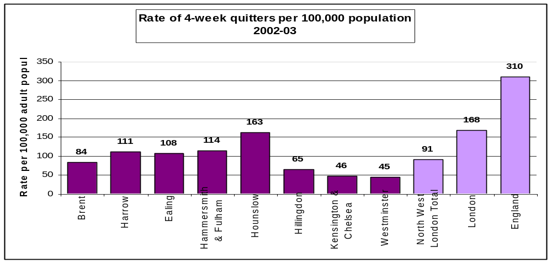
FIGURE 2: RATES OF 4-WEEK QUITTERS PER 100,000 POPULATION IN 2002/03

- The Ealing PCT target for 2003/04 is to enable 1082 smokers to successfully quit smoking at the four-week stage. This is unlikely to be met due to a lack of referrals to the service.

- As stated in a monitoring report for local smoking cessation services to the end of Quarter 3 2003/04, a total of 749 smokers have contacted the service between the start of April 2003 and the end of December 2003. This compares with 292 smokers during the same period in 2002/03. The total number contacting the service may change as late client files are received, GP status is established for those with a ‘not known’ GP status and an allocated number of out of area clients that have attended an Ealing clinics is taken into account.

- If Ealing is to achieve its target number of four week quitters it must generate a far greater number of smokers contacting the service. It is estimated that the service needs to generate approximately 370 contacts per quarter in order to realistically assume achieving the required quarterly four week quit target of 270. Figure 3 illustrates the progress against target for the number of four week quitters required. Ealing PCT is currently running at 47% of the allocated target for the first six months of the year.
 | Total smokers quit at 4 weeks
 | Q1 | Q2 | YTD | Q3 | YTD | Q4 | YTD
Ealing Actual 2002-2003 | 56 | 39 | 95 | 61 | 156 | 111 | 271
Ealing Actual 2003 - 2004 | 135 | 121 | 256
Ealing Target 2003 - 2004 | 270 | 270 | 540 | 270 | 810 | 272 | 1082
FIGURE 3: PROGRESS AGAINST TARGETS (AS AT DECEMBER 2003)

- Ealing PCT recognises that a key issue to seek to address is increasing the number of referrals (e.g. encouraging more GP referrals), as the service relies heavily on GP referrals or recommendations. A further key issue is ensuring that all information available on four week quitters is captured e.g. those assisted by community advisors and those achieved through prescribing nicotine replacement therapy (NRT) and Zyban.

- For 2002/03, Ealing PCT allocated £152,000 to smoking cessation services - the full indicative allocation available. For 2003/04, the allocation from government is £277,000 and this has been allocated by the PCT to smoking cessation services.

Current Smoking Cessation Provision in Ealing
- Ealing’s smoking cessation services are provided as a shared service, hosted by Hounslow Primary Care Trust. The Ealing, Hammersmith & Hounslow Smoking Cessation Services (EHHSCS) covers the areas as mapped in Figure 4. Areas in grey are those coming under Ealing PCT.


FIGURE 4: AREA COVERED BY EALING, HAMMERSMITH & HOUNSLOW SMOKING CESSATION SERVICES

- Clinical guidelines for smoking cessation published in the journal Thorax in December 1998 and updated in December 2000 (Raw et al 1998, 2000) reviewed the evidence base and set out recommended treatments. Extensively peer reviewed and endorsed by a wide range of professional bodies, these guidelines form the blueprint for the structure and operating procedures for the EHHSCS.

Ealing, Hammersmith & Hounslow Smoking Cessation Treatment Services
- EHHSCS operates in accordance with the national minimum standards for an NHS smoker’s clinic as outlined by the Department of Health. The service operates three service components supported by a core clinic as illustrated in Figure 5.

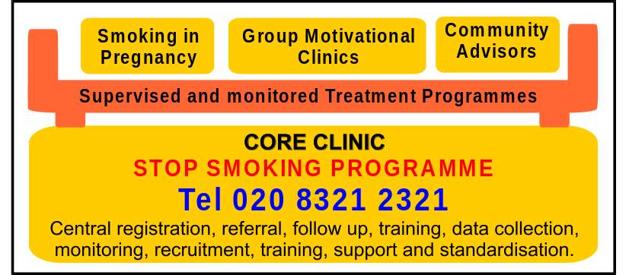
FIGURE 5: SERVICE COMPONENTS OF THE SMOKING CESSATION TREATMENT SERVICES

Core Treatment Programme
- Each component of the smoking cessation service delivers an evidence based treatment programme to smokers to assist them in stopping smoking. The treatment programme, as illustrated in Figure 6, is a six-visit format involving attendance once a week with the smoker setting a quit date and finishing the programme if successful at a stage where abstinence has been achieved for four weeks. All smokers invited to attend the service are followed up at four weeks and at 52 weeks to establish their current smoking status whether they have completed the programme or not.
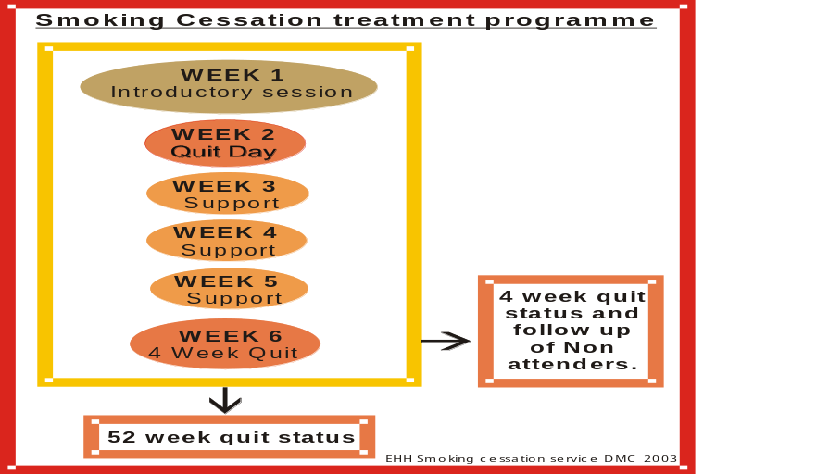
FIGURE 6: FORMAT OF THE SMOKING CESSATION SERVICES TREATMENT PROGRAMME

- If clinically appropriate smokers can use Zyban or NRT products in conjunction with attending the programme to help them quit. Prescriptions for obtaining Zyban or NRT are not issued by the EHHSCS but rather must be obtained by prescription from the patient’s GP before the start of the programme.

Group Motivational Clinics
- The EHHSCS runs group motivational clinics across Ealing PCT as illustrated in Figure 7. Group motivational clinics run in the evening and daytime, lasting approximately an hour at a time. Clinics are demand led and there must be a sufficient number of smokers registered in a particular area for a clinic to run effectively. The EHHSCS will run 13–15 clinics in the Ealing PCT area per year depending on the level of demand generated in the PCT.

Community Smoking Cessation Advisors and Drop In Clinics
- This is a network of professionals trained by the EHHSCS to deliver its evidence based treatment programme to smokers on an individual basis. Community advisors are a mixture of health professionals (pharmacists, practice nurses, specialist nurses), based in a variety of premises suitable to deliver support in accordance with the national guidance on the minimum standard for service operated by the SCS. The drop in clinics are staffed by the EHHSCS at specific times during the week to offer one to one support to smokers.

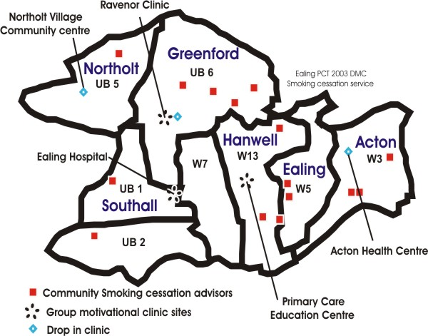

FIGURE 7: LOCATIONS OF GROUP MOTIVATIONAL CLINICS, COMMUNITY SMOKING CESSATION ADVISORS AND DROP IN CLINIC LOCATIONS WITHIN THE EALING AREA

Smoking In Pregnancy Service
- This service offers support to all pregnant smokers who wish to give up and is offered by a specifically trained smoking in pregnancy facilitator. Access to the service is offered to women at their first booking appointment with their midwife. Women can also self refer.

WHAT DID THE TASK GROUP WANT TO ACHIEVE? – OUTCOMES AND TASKS

- The Task Group identified the following desired outcomes for its work into local smoking cessation services:
- To arrive at a considered view of the smoking cessation services available in the borough and building on this work in order to make smoking cessation services a local priority.
- To forward suggestions for improvements to smoking cessation services and how take up/success of services can be maximised, in order to reach government and local targets.
- To have a better understanding of the impact of socio-economic and cultural influences on take up of smoking cessation services, especially in a diverse borough like Ealing.
- To monitor in the medium to long term rates of smoking cessation and assess the success of smoking cessation initiatives against targets (monitoring by Community Scrutiny Committee as long term exceeds lifespan of this task group).
- To determine if Ealing Council could contribute more to anti-smoking initiatives than it currently does and whether there are opportunities presented in the wider delivery of services to promote anti-smoking and quitting.

- In order to achieve these outcomes, the Task Group identified the following tasks to complete:
- (Priority) Task1 - Better understanding of smoking cessation services in general e.g.:
- National/policy context;
- Background information on smoking cessation services provided locally;
- Local projects underway and plans in the pipeline; and
- Implications and implementation of standards/recommendations for service delivery made in recent Health Development Agency document e.g. addressing what a successful service should have in place, how many of these does Ealing have, where are the opportunities for service development?
- (Priority) Task 2 - Exploration of the take up of local smoking cessation services e.g.:
- Referrals - number of referrals, sources of referrals;
- Demographics of clients;
- Interface with national NHS Smoking Helpline;
- Explore why people do not take up the interventions available to them – what are the impacting/contributory factors to consider; and
- Meeting targets set by central government (through Strategic Health Authorities) and locally (by PCT) – analysis of performance information, looking for trends etc.
- (Priority) Task 3 - Research opportunities for raising awareness e.g.:
- Through health promotion at local leisure and sports facilities;
- Places where young people congregate;
- Through GPs, to encourage more referrals;
- Research what other (similar) boroughs are doing with regard to smoking cessation initiatives; and
- Use of various media and communication channels in raising awareness, including national/local media.
- Task 4 - Develop ideas / make suggestions for addressing target client groups e.g.:
- Young people – work with schools, youth centres, teenage parents;
- Council staff – as one of the largest employers in the borough, input of the council into the work of the PCT, role of council services in a co-ordinated approach to smoking cessation;
- People on low incomes;
- Pregnant women – linking to maternity services; and
- Ethnic minority groups – addressing traditionally hard to reach groups, working with and within communities to tackle health issues.
- Task 5 - Consideration of joint working approaches e.g.:
- Opportunities for partnership working;
- Identifying potential overlap in service delivery and avoiding duplication of efforts;
- Explore the feasibility of cross-use of budgets and resources; and
- Linking to wider NHS framework e.g. NSF for Coronary Heart Disease and Cancer
- Explore the feasibility of all local bodies working together to consider a ‘no-smoking week’ type event(s) in Ealing.

- The Task Group recognised that whilst its scope focused on issues relevant to smoking cessation services in a local context i.e. affecting local Ealing borough residents and workers and people using Ealing borough services, this sits within a broader policy context of tobacco control and relates to recent societal debates on smoking in public places and the impact/implications of passive smoking.

HOW DID THE TASK GROUP ACHIEVE ITS AIMS? – METHOD

- The Task Group determined approaches to tasks as time progressed and its knowledge of the subject area and issues grew. The Task Group employed a range of methodologies in addressing the tasks it had set itself:
- Desktop research – officers gathered information from national and local contexts
- Literature review – consideration of published reports and other documents available on smoking cessation services in a national and local context
- Speaking to a range of ‘witnesses’ – professionals in the field e.g. smoking cessation services co-ordinators and the Council’s health promotion officer
- Presentations on smoking cessation services and subsequent ‘question & answer’ sessions
- Conducting a publicity campaign on Ealing Council’s intranet site
- Conducting a survey of Ealing Council staff – gauging views of all staff (smokers, non-smokers and ex-smokers) and highlighting of services available to staff wanting to quit
- Anecdotal evidence of ‘case studies’ of people who had recently given up smoking, relaying their experiences and the barriers faced
- Analysis of performance management information to look for patterns/trends in smoking cessation services data
- Inviting verbal or written evidence from representatives from interest groups and inviting the relevant portfolio holder to also comment on task group findings.

CONSULTATION

- Pursuing one of the key principles of health scrutiny, the Task Group worked with an outward looking focus. This involved and sought the views a number of internal Council and external representatives (* asterix for those who were consulted but did not provide a response or comments on the draft report):

- Local councillors
- Ealing Primary Care Trust
- Ealing, Hammersmith & Hounslow Smoking Cessation Treatment Services
- North West London Strategic Health Authority
- Health Development Agency
- Ealing Community Health Council
- Ealing Council officers
- *Ealing Portfolio Holder for Independent Living
- *Ealing Council staff in general
- *ASH (Action on Smoking and Health UK)
- *QUIT
- *FOREST (Freedom Organisation for the Right to Enjoy Smoking Tobacco)
- *National Asthma Campaign
- *SmokeFree London

TASK GROUP MEETINGS

Meeting One- 16 September 2003
- Prior to the meeting, the Task Group received a information pack providing key documents on smoking cessation with which members could familiarise themselves on the broad policy area.

- Members spent the first meeting considering draft terms of reference that had been drawn up by the Scrutiny Unit and also acquainting themselves with the targets and spending allocated to Ealing PCT. In order to broaden its knowledge, the Task Group used this opportunity to hold an informal question and answer session whereby the advisors provided clarification on various smoking cessation issues. For example, an introduction to local smoking cessation services, what services are available locally, who uses the services, how they are promoted, known barriers to quitting and also a focus on the Council’s position on smoking cessation.

Meeting Two – 13 October 2003
- The EHHSCS manager gave a presentation on the service within Ealing. This outlined local smoking cessation services e.g. what is available, how they are advertised, communications strategies (publicity), general demographics of service users, the options available to people wanting to quit smoking and the step-by-step process of quitting. This drew on existing literature and allowed the Task Group to further refine and prioritise its terms of reference.

- The Task Group also briefly discussed initial ideas on how to raise local awareness of services. Addressing large employers as possible key targets, this included featuring the services on Ealing Council’s staff intranet site and including information in staff (PCT and Council) payslips.

Meeting Three – 3 November 2003
- The Task Group received a presentation from the EHHSCS manager on the service’s current marketing strategy and future plans. This was used to generate ideas on how to raise awareness within different target groups (e.g. young people, workforces, people on low incomes, pregnant women and the general public), at various sites/venues (e.g. large employers, religious sites) and also through various means (e.g. by encouraging GP referrals).

- Information was fed back from a brief audit that had been conducted of the smoking policies and initiatives across Ealing Council’s departments. In light of this, the Task Group decided to commission a smoking survey of Council staff, following up on the internal smoking cessation publicity that had recently featured on the intranet.

Meeting Four – 16 December 2003
- Key findings from the Ealing Council staff survey on smoking were fed back to the task group and the implications for Ealing Council and large employers in general were discussed. Drawing on the cross-agency contacts within the Task Group, a smoking strategy group had been set up and officers reported back on its first meeting and its approach to take forward future work in the area. Preparations for No Smoking Day (Wednesday 10 March 2004) were also briefly discussed.

Meeting Five – 12 February 2004
- The Task Group spent this meeting finalising its summary report and the recommendations made within it, in preparation for Community Scrutiny Committee in March 2004.

EMERGING THEMES

Theme 1: Increasing Take Up of Services

Reaching Targets
- With no improvement, all but one strategic health authority (SHA) in the country will fail to meet smoking cessation targets (for 2003-06), although half of the 28 SHAs will reach their target trajectory for this year (2003/04). Set in this context, Ealing’s smoking cessation situation whilst still cause for concern, is by no means exceptional. This national picture has prompted the Department of Health to consider launching a national campaign to promote local services.

- A survey by BMRB (British Market Research Bureau) in 2001 found that 31% of smokers in the Ealing, Hammersmith & Hounslow area (EHH) had tried to give up smoking in the last 12 months, compared with a London figure of 33%. This highlights that many smokers may wish to give up smoking and are receptive to change if the right help is offered.

- There is a plateau in the take-up of smoking and that the increase and availability of smuggled cigarettes impact upon prices. The price element of tobacco is therefore not as strong as before.

- When looking at the barriers that exist preventing people taking up smoking cessation services, in part this rests on the marketing of the services available. There appears to be very little understanding of what the services are, although the NHS has its own helpline. In Ealing, group motivational courses account for about 70/80% of smoking cessation settings because they are the most effective.

Encouraging Referrals by GPs
- When examining data relating to how users of local smoking cessation services heard of the service, between April and June 2003 the majority of referrals came from GPs (54%), followed by previous attendance, national TV campaign, friends/family and hospital referrals.

- Although the BMRB survey findings should be treated with caution at borough-level due to the small sample size, of those who had approached their GP in trying to give up smoking in the last 12 months, 44% of London but 83% of the Ealing sample had found their GP unhelpful. This seems to suggest that more information needs to be directed at GPs in Ealing. A similar pattern is evident for other types of help sought – approaching another health professional (unhelpful; London 29%, Ealing 67%), pharmacist (unhelpful; London 26%, Ealing 49%).

- GPs are key to the success of smoking cessation services. Furthermore, practice nurses as well as pharmacists in the borough are trained to offer smoking cessation advice and guidance. One local aim is to get all health professionals aware of smoking cessation services and to consistently promote them. Recently, the Ealing Gazette has featured smoking cessation adverts and a flyer targeting health professionals has been included in NHS payslips. Experience shows that local ads do not bring in many referrals and thus are relatively costly. Therefore the main focus for efforts is on GP referrals as these represent the most substantial gains. Ealing PCT has recently written to all GPs in the borough with the offer to write out to all known smoker patients on the GPs’ behalf, highlighting the availability of local smoking cessation services.

- Encouraging GP referrals therefore appears to be the most fruitful way forward. The new contracts for Ealing’s GPs makes mention of this and encourages referrals. One example of success in this approach was is that the Wirral’s where smoking cessation services made a concerted effort to go out to all GP practices to inform them about available services. Following this a record of referrals from each GP surgery was kept and in the long term this led to a ‘league table’ format of referrals by GPs. This encouraged GP referrals, leading to a large increase in throughput and overall success rates.

- Referrals to all components of the EHH Smoking Cessation Service come through one central telephone number (020 8321 2321) and are then directed to the most suitable component, as illustrated in Figure 8. Essential to a successful service is the participation of all PCT GPs and health professionals to be aware of the service and refer into it. This ensures that smokers receive the best possible chance of giving up and the most effective use of Zyban and NRT can be made. All health professionals should simply provide smokers interested in stopping the encouragement to do so and provide them with the number of the service.

- GPs are also essential in the respect that people can get free NRT through their GP. The only cost will be that of the prescription for the four week course. This is particularly beneficial for low-income families who are exempt from paying prescription costs. Previously the cost of NRT had been a disincentive as it could cost as much as cigarettes themselves.

- Conclusions:
- Ealing is not meeting the smoking cessation targets set by the Department of Health, reflecting the picture nationally. Local surveys have shown however that smokers do wish to give up and are receptive to change if the right help is offered to them. One barrier to the success of smoking cessation services is smokers’ understanding of what services have to offer.
- The majority of referrals come through GPs. However in Ealing it appears more information needs to be directed at GPs so that they are suitably informed to encourage smokers to quit. Local smoking cessation work has targeted health professionals with such information.
- GPs can also prescribe NRT and this could be a particular incentive for those on low incomes and exempt from paying prescription charges.
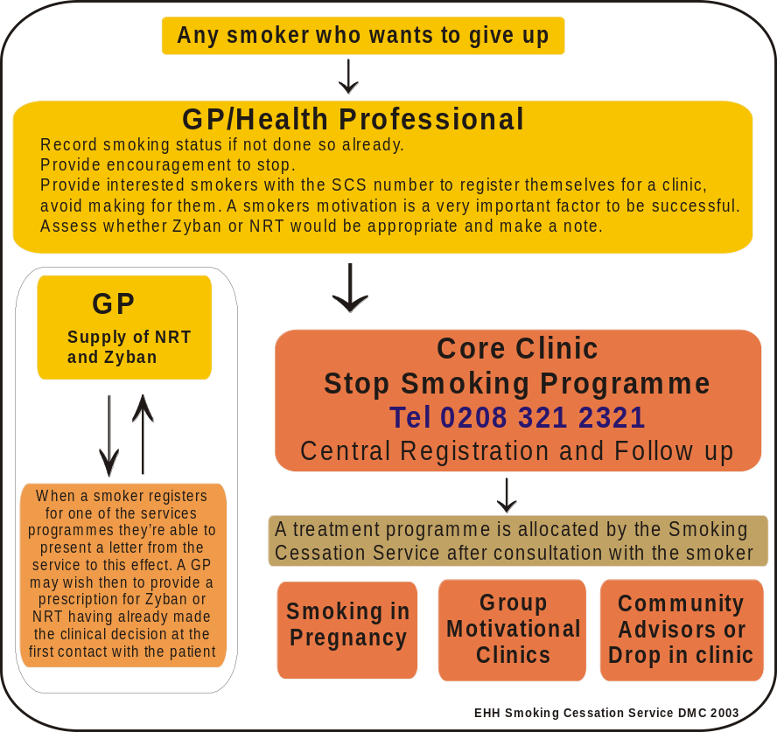
FIGURE 8: REFERRALS TO THE COMPONENTS OF THE SMOKING CESSATION SERVICE

Theme 2: Marketing Services Through Publicity

Raising Awareness
- There is a need to get more people who want to quit smoking to be aware of the availability of smoking cessation services and to ring the helpline number, in order to receive the appropriate guidance. The need for this heightened awareness is highlighted by the fact that locally there is approximately a 65% chance of these people quitting at four weeks if they go on the smoking cessation treatment course advised.

- With regard to Government action around marketing, the 'Don't give up giving up' campaign was launched in December 1999 with a series of TV ads and an outdoor poster campaign. The most visible aspect of the campaign still remains the TV advertising. This offers realistic advice and support to smokers who would like to give up for good. Furthermore, there is the NHS Smoking Helpline (0800 1690169), which is open from 7am to 11pm seven days a week and also offers friendly, practical advice on giving up smoking. It will also connect the smoker to their local stop smoking programme.

- Local action around marketing links into the national marketing provided by the Department of Health. The services core market audience is the local population of smokers who want help in stop smoking. The key message is that ‘there is support available to help you to achieve your aim of not smoking and here is how to contact us’. National advertising is more effective than local, however the latter still has a role to play in reinforcing the key messages e.g. editorials in local press.

- Key future marketing plans for Ealing centre around March especially the next No-Smoking Day on Wednesday 10 March 2004. The Task Group suggested a number of wider Ealing smoking cessation marketing ventures that could coincide with this, for example repeating last year’s strategy of promoting services in local pubs through beer mats as often drinking and smoking are socially linked. However, a problem is the sheer volume of mats needed to reach all smokers. A comprehensive list of pubs and bars in the borough has been obtained through Ealing Council’s Licensing section to facilitate full coverage in future plans.

- Local smoking cessation services could also look to promote services to the general Ealing public through advertising on the back of till receipts in supermarkets and other stores (e.g. HMV for young people etc), perhaps pointing out how much money is saved by giving up smoking. The BMRB survey revealed that financial incentives were motivationally strong in persuading people to quit smoking.

Improving Local Knowledge
- The BMRB survey revealed that less than half of EHH smokers (43%) knew that tar is the main cancer-causing substance in cigarettes. 34% of EHH smokers believed wrongly that nicotine is the main cancer-causing substance. This is notably higher than the London average of 29% and is concerning as it may dissuade smokers from using nicotine replacement therapy. Most EHH smokers knew that giving up smoking would benefit their health, however only 10% mentioned the reduced risk of cancer specifically. 59% mentioned saving money as an advantage of quitting. This highlights the potential use of convincing smokers that quitting has both health and financial benefits in future advertising/marketing.

- It is a common assumption that cutting down cigarette consumption gradually is a good quitting strategy, e.g. changing the habit through behaviour modification and small manageable amounts as a step in the right direction. However, in reality this is a fallacy as cutting down is not beneficial, as the body takes the level of nicotine that it wants (whether this be from 5 or 20 cigarettes per day) – the propensity of nicotine uptake does not reduce through cutting down the number of cigarettes smoked. Furthermore, people who ‘cut down’ are more likely to smoke more later on than actually quit. Therefore the health message must be of total abstinence and this is the message given out by local smoking cessation services.

- Conclusions:
- People wanting to quit smoking need to know that help is available to them, especially given that locally about two-thirds of smokers using smoking cessation treatment services will be successful at the four week stage.
- The Task Group suggested a number of local marketing initiatives that could be explored to help raise awareness amongst the Ealing public e.g. through pubs, supermarkets and other shops.
- National marketing focuses on television and poster ads, backed up by the NHS Smoking Helpline. Local actions link into and complement this.
- The BMRB survey has highlighted gaps in EHH smokers’ knowledge of smoking issues and these may negatively impact on the receptiveness to and take up of smoking cessation services. Smokers are to be made aware of the particular health and financial incentives of quitting their habit.

Theme 3: Approaching Target Groups

Workforces
- Research is clear that when no-smoking workplace policies are implemented, workforce smoking consumption decreases and cessation increases. The concept of having smoking rooms in workplaces has been negated in recent years on an insurance basis. In local health settings, smoking policies exist e.g. Ealing Hospital has a smoking policy related to smoking within hospital buildings with the provision of smoking shelters.

- Large organisations recognise the importance of occupational health issues. Reducing the incidence of staff smoking and smoking related illnesses contributes to an overall corporate decrease in staff absenteeism. EHHSCS could progress smoking cessation in Ealing’s workforces by exploring how to develop work with large organisations in Ealing regarding corporate smoking policies and support. This could be achieved by approaching Ealing Business Partnership and the Local Strategic Partnership as first ports of call and using their links to Ealing businesses.

- The Task Group raised a number of ideas that could be explored to approach large organisations with a view to progressing corporate smoking policies and encouraging smoking cessation among staff. Publicity of smoking cessation services through staff intranet facilities is one option. More and more organisations are using this as a means of staff communication. Ealing Council has an intranet system through which most staff can be informed of the latest news and service developments. At the instigation of the Task Group, a brief article on smoking cessation services, offering help to quit was currently has featured on the Ealing Council intranet site. This was subsequently followed up with a staff survey on the intranet seeking staff views on possible smoking cessation support within the council. This is discussed in more depth later in the report.

- A further local workforce approach for smoking cessation messages could be through information contained within monthly payslips. Large organisations such as Ealing PCT, Ealing Hospital, West London Mental Health Trust, Ealing Council, Police, Thames Valley University, and BAA Heathrow Airport could promote smoking cessation services in this manner, and cover a large number of staff in the process. Smoking cessation information featured in Ealing Hospital payslips in November and in January payslips for Ealing Council staff. Other wide-reaching communications could follow the same format e.g. messages could be included on council bills thereby reaching the wider Ealing public. Equally as proactive would be for large employers to hold health check mornings for staff, and including smoking cessation services within this. Checks and advice could include checks on blood pressure, heart rates, stress factors, dietary needs etc. Experience has shown that the post-Christmas (January to March) peak period is a prime time to target marketing as many people want to give up smoking in the new year

Young People and Schools
- 70% of adult smokers started smoking when they were aged 11-15 years. Young people often start because of preconceptions of smoking as being glamorous and ‘grown-up’, however they underestimate the addictive nature of nicotine – nicotine is said to be as addictive as heroin and cocaine. It is recognised that stopping smoking is difficult and therefore the best solution for young people would be to refrain from starting to smoke in the first place.

- There is limited research on what smoking cessation messages and strategies work best with young people. The international expert community is agreed that smoking among children is best tackled by reducing smoking amongst adults as children often mimic adult behaviours. Parents’ and siblings’ own smoking attitudes and behaviours are important influences in children taking up smoking. Smokefree public places and workplaces help to address social norms around smoking and young people’s smoking behaviour. For example, some of the lowest smoking levels amongst young people have been reported in California which has very strong restrictions on smoking.

- Young people do not necessarily recognise smoking as a major death factor relevant to them and perhaps think of cancer as an older person’s disease. The hard hitting campaigns highlighting the risks of smoking are effective in reducing smoking and the NHS testimonials campaign on television has been developed specifically to address smoking amongst 16-24 year olds.

- Drawing on the findings of the BMRB survey, young smokers in London tend to have tried to quit more recently than older smokers. There is a marked difference for Ealing and London in these figures – 82% of Ealing 16-34 year olds and 72% of 16-34 year olds in London have tried to give up smoking in the past. This suggests that it may be particularly worthwhile targeting smoking cessation services at the younger age range in Ealing. With regard to targeting work with youth centres and schools to target young people, it is not the intention of local services to force young people to stop smoking. Smoking cessation only proves successful if the decision to quit is of the smoker’s own volition.

- School policies on smoking and the enforcement of these in and around schools are important. Under the healthy schools initiative, schools can promote their smoking policies and the PSHE curriculum educates young people to help them make informed decisions. A number of young people will be affected by the social acceptability of smoking e.g. smoking in public places, seeing adults smoke, advertising etc. The Task Group felt that there is a need to introduce school governors to the issues surrounding smoking among young people and the issues that will develop in later life. A template is available for developing smoking policies in schools and the Task Group suggested that this be cross-referenced with Healthy Schools Standards in order to develop a general smoking policy for Ealing’s schools, which could then be implemented in schools with the support of local smoking cessation services.

- Within any plans designed for young people, it is vitally important to involve the young people themselves in decisions. Members suggested tapping into young people’s views on smoking and quitting through youth forums, in order to debate the issues most pertinent to smoking behaviours and the impacting factors as the young people themselves saw them. This knowledge would be best used to develop any smoking policies for schools and youth centres.

- Conclusions:
- The implementation of no-smoking workplace policies decreases smoking consumption and increases cessation amongst staff. This is particularly of note when recognising the level of staff absenteeism due to incidence of staff smoking and smoking-related illnesses.
- EHHSCS could progress smoking cessation in Ealing’s workforces by developing work with large organisations in Ealing with regard to progressing corporate smoking policies and encouraging smoking cessation support for staff. Internal communication mechanisms such as the intranet, payslips and health check mornings could all be explored as a means of spreading the smoking cessation message.
- The majority of adult smokers started smoking when they were aged 11-15 years. Although there is limited research on what smoking cessation messages and strategies work best with young people, it is generally agreed that as children often look towards adults’ behaviour, it is best reduce smoking among adults and role models and also highlight the relevance and risks of smoking.
- BMRB work has shown that the vast majority of Ealing’s 16-34 year old smokers have tried to give up smoking in the past and these people should be targeted in smoking cessation work.
- Schools are key to approaching young people about smoking and its associated risks. Information and education are available through the curriculum, as well as school policies on smoking and their enforcement. The Task Group suggested that a general smoking policy be developed in conjunction with young people themselves, for Ealing’s schools which would then be implemented in schools with the support of local smoking cessation services.

Theme 4: Work Within Ealing Council  – Prioritising Smoking Cessation  Smoking Policies | 
- A no-smoking policy for the Council was developed in 1997, however in light of resistance from trade unions representation, the policy was never formally ratified. This situation requires attention as a matter of priority. A clear consistent smoking policy would be expected for implementation throughout the whole of Ealing Council including all of its buildings, school premises and those available for hire. It is advisable that the original document be revisited with a view to formally recognising and enforcing it. This could draw on policies that already exist, for example at other local authorities and large organisations. Other agencies could then perhaps consider this as a template of a smoking policy for large organisations. Furthermore ASH has recently done some work specifically into the issue of passive smoking at work which could be drawn upon.

- With regard to Ealing Council’s general conditions of hire of halls/rooms, this states that:
“Smoking is not allowed at any event where people are seated on rows of chairs (“theatre-style” close seated). For other events, if you wish to allow smoking, you must discuss this at your meeting with the Duty Manager normally four weeks before the event.”
Therefore, although the Town Halls and rooms within them are no-smoking, it is at the discretion of Duty Managers whether smoking will be allowed at functions held at the larger halls e.g. for wedding banquets. The Task Group noted that this did not necessarily take account of passive smoking issues or that smoke can linger in halls, thus affecting people with subsequent bookings for the halls.

- During the course of the Task Group an initial audit of Council run activities that contribute to health improvement in relation to smoking was conducted. A brief summary of key findings is contained in Figure 9.

Ealing Council’s smoking policy: A smoking policy was adopted in the 1990s. A revised smoking policy was developed in 2000 but appears not to have been fully ratified. A review of the smoking policy is on forward plan for the Talent and Diversity department, but is not a current priority. All central complex offices are maintained completely smoke free. The booking agreement in place for use of halls and other venues belonging to Ealing Council is flexible in its imposing of restrictions on smoking.

Occupational Health: The corporate smoking policy is supported by provision of smoking cessation opportunities for staff. The Council has employed a health promotion officer for five years. The officer has undertaken training in the provision of a six week course of behaviour modification, to support staff wanting to give up smoking and also actively works to raise awareness on smoking cessation within the Council (e.g. of National No Smoking Day) with employees.

Housing and Social Services: Within this department in the past, smoking cessation events have been encouraged with offers of free 13 week nicotine patches. While staff are aware of the health implications of passive smoking the engagement of their client groups must be their priority. In residential homes and sheltered housing, staff use their discretion as to where smoking is allowed.

Environmental Health and Trading Standards: Officers have a role with enforcement of underage sales legislation and undertake investigations, with environmental health officers undertaking food inspections whereby they make mention of smoking as a hygiene/health risk in food premises. While elimination of passive smoking in workplaces is not statutory for employers, it is considered good practice to provide smoke-free areas.

Active Ealing (leisure services): The team is very supportive of the aims of smoking cessation. During fitness assessments, people are asked whether they smoke and this can be followed up with advice regarding the availability of smoking cessation services. Leisure facilities are used to publicise smoking cessation.

Education: The Healthy Schools Initiative encompasses education on smoking issues. Anecdotal evidence suggests that most schools operate a total no smoking arrangement. Smoking policies within schools are at the discretion of governors e.g. a school may have a smoking room for staff but a zero-tolerance policy for children.

FIGURE 9: AUDIT OF SMOKING POLICIES WITHIN EALING COUNCIL’S DEPARTMENTS

- From the audit, it appears that Ealing Council can potentially take action on several fronts:
- Promoting health and wellbeing e.g. smoking policy and through provision of information, advice and guidance on smoking;
- Protecting health e.g. through provision of smoke free environments;
- Preventing disease e.g. enabling employees to access smoking cessation services

Smoking Cessation Support for Staff
- With regard to smoking cessation provision for Ealing Council staff, the Council’s Health Promotion Officer is fully trained to support staff in smoking cessation through a 6-week programme (a national programme sponsored by the PCT). This support includes behavioural (one-to-one meetings) and physiological (NRT patches) support. If the council does decide to look at its no-smoking policy in the near future, it will need to ensure that it can provide appropriate support to encourage staff to quit smoking. Considering the link between smoking and staff absenteeism through smoking-related sickness, one council aim could be to ask all departments to consider committing resources to smoking cessation support for their staff.

- Ealing Council’s Response Programme subscribes to the council’s duty of care to its customers. As staff have raised through staff surveys, there is a real issue with regard to building entrances being used by smokers and others having to pass through this smoke to enter council buildings. Under the plans for the Response Programme, customers will use a front entrance on Uxbridge Road while staff will use another entrance. It will be important to ensure that all staff feel comfortable using this entrance and that it is not used by smokers during cigarette breaks.

- At the request of the Task Group, a brief article on smoking cessation featured on Ealing Council’s intranet site for council staff. Following up interest in this, the Task Group commissioned a survey to be conducted through the intranet asking staff for their views on smoking and smoking cessation opportunities. The survey ran for just under two weeks and resulted in 136 survey responses from staff across the organisation. 51% of respondents were non-smokers, 27% smokers and 23% ex-smokers. Key findings from the staff responses are given in Figure 10.

- Most smokers smoked during work hours at the back of work buildings (outside).
- 75% of the smokers would consider giving up smoking. Most of these smokers had tried unsuccessfully in the past to give up smoking. This represents a potentially large audience to target in terms of smoking cessation services for the council.
- One mindset to tackle for services may be that people have used and would prefer to use willpower alone to quit smoking i.e. the tendency to ‘go it alone’ rather than seek help.
- In terms of people’s knowledge of the help available to them, there are still gaps in people knowing that free smoking cessation help is available and that GPs can prescribe nicotine replacement aids. It is hoped that by conducting the survey, staff awareness of these issues will be heightened to the opportunities available.
- Many staff believed that the council could promote smoking cessation services by providing more publicity and direct support.
- The majority of respondents were positive about the council’s smoking policy, although some were not aware of it. Many staff commented on the perceived unfairness of smokers taking breaks during work hours and in effect working fewer hours than non-smokers. This proved a rather contentious issue among staff.
- With regard to the effect of staff smokers on the council’s image, a number of themes were prevalent in responses. For example, smoking portraying a bad image, smokers having few alternatives than smoking outside buildings, providing designated areas for smokers as well as the issue of passive smoking for non-smokers walking into buildings through staff entrances.

FIGURE 10: KEY FINDINGS FROM THE EALING COUNCIL STAFF SURVEY ON SMOKING (NOVEMBER/DECEMBER 2003)

- The smoking cessation information and survey appearance on the Ealing Council intranet site have been very successful in getting smokers to initiate giving up with some early successes. The Health Promotion Officer reports an expanding waiting list (12 members of staff, as at end of December 2003).

- Conclusions:
- Ealing Council’s no-smoking policy was developed in 1997 but never ratified. The council as a priority should revisit this. A clear consistent policy for implementation across all council premises could draw on work done by other agencies and in turn serve as a template for other organisations to consider when developing their own policies.
- Departments across the council conduct various activities to support the smoking cessation message and the Task Group identified a number of fronts where the council can take action involving promoting health and wellbeing, protecting health and preventing disease.
- Smoking cessation support is available for council staff through the Health Promotion Officer. This is particularly relevant with regard to supporting staff wellbeing, addressing factors in staff absenteeism and revisiting the no-smoking policy.
- A staff survey commissioned by the Task Group uncovered a number of general staff views on smoking and smoking cessation support. One theme of special relevance given the council’s progress on its Response Programme is the provision of smoke-free entrances to council premises in terms of passive smoking issues and the council’s image. There are opportunities to highlight smoking cessation services and support to staff, as well as provide general information on smoking issues.

Theme 5: Joint Working and Partnerships

Sharing Information and Spreading the Smoking Cessation Message
- The Task Group has facilitated the sharing of information and knowledge between various agencies and this should be used to its full potential. For example, the wealth of qualitative information obtained through the Ealing Council staff survey should be shared with the local smoking cessation services to help inform their service development and delivery, both with Ealing Council and other large organisations.

- Other agencies fit into the work of the smoking cessation services. The PCT supports all of the smoking cessation service’s activities, funding costs and directly marketing services to smokers. For example, it has recently considered running drop-in sessions at a local mosque and promoting Asian Quitline, to coincide with Ramadan, in order to address smoking cessation among a specific community within Ealing. Members have worked with a local Asian radio station to highlight smoking cessation services. The option of running focus groups for Asian communities to ascertain their views on accessing services will be explored by the PCT. The EHHSCS has worked with local mosques to promote quitting during Ramadan. However, traditionally there is not good take-up and perhaps Ramadan is not the best time to approach people. Technically when fasting people cannot use NRT and so maybe the best time to target would be before or after the Ramadan period.

- There are numerous service areas where the PCT and local Council can join forces to promote smoking cessation message e.g. encouraging successful quitting at leisure centres. Some boroughs have supported successful quitters at leisure centres by giving them vouchers to use within the leisure centre as an incentive for success. Furthermore, these two major bodies should link with other agencies and partnerships, perhaps through bodies such as the Local Strategic Partnership, as a means through which to progress work in smoking cessation and broader tobacco control within the borough.

Broader Tobacco Control Policy
- Smoking cessation goes beyond helping people quit smoking. The problem can be alleviated at an earlier stage through preventing people taking up the habit and also placing many disincentives to smoking in the public eye. This relates to broader tobacco control policies and the recent debates surrounding banning smoking in public places due to the impact of passive smoking on the health of all. In California 19% of adults are smokers and 7% of young people. In the UK the respective figures are 28% and 10-15%. This in part can be explained by the impact of Californian law banning smoking in public places.

- The Task Group believes that there is a need to look towards a borough-wide strategy for smoking cessation as well as a broader tobacco control strategy, building on partnership work between the PCT and the Council, as two main players in the borough. An interagency group (Ealing Tobacco Strategy Group) is already looking into the development of tobacco policy work in Ealing and will be able to inform any further work.

- The local authority and PCT could use their positions locally to champion smokefree policies e.g. within local health and leisure facilities and sponsor a tobacco control strategy for the LSP. At present efforts focus on GPs as a chief source of referrals, however council staff have numerous contacts with the public e.g. housing officers. Such work could look to identify and bridge gaps and improve services in general. It is of note that ASH has recently employed a solicitor to look into what councils can legally implement with regard to smoking and borough-wide policies. Reporting in March, this may help inform any local work in this area.

- Conclusions:
- The Task Group has facilitated the sharing of information and knowledge between various agencies and this should be used to its full potential. As the borough’s two main players, the PCT and Ealing Council can join forces in a number of areas and strands of work to promote the smoking cessation message.
- Links should also be made through partnership bodies such as the Local Strategic Partnership to progress work on borough-wide smoking cessation and tobacco control strategies.

RECOMMENDATIONS

- Based on the conclusions for each theme area, the Task Group makes the following recommendations. It is anticipated that once the various agencies assigned responsibility for the implementation of these recommendations have considered and responded to the recommendations, the boxes for financial implications and timescales will be completed by the agencies. This will be drawn up into an action plan and reported back to the Community Scrutiny Committee in due course.

Ref | Recommendation | Responsibility assigned to: | Desired impact | End Date | Action By | Financial Implications
1 | Primary Care referrals are the main route for referrals to smoking cessation services in Ealing. The PCT should continue in its drive to give more information and encouragement to GPs and other health professionals about smoking cessation services. Ealing should explore approaches such as in the Wirral to encourage GP engagement. This does not necessarily however target those groups that find it hard to access NHS services and this inequity needs to be addressed through targeted outreach interventions. | Ealing Primary Care Trust | Increasing the number of GP referrals to smoking cessation services.  More outreach work.
2 | People wanting to quit smoking need to know that help is available to them. The Task Group suggested a number of local marketing initiatives that could be explored to help raise awareness amongst the Ealing public e.g. through pubs, supermarkets and other shops and EHHSCS should explore these. Particular mention should be given to both the health and financial benefits of quitting. | Ealing, Hammersmith & Hounslow Smoking Cessation Services | Widespread publicity for local services.
3 | EHHSCS should develop work with the larger organisations in the borough and look to approach their workforces with smoking cessation services information through staff communications e.g. intranet, payslips and health check mornings. | Ealing, Hammersmith & Hounslow Smoking Cessation Services | Developing non-smoking culture in organisations.  Supporting quitters and impacting on staff absenteeism.
4 | Encouraging school governors to develop (and adopt) a written tobacco policy for their school is a useful first step towards making schools smoke-free. A template policy used by Health Promotion is simple and flexible enough to allow all schools to develop and own their policies. Policies should be developed in parallel with provision of smoking cessation services, available for governors, staff, students and parents. Tobacco use is in the curriculum and should be covered at the same time to enable a whole school approach to the issue. A policy on tobacco could link to that on illegal substances but should be capable of standing alone. | Ealing Council Executive Director Learning & Ambition  School governing bodies | Making schools smoke-free.  Consistent approach to smoking in Ealing schools.
5 | In addition to a tobacco policy being developed and adopted in schools (as recommended in Recommendation 4), a similar policy should be developed to extend to services covered by the Youth and Connexions Services. | Ealing Council Head of Youth & Connexions Service | Making youth provision smoke-free.  Consistent approach to smoking across youth provision.  Discouraging young people to take up/continue smoking.
6 | Ealing Council’s smoking policy should be confirmed and fully ratified. This should draw on the previously drafted smoking policy for the council and the draft smoking policy developed by ASH to guide the process of developing a corporate policy. This should note the availability of smoking cessation services to support staff wanting to quit smoking and use the findings from the staff survey as a basis for addressing staff attitudes and needs and to develop a comprehensive strategy for smoking cessation support within the organisation. In the long-term, this could be used as a template to progress work in other large organisations in the borough. | Ealing Council Executive Director of Talent & Diversity | Confirmation of Ealing Council’s approach to smoking and its wider impacts.  Encouraging smokers to quit and offering adequate support to aid this.  Positive impact on staff absenteeism.
7 | Council work on the implementation of no-smoking frameworks and initiatives should begin within Perceval House as the central council complex (tying in with Response Programme developments) and then extend out to other council buildings. Ealing Council should enforce a ban on smoking by staff and members in the near vicinity of entrances to the Council’s public buildings, and offer alternative facilities for smokers (e.g. dedicated outside shelter). It should set an example to other organisations through Council halls and rooms that are hired out being completely smoke-free. There is enough expertise within the PCT and the council to provide advice on implementation of policy, a start point being the last policy drawn up by the council. | Ealing Council, Executive Director of Customer Engagement & Innovation | Cleaner, more welcoming entrances.  Displacement of smokers.  Encouraging smokers to quit.  Relating to Response Programme image of Council. |  |  | Cost of signage and any alternative facilities for smokers (Ealing Council)
8 | An interagency group is already looking at the development of tobacco policy work in Ealing. The Council and PCT should formalise this group as an interagency task group - the ‘Tobacco Strategy Group’ should be formed as a sub-group reporting to the Health Improvement Group and work on tobacco would then be reported up to the Health and Wellbeing Board. This group’s terms of reference would include the development of a borough wide ‘Tobacco Strategy’ in which all agencies (including the LSP) can contribute and which links the work by agencies into one strategy and joint action plan. The work proposed should be multi-agency and done through the LSP, with the PCT leading on this and actively working with the LSP. The LSP is recommended to commission the development of a tobacco strategy for the borough. | Local Strategic Partnership to lead | Progressing cross-agency partnership working.  Adopting a borough-wide approach to tobacco issues.
9 | The link between fitness and being smoke-free should be emphasised by Leisure services. Every support should be given to Active Ealing in promoting the smoke-free message to their staff and clients. | Ealing Council Head of Sports, Halls & Events | Co-ordinating public health messages e.g. health, fitness and smoking links.

BACKGROUND READING

Local Authority Overview and Scrutiny Committee Health Scrutiny Functions Regulation 2002. Statutory Instrument No. 3048, HMSO 2002.

Tobacco in London: A Survey by BMRB International Ltd – Charting Smoking In the Capital. SmokeFree London, 2001.

Tobacco in London: A Survey by BMRB International Ltd – Attitudes to Smoking in the Capital. SmokeFree London, 2001.

BBC website article on smoking/willpower: http://news.bbc.co.uk/1/hi/magazine/3452305.stm

Smoking Kills – Executive Summary. Department of Health, 1999.

Health Select Committee: Report on Smoking Cessation. Wokingham Unitary District Council, 2003.

Meeting Department of Health Smoking Cessation Targets: Recommendations for Service Providers. Health Development Agency, 2003.

Meeting Department of Health Smoking Cessation Targets: Recommendations for Primary Care Trusts. Health Development Agency, 2003.

Marketing of the Smoking Cessation Services in the London Borough of Ealing. Ealing, Hammersmith & Hounslow Smoking Cessation Services, 2003. (Contact: David McArdle, david.mcardle@hounslow.nhs.uk / 020 8321 2321).

Ealing Primary Care Trust April 2003 – March 2004: Smoking Cessation Service Summary. Ealing, Hammersmith & Hounslow Smoking Cessation Services, 2003. (Contact: David McArdle, david.mcardle@hounslow.nhs.uk / 020 8321 2321).

Smoking Cessation Services. Report to Ealing Primary Care Trust PEC Board by EPCT Director of Public Health, August 2003. (Contact: Jackie Chin, jackie.chin@ealingpct.nhs.uk / 020 8893 0114)

Ealing Primary Care Trust: Smoking Cessation Services Monitoring Report 1 April 2003 – 31 December 2003. Ealing, Hammersmith & Hounslow Smoking Cessation Services, 2003. (Contact: David McArdle, david.mcardle@hounslow.nhs.uk / 020 8321 2321).

Ealing Council Staff Survey on Smoking – Summary of Findings. Ealing Scrutiny Unit, December 2003. (Contact: Nahreen Matlib, matlibn@ealing.gov.uk / 020 8825 8269)

USEFUL WEB ADDRESSES

Action on Smoking and Health UK: www.ash.org.uk

Freedom Organisation for the Right to Enjoy Smoking Tobacco: www.forestonline.org

NHS Stop Smoking site: www.givingupsmoking.co.uk

Quit, an independent charity helping smokers to stop: www.quit.org.uk

SmokeFree London, an alliance of agencies working together to improve the health of Londoners by eliminating/reducing their exposure to tobacco: www.smokefreelondon.com

Ealing Council scrutiny webpages including all agendas, notes and reports of the Smoking Cessation Task Group: www.ealing.gov.uk/scrutiny

Health Development Agency: www.hda-online.org.uk

Ealing Primary Care Trust: www.ealingpct.nhs.uk

Department of Health: www.doh.gov.uk

REPORT PRODUCED BY:
Ealing Scrutiny Unit
Ealing Council
Perceval House 4/SW
14-16 Uxbridge Road
London
W5 2HL

Tel: 020 8825 6366
Fax: 020 8825 8082
Email: scrutiny@ealing.gov.uk
Web: www.ealing.gov.uk/scrutiny

