Introduction to Secure Email for LBE Staff

Dear Staff Member,
Adults Social Care and Children’s Services Management is in the process of introducing EGRESS Secure email to the service.
This is an important tool in keeping private or confidential information secure which will be on your desk top. It is integrated into your Microsoft Outlook email client and when it is deployed to you, you will have a couple of new buttons available when you start a new email or reply to one.
The Envelope icon button labelled ‘Unprotected’ is the EGRESS Switch Security Label button. This lets you choose levels of security. In the first instance, there are 3 levels: Unprotected, Encrypt Attachments and Encrypt Message with Attachments.
When you encrypt an email it is safest to encrypt both the message body and the attachments.
Note: You CANNOT use Outlook’s text search with encrypted messages to search the body or attachment for that very reason. You CAN still search for subject lines, so it is important to put sensible titles to emails that you may wish to later retrieve with a search.
All confidential client information should be held in the a relevant case management system. So loss of body/attachment searching should not be an issue.
The first time that you use EGRESS, you will go through a simple signing-up procedure to authenticate your LBE email address. Afterwards, you will see the package below on your desktop.
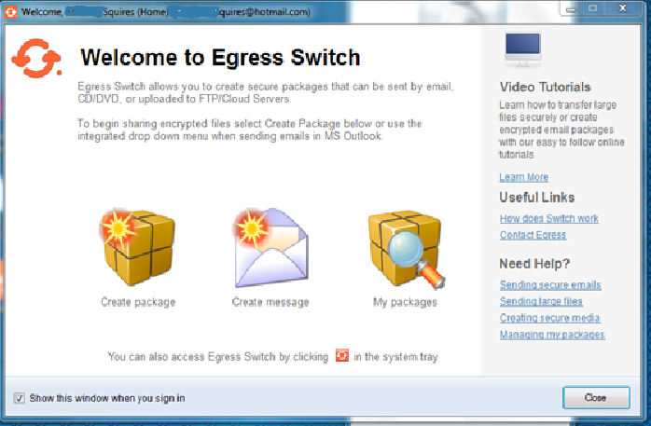
When you log in to your desktop, you should be signed in automatically. If not, click on the double up arrow icon on your task bar to show hidden icons. Then right click on the EGRESS icon to reveal the sign in option below.
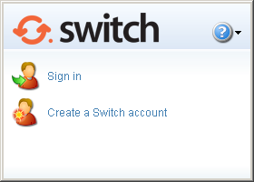
But you will need to first create an account. You only need to do this once. Click on the appropriate option and then follow the prompts, using your local email address as the account name :e.g. bloggsj@ealing.gov.uk
If the recipient has EGRESS (internal staff), and it is integrated to Outlook, they will receive the message as normal and will be able to automatically decrypt the message and read it in Outlook.
If the recipient is outside of LBE, they do not need any special software. The first time that they receive an encrypted email, they will be invited to sign up for the free web service to decrypt and read the email and any attachments. Sign up is no more difficult than signing up for services like Amazon, e-Bay or Googlemail and takes a couple of minutes for them to do.
Recipients can then continue the email thread with it automatically being encrypted for them. They can also initiate new encrypted conversations themselves both to yourself and other staff in LBE who have EGRESS secure email.
If a user has not previously signed up for this free reader service, please send the attached guide to help them:

Why You Might Need More Than One Email Address…

Secure Domains and Encrypted Secure Email
Some organisations operate secure domains – such as the NHS, Police and Youth Justice (CJSM). These domains operate like fortresses in which all the emails are guaranteed to be transmitted in a secure manner. These domains can only guarantee the message security within the ‘fortress’ and up to its walls. Or else if they then send directly to another secure domain.
Once the message is outside of a fortress (domain) its security is no longer guaranteed. So secure domains cannot normally communicate safely with citizens, education or voluntary sector, amongst others. In effect, they all live outside the fortress walls.
Encrypted secure email (EGRESS) is more like sending a suitable bodyguard with every message. Although the message starts outside of any ‘fortress’, it has suitable security to make sure that no-one can intercept and successfully read the message. So you can use it with citizens, third sector, schools and others safely.
Some domains will let encrypted messages inside the fortress walls (like NHS) and some do not (like CJSM). This is why you may need to use multiple email accounts from time to time. e.g. a CJSM account or an NHS mail account depending on your job function.
Any problems contact: Frameworki_Children@ealing.gov.uk

