This handout is intended to explain Child Protection conferences to children and young people who have been invited to attend.

What is a Child Protection Conference?

This is a meeting arranged by your Social Worker because people working with you and your family are worried about your safety. The meeting is about what needs to be done to keep you safe.

Who will be at the Conference?

You are the most important person at the Conference and your social worker will talk to you about attending. You may want to attend a part of the meeting or not attend at all and this is ok. You may want to bring someone with you but this needs to be an adult and could be a relative or someone you trust.

Your views are very important, whether you go to the conference or not. The people at the meeting must consider your wishes and feelings. If you don’t want to come to the meeting, you may want to tell your social workers your views, you could write to the Chair or ask your social worker to help you.

Many people that you already know will be at the Conference including your parents or carers and maybe another member of your family. Some of the adults who work with you will be asked to come, including your social worker, school nurse and someone from school.

There will also be people there who you haven’t met before – maybe someone from the police or a solicitor. There is a person called the “Chair” who leads the meeting and another person to write down what is said in the meeting.

If you do wish to attend you might find it useful to use the template attached to this leaflet to record your thoughts.

What will happen before the Conference?

Your social worker will talk to you about the report they have written about you and answer any questions you have about the meeting. About 20 minutes before the conference starts the Chair will meet you to explain about the meeting and answer your questions.

What will happen at the Conference?

The Chair will ask everyone to introduce themselves and check your family information. The people at the Conference will share all the important information about your life and your family – what they are worried about and what is going well. The Chair will write the most important things on a board behind them. After each person has finished speaking the Chair will ask you if there is anything you want to ask or say.

The Chair then asks everyone what needs to change for you to be safer and asks people to agree to take action to make those changes happen. This is called a plan and is written up on the board. It is really important that you say what you think would make you safer and feel happier.

If the Conference thinks that you are at risk of significant harm and this is likely to continue they will call this plan a Child Protection Plan.

What happens if I need a Child Protection Plan?

A group of people, decided at the Conference, will append time helping you and your family make things safer for you. They are called the Core Group and they will meet regularly to make sure the Child protection Plan is keeping you safe. After a few months there will be another Child protection Conference to see if you are still at continued risk of harm.

What happens if I do not need a Child Protection Plan?

The plan from the Conference will make sure that you can still get all the help and support to make your life better. This is called a Child in Need Plan. Therefore you will not have another Child Protection Conference, unless there are concerns in the future.

Can the Conference decide I will be taken away from my parents or carers?

No. The Conference decides what plan is needed to keep you safe and how everyone will work together to make sure that happens. Only a Court can order that children no longer live with their parents/carers. Most children who have a Child Protection Plan stay at home with their parents/carers.

What if I do not agree with the Conference decision?

You have the right to complain. People will listen. You can talk to your social worker or ask to talk to the Chair. You may also talk to the Safeguarding Manager. To obtain their details, please contact your social worker/Chair. If you prefer you may want to talk to someone you know or you could contact Children’s Services Customer Care Team complaints_childrens_services_@ealing.gov.uk

If you need this information in a different format, such as audiotape or in another language, please ask an English speaker to contact the people listed above.

This document contains information about council services. If you are unable to read it
And you don’t know anyone who can read it for you, please contact our customer
Service centre at the address below

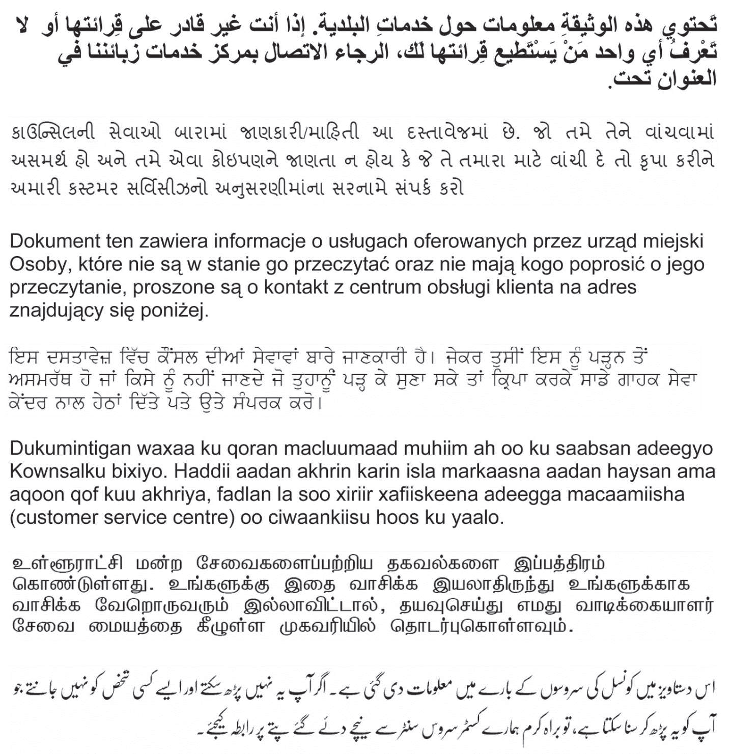

Perceval House 14/16 Uxbridge Road Ealing London W5 2HL

