This handout is intended to explain Child Protection conferences to parents and families.

What is a Child Protection Conference?

A Child Protection Conference is a meeting between families and professionals that is held when there is a concern about the safety of a child within a family.

The purpose of the conference is to:

- Share information about a child’s health, safety and wellbeing

- Assess whether a chid is suffering or likely to suffer significant harm

- Identify the strengths within the family

- Identify any support needed by the family and the professionals / agencies who might be able to provide this

- Identify changes needed (if any) in order to ensure the safety of the child

- Decide if the child needs to have a child protection plan

A child protection conference does not make decisions about legal or court action, or about where children should live.

As a parent, you are invited to attend the conference and we would encourage you to take an active part and prepare for it by using the form. You may also bring someone with you as a supporter if you would like to. This can be another member of your family, a friend, or some other person of your choice.

Who else will be at the conference?

An independent person will chair the conference. There will also be someone to take notes at the meeting.

A number of professionals will also be invited to the meeting and prepare a report which they should share with you in advance. Examples are:

- Social Workers

- Health Visitors, Doctors

- Teachers

- Education Welfare Officers

- Police

All professionals who have had involvement with your family will be invited, but there may also be some individuals and some agencies represented whom you may have not met before. These individuals are invited because of their expertise or because they might be able to provide help. You will be introduced to everyone at the start of the conference.

What happens at the initial conference?

The Chair of the conference will meet with you immediately beforehand to welcome you, to explain how the conference will run and to talk about the best way for you to contribute to the discussion. The chair will also ask you to help confirm your family details which will be put at the front of the room on a white board.

If any of the attendees have confidential contact information which they think needs to be kept from another attendee at the conference, this needs to be raised with the chair before the conference begins.

At the start of the conference all of the participants will introduce themselves and the chair will then ask professionals to summarise the most important parts of their reports. You will then be invited to contribute to the discussion, after which a decision will be made about whether the risks to your child are significant enough that a child protection plan is needed.

A child protection plan is a list of actions with details of who is to carry out these actions and over what timescale.

You should come out of the conference clear about what (if anything) needs to change. More detailed plans are usually made at a later meeting between you and the relevant professionals. This meeting is called a Core Group and should happen within 10 working days of the initial conference.

How can you prepare?

During the conference you will be given the chance to comment about what others are saying and to give your own information and views. You will also be asked what you think should happen in the future, including any help that you feel is necessary.

Many families who have attended conferences in the past tell us that they were very nervous and don’t say as much as they would like to. To help overcome this, it is useful to do some participation in advance.

Many of the professionals who come to the conference will have already prepared a report – setting out the facts, as they are known, their views and ideas. Some families do the same. If you would like to do this, talk to your Social worker about it as they may be able to help you.

If you don’t want to produce written information, you could still do some preparation before the meeting – and perhaps bring along notes for yourself as a prompt. You might find it useful to think about the following and use the template attached to this leaflet to record your views:

- Strengths

What do you think are the strengths in your family?
What are the things that you think you do well?
What positive things would you like professionals to know about you and your family?

- Risks/concerns

What (if anything) do you think needs to change in order for your child to be safe?

- Services/support needed

Does your family need any additional services or support?
How would this support help?

- Next steps

What do you think needs to happen after this conference?
What do you think you or others could do to improve the current situation?

What happens after the conference?

After the conference you will be sent a copy of the notes (minutes – a summary of the key discussion and decisions)

If a child protection plan is made, you will be asked to attend regular meetings called Core Group meetings. At these meetings you will look at the plan and discuss what progress has been made.

A Review Conference will be held after 3 months and then at 6 monthly intervals for, as long your child is the subject of a child protection plan.

It may be that your child does not receive a child protection plan, but that the discussion has identified support that may benefit your child and family. If this is the case, then a CIN plan (Child in Need) will be developed instead. The relevant professionals will meet with you from time to time to discuss how this plan is progressing.

What can you expect from us?

We want to work in partnership with you and your family. As a parent/carer, you should expect to:

- Be listened to
- Be treated with respect
- Be kept informed and involved in decisions
- Get all the help and support that has been offered to you within the agreed timescales
- Receive a reliable service, with professionals doing what they say they will
- Receive copies of all reports two days before an initial conference and 5 days before a Review conference
- Get a copy of the conference record/minutes within 20 working days of the conference
- Confidentiality is very important and you will find that the Chair will remind everyone present at the conference about this

If you don’t feel we are meeting these standards, you should let us know.

Contact information

You can call: Your Social Worker or The Child Protection Advisor/Chair

Equal opportunities

Ealing Council is committed to equality of opportunity. We will treat everyone with respect, regardless of race, disability, gender age, religion or sexual orientation.
If your first language is not English and you are worried you might not understand what is being said, we will provide an interpreter, If you have any other difficulties which might stop you attending or understanding, you should tall to the social worker to see what support we can offer to help with this.
If you need this information in a different format, such as audiotape or in another language, please ask an English speaker to contact the people listed above.

This document contains information about council services. If you are unable to read it
And you don’t know anyone who can read it for you, please contact our customer
service centre at the address below

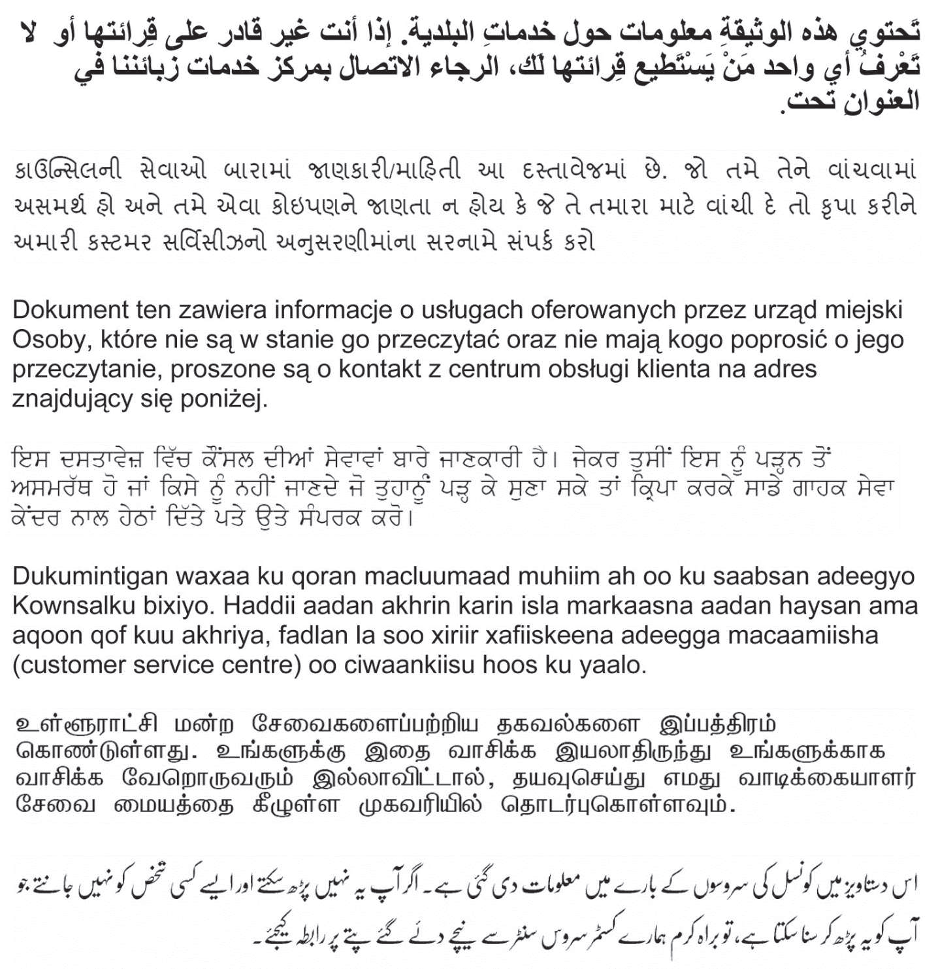

Perceval House 14/16 Uxbridge Road Ealing London W5 2HL

