LICENCE COPY REQUEST FORM 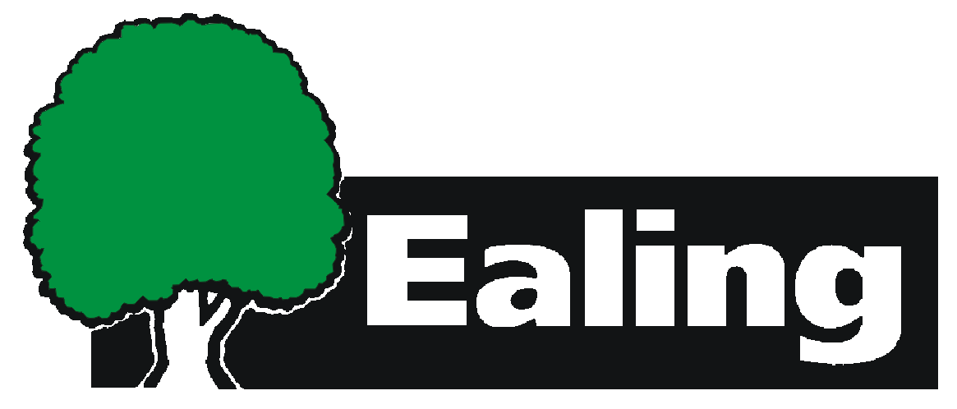
www.ealing.gov.uk

DATE

NAME

ADDRESS

CONTACT DETAILS
TELEPHONE:

EMAIL:

LICENCE TYPE
(Please note that only copies of Non-medical poisons, MST and Explosives certificates can be emailed)

LICENCE NUMBER

ADDRESS ON LICENCE
(If different from above)

REASON FOR REQUEST

Please return to: Licensing team, Environmental Health and Trading Standards, Perceval
House, 14-16 Uxbridge Road, Ealing W5 2HL. Tel: (020) 8825 6655
Email: licensing@ealing.gov.uk

