Draft CYPP 2011

Index

- Foreword
Introduction
1.1 Changed political context
1.2 Ealing’s vision for children and Young People
1.3 Local Context
1.4 New legislative changes
1.5 Progress on Priorities for improvement since 2010
1.6 Consultation
1.7 Revised local Priorities 2011

2. Children’s Joint Strategic Needs Analysis, aims objectives and outcomes 2010
2.1 Child Population health data
  - Staying Safe in Ealing
  - Education
  - Deprivation
  - Employment and Training

3. Update on progress on priorities since 2010
3.1 On children’s health
3.2 On staying safe
3.3 On Education
3.4 On Making a Positive Contribution
3.5 On Achieving Economic Well being

4. Delivering better outcomes through integrated strategy,
4.1 Progress on integrated strategy during 2010
4.2 Better outcomes for all children

5. Delivering better outcomes through service delivery and joint commissioning
5.1 Statement of Resources
5.1.1 LA Resources - Schools and Social Care
5.1.2 Health Resources – Ealing PCT
5.2 Joint Planning and Joint Commissioning
5.3 New legislation - Changes to Commissioning

6. Planning the Future of Children’s Services in Ealing
6.1 Embracing diverse delivery
6.2 Creating sustainable and improved Children’s Services

Glossary of definitions

Appendices
1. Children’s Trust Structure chart
2. 2011/12 Priorities

3. Action Plan
4. Children’s Services structure chart
1. Foreword
Introduction
1.1 Changed political context
1.2 Ealing’s vision for children and Young People
1.3 Local Context
1.4 Progress on Priorities for improvement since 2010
1.5 Consultation
1.6 Revised local Priorities 2011

2. Children’s Joint Strategic Needs Analysis, aims objectives and outcomes

CHILD POPULATION

There were 5,346 Live Births in 2007 in Ealing and there are currently 21,781 children aged between 0 and 4 years which is around 8% of the borough’s population. There are 71,661 children aged between 0 and 19 yrs, making up over 23% of the population. By 2020 it is predicted that the number of children between 0 and 19 will be 75,700.

It is estimated that about a third of children in Ealing aged between 0 and 15 are living in poverty. There are 28,334 school children from Black/Ethnic minority backgrounds which is about just under 77% of the school age population.

Ethnicity Profile

Figure 7.1 School Children by Ethnic Group
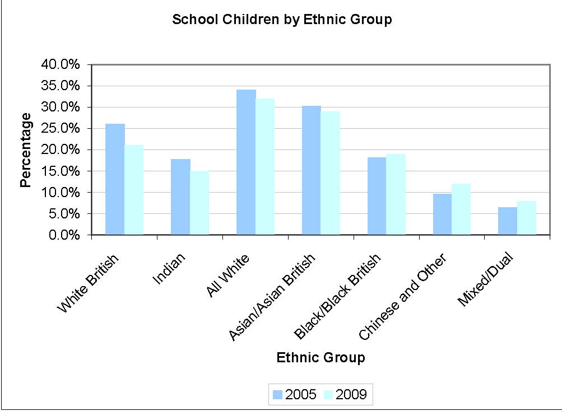
Source: Ealing School Census 2005 and 2009

Ealing has seen changes in the ethnic make up of its school children largely becoming more diverse between 2005 and 2009. The white British and all white school population has fallen. However this is similar to the Indian and Asian/Asian British population. Black/Black British, Chinese and other and Mixed or Dual ethnic groups have increased in Ealing’s school population.

BIRTHS

Figure 7.2 Births By Ward 2008/09
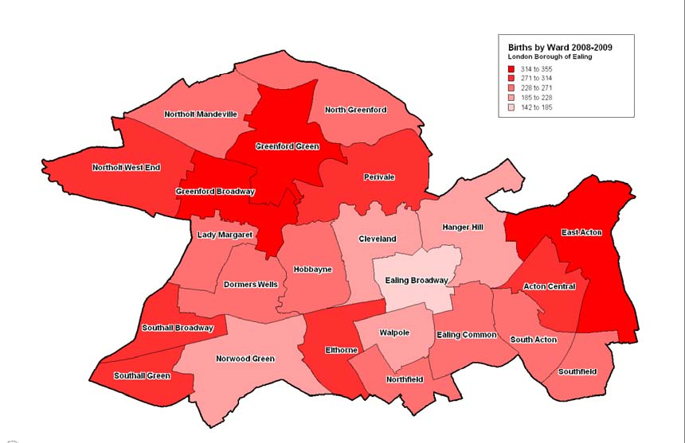
^{Source: Ealing PCT 2009}

Greenford Broadway, Greenford Green, Acton, East Acton and Southall Broadway had the highest number of births in 2008/09. They were usually between 314 and 355 births in each of these wards.

Fertility Rate

Figure 7.3 Fertility Rate for Live Births
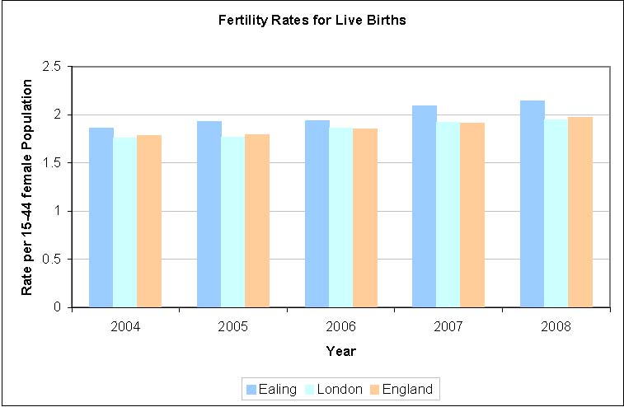
Source: National Centre for Health Outcomes Development 2009

Fertility rates in Ealing are higher than the rates for England and London and have been rising since 2004. There are now 2.14 live births per female population (15-44) compared to 1.86 in 2004

Country of Birth of Mother

Table 7.4 Country of Birth of Mother – Top Ten in Ealing

 | 2007 | 2008 | Percentage Change
England | 1760 | 1807 | 2.7
Poland | 482 | 648 | 34.4
India | 420 | 425 | 1.2
Somalia | 362 | 399 | 10.2
Sri Lanka | 254 | 231 | -9.1
Afghanistan | 233 | 218 | -6.4
Pakistan | 223 | 212 | -4.9
Iraq | 99 | 106 | 7.1
Ireland | 73 | 60 | -17.8
South Africa | 52 | 57 | 9.6

^{Source: NHS Ealing 2010}

Women giving birth in Ealing could have been born in any one of 144 countries. Table 7.4 shows the top ten countries according to number of births. These were in the same order for both 2007 and 2008. The top four countries, England, Poland, India and Somalia all saw increases between 2007 and 2008. This suggests that that Ealing diversity is likely to continue increasing over the medium term.

INFANT MORTALITY

The infant mortality rate (IMR) is defined as the number of deaths of infants aged less than 1 year per 1,000 live births. Infant mortality has fallen in Ealing, in line with England and Europe as a whole. The rate in Ealing is lower than the average for England but still highest than the lowest in London, suggesting that improvement is still possible.

Table 7.5 Infant Mortality Rates (2000-02 to 2005-07)

INFANTS UNDER 1 YEAR (per 1000 live births)
 | 2000-02 | 2001-03 | 2002-04 | 2003-05 | 2004-06 | 2005-07
Ealing | 6.2 | 5.9 | 5.0 | 4.0 | 4.2 | 3.9
London | 5.7 | 5.7 | 5.4 | 5.2 | 5.0 | 4.8

Source: National Centre for Health Outcomes Development and London Health Observatory 2009

LOW BIRTH WEIGHTS

The low birth weight rate of a population is caused by a combination of babies being born too early or too small or both. Low birth weight is a predictor of poorer infant and child health. Optimal for a growing fetus or newborn may vary to some extent by mother’s ethnicity. Babies gain most of their weight during the latter part of pregnancy therefore prematurity (<37 weeks gestation) is the primary reason for low birthweight. Babies born after 37 weeks may also have a low birthweight for any of the following reasons:

- • poor placental function
- • poor maternal health (poor nutrition, inadequate antenatal care)
- • maternal substance use (smoking, alcohol, drug use)
- • multiple birth (i.e. one of twins, triplets etc)
- • birth defect
- • maternal age – especially teenage mothers
- • maternal low socio-economic status
- • maternal ethnicity

Figure 7.6 Low Birthweights data
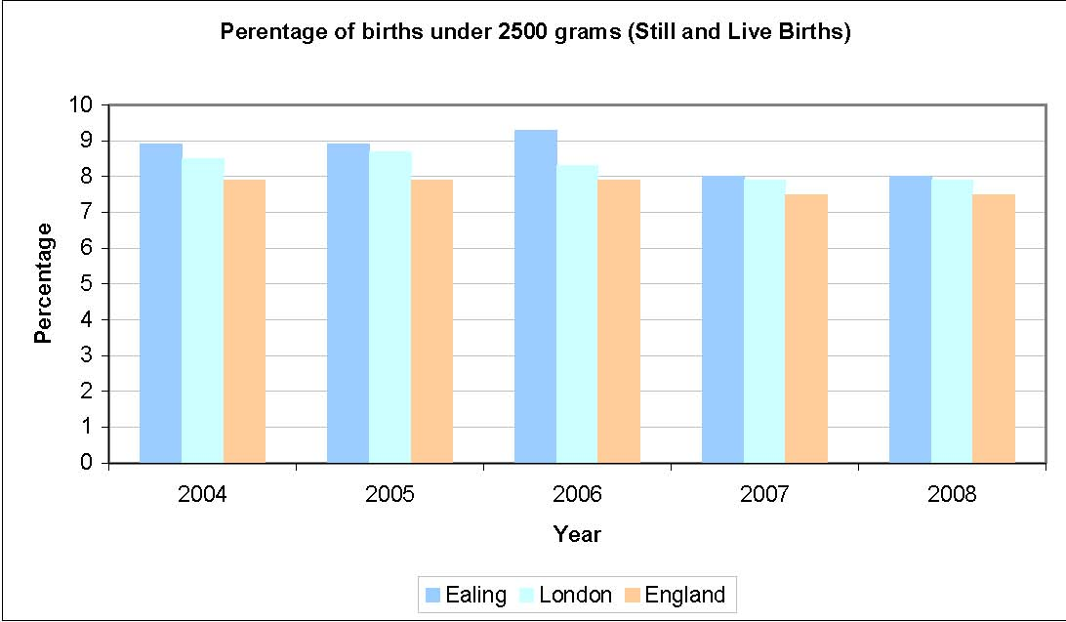 Source: Office for National Statistics 2009

Figure 7.6 shows that Ealing percentage of low birthweights is higher than England and London’s. Although in 2007 and 2008 the gap between the London and Ealing rate appeared to be narrowing.

Smoking in Pregnancy

Maternal smoking in pregnancy is an important cause of low birth weight. Rates in Ealing have decreased between 2005 and 2008, have always been below the London rate. Currently less than 1 in 20 mothers smoke during pregnancy.

Table 7.7 Smoking during pregnancy

Percentage of Expectant Mothers smoking during pregnancy
 | 2005/06 | 2006/07 | 2007/08
Ealing | 7.9% | 6.1% | 4.5%
London | 9.4% | 8.3% | 6.7%
Source: London Health Observatory

Breastfeeding

There is clear evidence that breastfeeding has positive health benefits for both mother and baby in the short and longer-term (beyond the period of breastfeeding). Breast milk is the best form of nutrition for infants and exclusive breastfeeding is recommended for the first six months (26 weeks) of an infant's life¹⁶. For infants, it reduces the incidence of gastrointestinal and respiratory infections, otitis media and recurrent otitis media and reduces the risk of allergies. There is also some evidence that it protects against neonatal necrotizing enterocolitis, respiratory and urinary tract infection, and that it reduces the risk of auto-immune disease, such as diabetes mellitus type I, and of adiposity later in childhood. For mothers, it promotes maternal recovery from childbirth, reduces the risk of pre-menopausal breast cancer and possibly of ovarian cancer, accelerates weight loss and a return to pre-pregnancy body weight and prolongs the period of postpartum infertility (World Health Organisation Regional Publications, European Series, No.87).
There is evidence indicating that the longer the duration of breastfeeding, the greater the health benefits in later life. Breastfeeding initiation rates have been improving over the last 10 years and, in 2005, 78% of mothers in England initiated breastfeeding. However, only 50% of all mothers who initiated breastfeeding were continuing to breastfeed at 6 weeks and 26% continued some breastfeeding at six months. There is clear evidence that adequate support to breastfeeding mothers in the first few weeks is likely to increase the duration of breastfeeding. Breastfeeding has an important contribution to make towards reducing infant mortality, childhood obesity and health inequalities¹⁷.

Table 7.8 Percentage initiating breastfeeding

 | 2006/07 | 2007/08 | 2008/09
Ealing | 87.01% | 86.19% | 87.97%
London | 79.20% | 84.20% | 83.70%

Source: Department of Health 2009

Table 7.8 indicates that on the whole mother initiate breastfeeding in Ealing more than in London. The percentage has remained relatively stable in recent years. However it is worth noting that they represent the percentage of women about data are collected.

UNDER 15 MORTALITY

Table 7.9 compares the number of deaths of under-15s per 100,000 population in Ealing with London and England between 1993 and 2008. The national and regional mortality rates have declined by over a third over the period. The pattern in Ealing is consistent with this decline, although absolute numbers are too small to show a lear trend. In 2008, 26 people aged under 15 died in Ealing which higher than the previous year (23) but notably lower than 43 in 2002.

Table 7.9 Under 15 Mortality rate 1993 to 2008

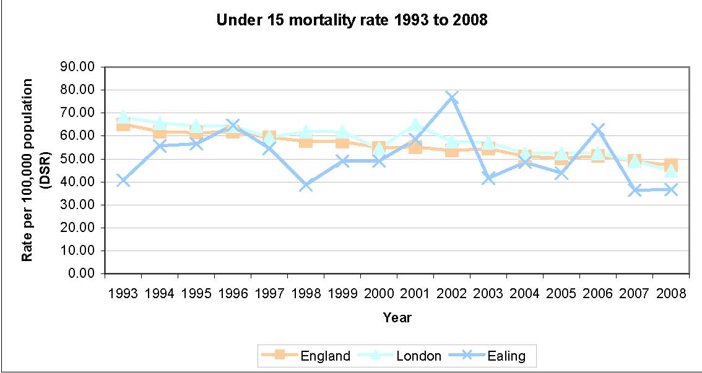Source: National Centre for Health Outcomes Development 2009

DENTAL HEALTH

Dental caries and periodontal disease are almost entirely preventable, and oral cancers are strongly related to behaviours such as smoking or oral tobacco use and alcohol consumption. The other main causes of poor oral health are increased consumption of sugary food and drinks, poor oral hygiene and lack of exposure to fluorides.

The dental health of young people in Ealing is worse than the national and London average. Data on under five year olds (Table 7.10) reveals high numbers of decayed, missing or filled teeth and high proportions of children and young people with active decay or experience of decay. Decayed, missing or filled teeth in the under fives is strongly linked to deprivation and may indicate sizeable health inequalities in Ealing. Nearly a third of all five year olds surveyed had active decay in Ealing.

Table 7.10 Under 5 Dental Health 2007 – 08

 | Average no. of decayed teeth | Average no. decayed, missing/filled | Percentage with experience of decay | Percentage with active decay
Ealing | 1.30 | 1.52 | 36.3% | 32.8%
London | 1.00 | 1.31 | 32.7% | 29.0%
England | 0.87 | 1.11 | 30.9% | 27.5%

Source: NHS Dental Epidemiology Programme (NHS DEP) for England 2009

Figure 7.11 Percentage of the child population seen in the previous 24 months by a dentist 2006 -2010
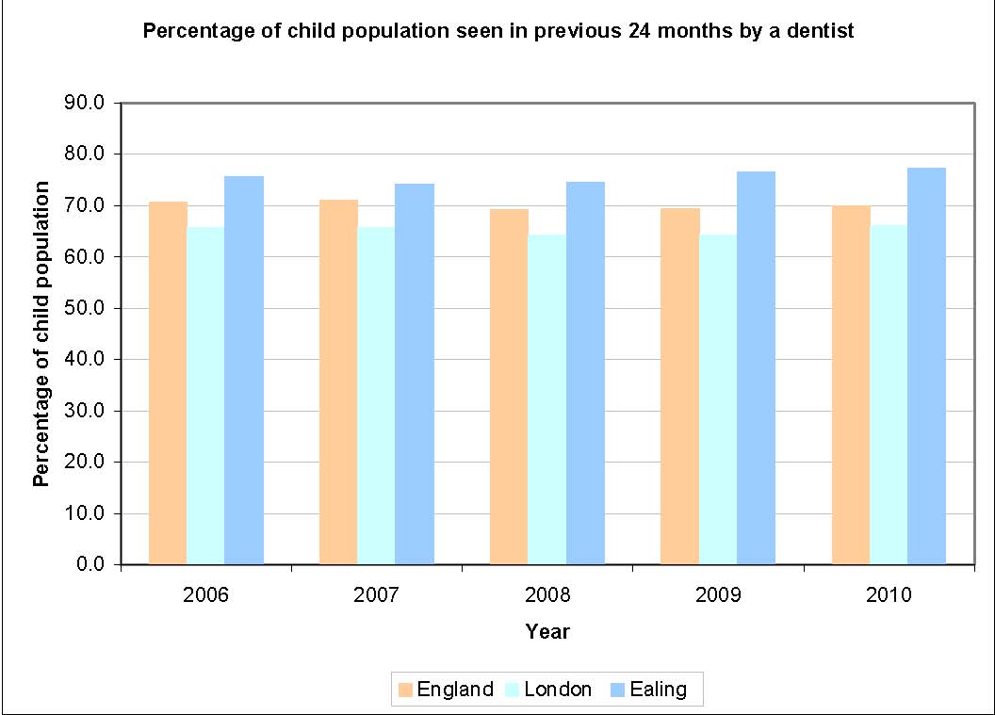
Source: The Information Centre, Department of Health 2010

The percentage of children (17 years or younger) who have seen a dentist in the last 24 months is higher than the London and national rate. Given the rates of decay in younger children, it is not possible to say if the high percentages are due to active dental care or necessary dental care.

In Ealing 85% of primary and 82% of secondary pupils brush their teeth two or more times on the day before pupils were survey. Only 1% in primary and secondary did not clean them at all.³¹

The questions about dental health continue to raise concerns. 30% of primary pupils and 13% of secondary pupils had a filling on their last visit to the dentist compared to 21% primary pupils and 7% secondary pupils nationally. 12% of primary pupils and 15% of secondary school pupils had not visited the dentist in the past year and further still 21% had not been in the last 6 months.³¹

OBESITY

In the UK there are around 1 million obese children under 16 years of age.

Increasing rates of obesity have led to an increase in childhood type II diabetes and are likely to lead to a higher incidence of heart disease, osteoarthritis and some cancers in future. Estimates indicate that, if current trends continue, at least one fifth of boys and one third of girls will be obese by 2020 nationally.

Recognising this problem, the Government set a national target to halt the year on year rise in obesity among children under 11 by 2010.

In Figure 7.12 data for 2008/09 from the National Child Measurement Programme (NCMP) is shown. The NCMP weighs and measures children in Reception year (age 4-5 years) and Year 6 (aged 10-11 years) to assess overweight and obese levels.

Figure 7.12 Prevalence of Obesity in children in Ealing

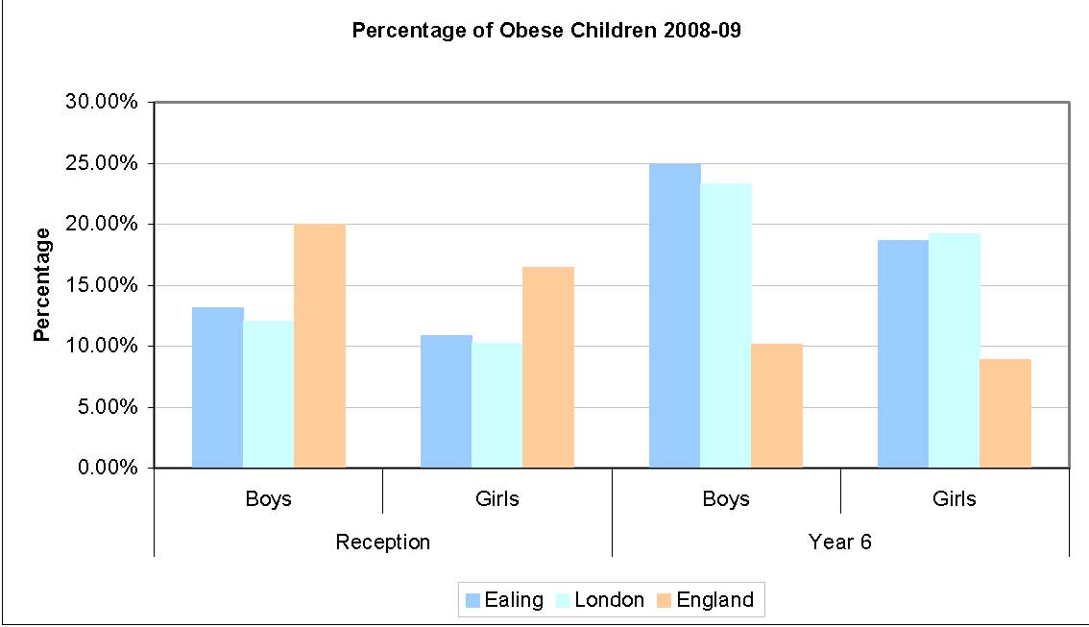Source: Information Centre, Department of Health 2010

Levels of obesity in boys in Ealing are high, it is above the London rate in reception and is higher than London and national levels by Year 6. While in Year 6 Ealing rates in boys are only slightly higher than London level, it is more than double the national figure. Ealing girls in Reception have a slightly higher obese rate than London but significantly lower than the national rate. However by Year 6 Ealing girls’ obesity is nearly double the national rate and only just below the London rate.

In Ealing, 19% of the secondary pupils and 14% of the primary pupils thought that they were too heavy, where as 11% of the secondary and 15% of primary pupils thought they were too light.³¹

40% of the primary school pupils said that they had tried to loose weight once or twice and 18% said lots of time. 57% of secondary pupils exercise sometimes or quite often to lose weight, while 13% said that they were always exercising to lose weight.³¹

MENTAL HEALTH

The effectiveness of child and adolescent mental health services (CAMHS) is measured and based on a self-assessment of how effectively mental health services meet children’s mental health needs. This is an aggregated score of 1 to 4 for each of the four questions, where a total of 4 is the lowest possible score and 16 is the highest.
Table 7.13 Effectiveness of Child and Adolescent Mental Health Services (CAMHS)

 | 2008 | 2009
Ealing | 16.0 | 16.0
London | 14.9 | 15.5
England | 13.8 | 14.7

Source: Department for Education 2009

Child and Adolescent Mental Health Services in the UK are described in terms of Tiers. The description below comes from the National Service Framework for Children, Young People and Maternity Services - The Mental Health and Psychological Well-being of Children and Young People (DH 2004)

- •Tier 1: Provision is centred on promotion of emotional and mental well being or early identification of children and young people who require referral to more specialised services
- •Tier 2: A service provided by specialist individual professionals in community based /setting and may be part of a multi agency team working with the child or family.
- •Tier 3: A specialised multi-disciplinary service for more severe, complex or persistent disorders.
- •Tier 4: A highly specialised multi professional care approach, usually inpatient care but occasionally outpatient care at a specialist unit. Admission is and should be considered a last option where the child or young person cannot be safely managed in the community even with extensive support.

Tier 2 and Tier 3 Referrals per month
Table 7.14
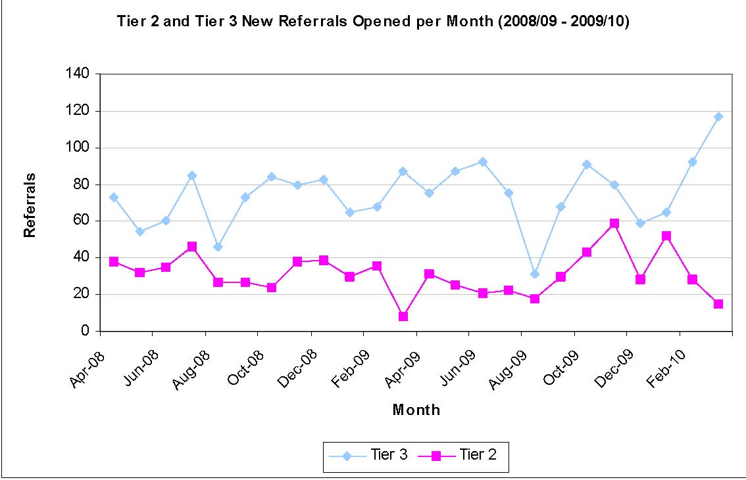
Source: Ealing CAHMS 2010

Over the period it is clear that there are more Tier 3 referrals than Tier 2, however since January 2010 it would seem that Tier 2 referrals have fallen while Tier 3 referrals seem to be increasing. It would normally be expected that as the severity of the hea
c

T
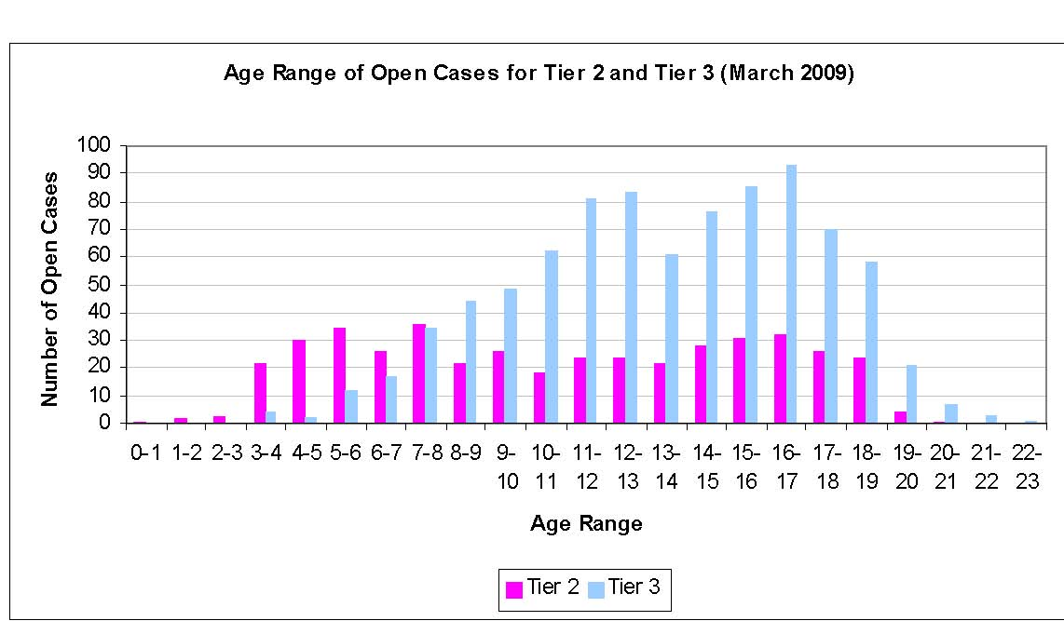
^{So}
During 2009/10 there were a total of 19 Tier 4 admissions, 10 female, 9 male. Over the past 18 months Ealing has had 29 admissions to tier 4 units. Data available from The Priory Group indicates that Ealing, despite a larger population, has a lower number of bed occupancy days and number of admissions than
s
The rates of mental disorder in Great Britain vary by sex and age. Overall, boys were more likely to have a mental disorder than girls, and this was evident in both the 5 to 10 year age group (10 per cent of boys compared with six per cent of girls) and the 11 to 15 year age group (13 per cent of boys compared with 10 per cent of girls). More specifically, the pre
among boys
Table 7.16 Pr
G
 | Male
Anxiety Diso | 3.5% | 4.0%
Depression | 0.9% | 1.0%
Conduct Disorders | 7.4% | 3.2%
Hyperkinetic Disorders | 2.4% | 0.4%
Pervasive Dev | 0.7% | 0.4%
Tic Disorder | 0.1% | 0.0%

Eating Disorder 0.0% 0.2%
^{S}

ADDITIONAL NEEDS

Table 7.17 Prevalence of longstanding illness in Great Britain

 |  | Male |  |  | Female
Year | 0 to 4 |  | 5 to 15 | 0 to 4 |  | 5 to 15
1998 | 15% |  | 21% | 15% |  | 19%
2000 | 14% |  | 23% | 13% |  | 18%
2001 | 17% |  | 20% | 12% |  | 16%
2002 | 17% |  | 21% | 12% |  | 19%
2003 | 14% |  | 18% | 10% |  | 17%
2004 | 15% |  | 19% | 11% |  | 15%
2005 | 14% |  | 19% | 10% |  | 16%
2006 | 11% |  | 17% | 10% |  | 15%
2007 | 8% |  | 17% | 11% |  | 14%
2008 | 9% |  | 15% | 7% |  | 10%

Source: General Lifestyle Survey 2009

Table 7.18 Prevalence of limiting longstanding illness in Great Britain

 |  | Male |  |  | Female
Year | 0 to 4 |  | 5 to 15 | 0 to 4 |  | 5 to 15
1998 | 4% |  | 8% | 5% |  | 8%
2000 | 4% |  | 9% | 4% |  | 8%
2001 | 5% |  | 9% | 4% |  | 8%
2002 | 5% |  | 8% | 3% |  | 9%
2003 | 4% |  | 7% | 4% |  | 7%
2004 | 4% |  | 8% | 4% |  | 7%
2005 | 5% |  | 7% | 3% |  | 7%
2006 | 3% |  | 7% | 3% |  | 6%
2007 | 2% |  | 6% | 3% |  | 5%
2008 | 2% |  | 7% | 3% |  | 4%

Source: General Lifestyle Survey 2009

There appears to be no significant difference between the prevalence of longstanding and limiting longstanding illness among the 15 years and younger male and female population. Longstanding prevalence for males aged 0 to 4 ranges from 8% to 17% and for females between 7% and 15%. Limiting longstanding illness prevalence ranges from 6% to 9% for males aged 5 to 15, for females in the same age group the range is 4% to 9%.

Using this prevalence for 2008, an estimate of predicted prevalence has been calculated using Ealing Council’s population estimates.

Figure 7.19 Projected numbers of children (0 to 15) with a longstanding illness
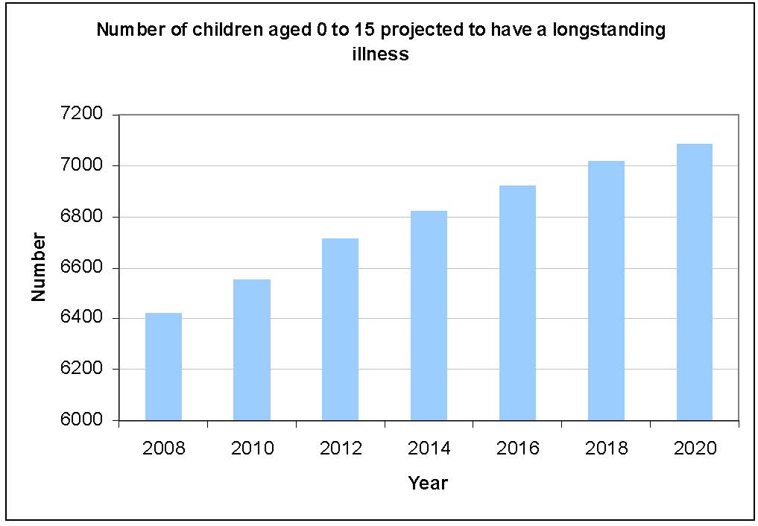
Source: General Lifestyle Survey 2009 and Ealing Council, Research and Consultation 2009

It is anticipated that the number of children with a longstanding illness in the borough will have risen by about 10% by 2020 to 7083. The numbers with a limiting longstanding illness is also set to increase to around 3187.

Figure 7.20 Projected numbers of children (0 to 15) with a limiting longstanding illness
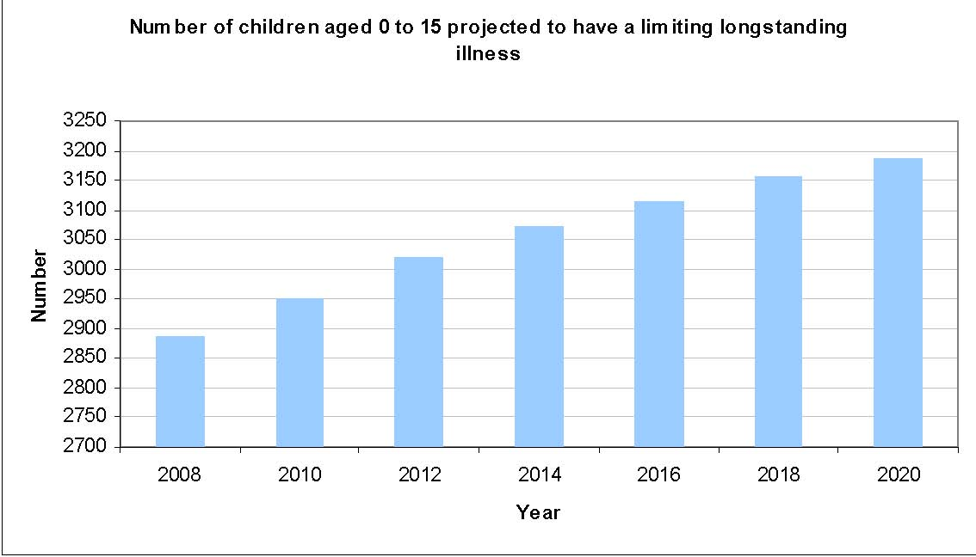
Source: General Lifestyle Survey 2009 and Ealing Council, Research and Consultation 2009

Table 7.21 Estimated number of 0-19 year old with a disability in Ealing, 2010

Estimated number 0-19 year olds disability in Ealing | Boys | Girls | All | Percentage of total
Mental disorders | 310 | 270 | 580 | 4%
Learning difficulties | 150 | 140 | 290 | 2%
Nervous System Disorders not elsewhere specified | 310 | 270 | 580 | 4%
Blindness or vision defects | 310 | 270 | 580 | 4%
Deafness or ear defects | 460 | 410 | 870 | 6%
Heart disease | 230 | 200 | 430 | 3%
Lung or respiratory disease | 460 | 410 | 870 | 6%
Asthma | 3,210 | 2,850 | 6,060 | 42%
Digestive disorders | 310 | 270 | 580 | 4%
Urogenitary disorders | 230 | 200 | 430 | 3%
Musculoskeletal disorders | 380 | 340 | 720 | 5%
Skin conditions | 610 | 540 | 1,150 | 8%
All | 6,970 | 6,170 | 13,140
Total population | 40,203 | 39,952 | 80,155

Source: The Health of Children and Young People, ONS 2004, Chap 10, Tables 10.5 and 10.1; Special Population Projections, GLA/LBE, 2009

There appears to be around 16% (Table 7.21) of Ealing’s 0-19 year old population with a disability, the most common being Asthma.

Table 7.22 Congenital Abnormalities admission data for Ealing registered patients (2007 – 2010)
All Outcomes | 2007/2008 | 2008/2009 | 2009/2010
Others (Low needs/remedied in early childhood) | 214 | 195 | 221
Atrioventricular septal defect | 1 | 2 | 4
Tetralogy of Fallot | 3 | 1 | 1
Deafness | 2
Atresia or stenosis of other parts of the small intestine | 1 | 2
Renal Dysplasia | 1
Craniosynostosis |  |  | 1
Valproate syndrome |  | 1 | 2
Down Syndrome | 4 | 1 | 5
Wolff-Hirschorn syndrome |  | 1
Limb reductions | 1
Grand Total | 227 | 203 | 234

^{Source: NHS Ealing 2010}

Table 7.22 shows under 16s with congenital abnormalities registered in Ealing. While the majority are registered with low level needs or those remedied in childhood, small numbers are registered with serious conditions which require high intensity interventions

ALCOHOL AND SUBSTANCE MISUSE

Evidence suggests that the life expectancy of males in Ealing is reduced by about 9 months on average due to excessive alcohol consumption. The life expectancy of females is reduced by just over 3 months.

Limited information is currently available on alcohol consumption by young people.
However, a study carried out by National Centre for Social Research (NatCen) and the National Foundation for Educational Research (NFER) (2006-2008) found that within the 11-15 age group, the proportions who have had at least one alcoholic drink varied between 55% in 2006 and 52% in 2008. Over the same period, there was a similar decline in the proportions who had drunk alcohol in the last week from 21% to 18%. Nationally boys and girls are equally likely to drink alcohol¹⁸.

In London, young people in this age group (11-15) are much less likely to have ever drunk alcohol than those living elsewhere. In London, 39% had ever drunk alcohol; this proportion varies between regions from 51% in the East Midlands to 63% in the North East.

As perhaps expected, young people in London are less likely to have had an alcoholic drink during the past week at the time the survey the was carried out; this was 12% in London compared, for example, with 19% in the East Midlands and South East and 26% in the North East.

The mean consumption (units of alcohol) of those who drank in the last week, shows London as the lowest (11.3 units) and highest in the North East (17.7 units).

Hospital Admissions due to alcohol

Table 7.23 Under 18s hospital admissions due to alcohol specific conditions 2008-09
Area | Rate per 100,000 under 18
Brent | 26.89
Ealing | 56.21
Hammersmith & Fulham | 58.83
Harrow | 22.05
Hillingdon | 56.69
Hounslow | 40.30

Source: North West Public Health Observatory 2009

As Table 7.23 shows that hospital admissions for alcohol specific conditions in Ealing is comparable to Hammersmith and Fulham, and Hillingdon, but is significantly higher than our other near neighbours such as Brent and Harrow. All the above London boroughs except Hammersmith and Fulham have a lower hospital admissions rate than the national rate.

331 primary pupils, 6% of those surveyed had at least one alcoholic drink in the week before the survey, although for more than half it was just on one day. 8% of secondary pupils had at least one alcoholic drink in the previous week; with 1% of all pupils drinking on 3 or more days.³¹

Drug Use

NatCen and NFER study (2006-2008) asks about awareness, availability and use of 15 named drugs (see table 7.24). The prevalence of drug use has declined since 2001. The proportion of 11 to 15 year olds who reported having taken any drugs in the last year was 17% in 2006 and 2007 and 15% in 2008. Similar proportions of boys and girls had taken drugs in the last year.

The proportion of 11 to 15 year olds who have taken drugs at least once varies from 15% in the South West to 20% in the North West. In London this stands at 16%. Prevalence is similar among boys and girls in all regions.

Table 7.24 Named drugs used in the NatCen and NFER study

Amphetamines
Ecstasy
Cocaine
Crack
Heroin
LSD
Magic mushrooms
Methadone
Tranquillisers
Anabolic steroids
Ketamine
Cannabis
Poppers
Glue
Gas
Source: The Information Centre, Department of Health 2009

The most commonly taken drug in this age group is cannabis. In 2006, 10% of 11 to 15 year olds had taken cannabis in the last year; in both 2007 and 2008 9% reported this. Boys are more likely than girls to have taken cannabis. The prevalence of cannabis use in the last year varies by region from 8% in the North East to 12% in the North West. In London the prevalence is 9%.

Recently the use of ‘legal’ drugs such as mephedrone were widely reported as increasing and were linked to a number of deaths. Data for the use of this drug is limited given that its legal status has only recently changed. A survey of 2000 people for dance magazine Mixmag showed that nearly 42% reported that they had tried mephedrone in the last month.²¹ Equally, although mephedrone has been implicated in the deaths of 34 people in the UK it has only ever been established in the case of one person.²²

13% of secondary pupils and 22% of year 10s specifically have been offered drugs. The most common type of drugs offered were cannabis, cannabis resin and cocaine. 6% of secondary pupils had taken drugs. This was much higher among year 10 pupils, where 10% had taken drugs, compared to 2% of year 8 pupils.³¹

Drug Treatment

According to the National Treatment Agency (NTA), drug addiction is rare among young people, trends in interventions offered to under-18s over the last four years shows a steady decline in the reported incidence of problems with hard drugs.

Figure 7.25 Percentage by Age Group accessing drug treatment 2008-09
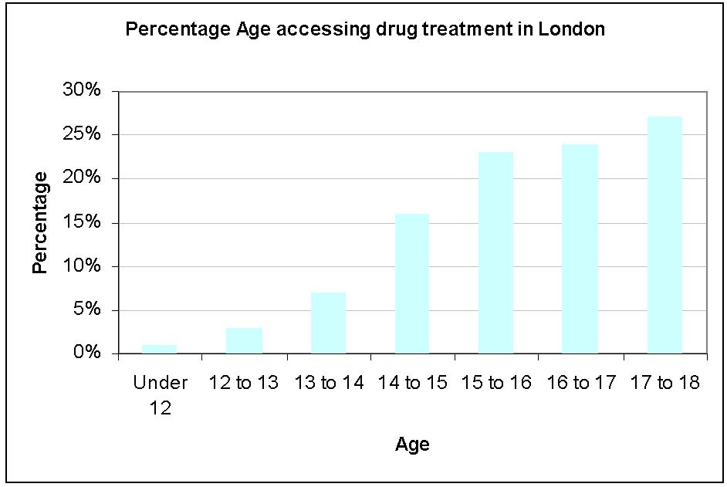
Source: National Treatment Agency 2010

The vast majority of young people who receive help do so for problems associated with the misuse of cannabis and/or alcohol.

Figure 7.26 shows that the percentage of children accessing treatment increases with age. Nationally, the number of under-18s treated for problem drug use associated with heroin and crack has fallen more than a third since 2005-06, from 1,081 to 657 in 2008-09. This represents 3% (2% in London) of the total number of young people receiving help. Although the numbers involved are much smaller, the pattern echoes a similar generational shift away from heroin and crack use among young adults (aged 18-24) in drug treatment. The analysis also shows the number of young people accessing services for ecstasy has fallen by a third to 210, while the numbers accessing services for cocaine has increased by more than half to 745. Cocaine users now represent 3% (2% in London) of all those young people receiving help.

Table 7.26 Young people (Under 18) accessing drug treatment in London 2008-09

Male | 2218
Female | 1273
Total | 3491

Source: National Treatment Agency, 2010

TEENAGE CONCEPTIONS AND SEXUAL HEALTH

Teenage Conceptions

The life chances of teenage parents and their children are worse than those of older parents and their children. Teenage mothers are likely to experience a poorer standard of living and poorer mental health. The children of teenage mothers are also likely to do less well in formal education, are more likely to become economically inactive and more likely to become teenage mothers themselves.

Figure 7.27 Under 18 conception rates in Ealing Wards (2004-06)
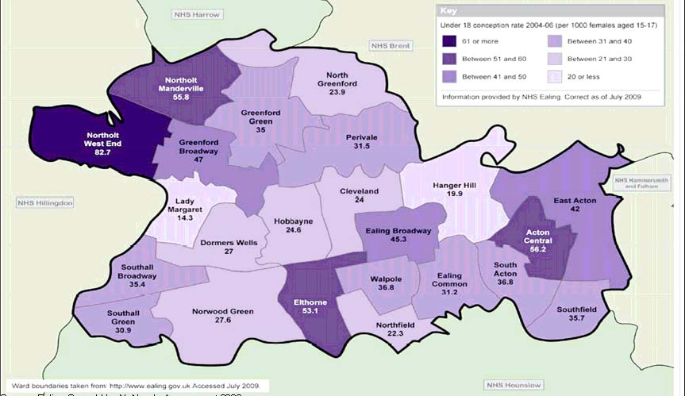
Source: Ealing Sexual Health Needs Assessment 2009

Looking at ward level data, Northolt West End, Northolt Mandeville, Acton Central and Elthorne have high under 18 conception rates. Northolt West End has 26.5 per 1,000 more conceptions annually than any other wards and is the one ward in Ealing with a conception rate amongst the highest in England. Greenford Broadway has seen the greatest increase in conception rates between the 2002 to 2006 periods (29.1 to 47 per 1,000) and Ealing Common has seen the greatest decrease during the same period (47.3 per thousand to 31.2 per 1,000).

Table 7.28 Under 18 conceptions 1998 –2008, rate per 1000 15-17 female population

 | 1998-00 | 2001-03 | 2004-06 | 2005-07 | 2006-08
England | 45.0 | 42.5 | 41.2 | 41.2 | 40.9
London | 50.6 | 51.7 | 47.0 | 45.8 | 45.3
Ealing | 41.0 | 37.3 | 36.4 | 34.5 | 33.8

Source: Teenage Pregnancy Unit, Department of Health 2010

Table 7.29 Under 16 conceptions 2001-2007, rate per 1000 13-15 female population

 | 2001-03 | 2002-04 | 2003-05 | 2004-06 | 2005-07
England | 7.9 | 7.8 | 7.7 | 7.7 | 7.9
London | 9.9 | 9.5 | 9.1 | 8.8 | 8.7
Ealing | 5.9 | 6.2 | 6.1 | 6.0 | 5.6

Source: Teenage Pregnancy Unit, Department of Health 2009

Tables 7.28 and 7.29 show under 16 and 18 conceptions in the borough; under 18 conceptions are falling. Under 16 conceptions are fewer but have only more recently appear to be falling.

Sexual Health

Below is the number of STIs reported from the selected four GUM clinics most utilised by Ealing residents (Level 8 Clinic, West London Centre for Sexual Health (WLCSH), Patrick Clements Clinic (PCC) and West Middlesex Sexual Health Clinic (W Middx) for those aged 19 and under. These figures represent the STI diagnoses for all clinic attendances and not for Ealing residents only.

Table 7.30 Under 19s STIs diagnosed for selected GUM clinics, 2008

 |  | Male | Female | Total
Syphilis | Under 15 | 0 | Less Than 5 | Less Than 5
 | 15-19 | Less Than 5 | Less Than 5 | 5
Gonorrhoea | Under 15 | 0 | Less Than 5 | Less Than 5
 | 15-19 | 43 | 71 | 114
Genital Warts | Under 15 | 0 | Less Than 5 | Less Than 5
 | 15-19 | 51 | 104 | 155
Genital Herpes | Under 15 | 0 | 0 | 0
 | 15-19 | 9 | 63 | 72
Chlamydia | Under 15 | 0 | 10 | 10
 | 15-19 | 169 | 387 | 556

Source: Ealing Sexual Health Needs Assessment 2009

Chlamydia is the most prevalent diagnosed STI among the under 19s with Gential Warts and Gonorrhoea also high. Generally, it seems that STIs are more prevalent among females than males but it may also indicate that Girls are more likely to seek treatment.

According to the Ealing’s Health Related Behaviour Survey, 2009, 68% of secondary pupils did not know where to get condoms free of charge. 13% of secondary pupils had never heard of HIV and AIDS. 18% have heard of it but know nothing about it, while a further 11% think it can be treated and cured. 24% of secondary pupils did not know of a contraception and advice service for young people locally.

SAFETY

There is relatively little local information on crime and fear of crime among children and young people. According to Social Trends report (2009) those living in London experienced the highest rate of personal crime in the UK, with 81% in the 12 months prior. Personal crime includes assault, sexual offences and all forms of theft.

The incidence of personal crime continues to be high among young people aged under 26. The 2006 Offending, Crime and Justice Survey (OCJS) reported that 12 per cent of ten to 25-year-olds had experienced at least one incident of personal theft in England and Wales in the 12 months prior to interview. More than one-quarter (26%) were victims of some kind of personal crime over the same period, including robbery, personal theft and assault (either with or without injury). Young males were more likely than young females to be victims of a personal crime within the last 12 months (31 per cent compared with 21 per cent). The difference was most pronounced among ten to 15-year-olds; nearly two-fifths (38 per cent) of boys of this age group were victims compared with around one-fifth (22 per cent) of girls.

Ealing’s Health Related Behaviour Survey 2009 shows that 29% of primary pupils had been approached by an adult who scared or upset them up 2% (in 53% of cases someone they knew). 7% kept the incident to themselves. Attitudes towards the police change dramatically as pupils get older. 82% of primary pupils feel that they can trust the police. By secondary school, only 57% feel that they can trust the police. 27% of primary pupils and 17% of secondary pupils worry about crime. 25% of secondary pupils rate the area they live in as poor or very poor for safety after dark and 6% rate it as poor or very poor for safety during the day. 6% of secondary pupils have had something stolen from them by force or the threat of violence in the last month down 2%, most commonly on the way to or from school. Only 17% of these reported the incident to the police and 26% did not tell anyone down 9%.

Bullying

Ealing’s Health Related Behaviour Survey 2009 found that fear of bullying has increased among secondary pupils but decreased among primary pupils. 35% of primary, down 1% and 17% of secondary pupils up 3% feel afraid of going to school at least sometimes because of bulling; with 8% of primary and 3% of secondary pupils feeling afraid often or very often.

65% of primary, up 1% and 83% of secondary pupils down 3% were never afraid to go to school because of bullying.

Looked After Children

Nationally, there is a significant and widening gap between the outcomes achieved by Looked After Children and those achieved by other children. Looked After Children have been over-represented in a number of vulnerable groups including those who are not in employment, education or training post 16, teenage parents, young offenders, drug-users and prisoners. Stability is a key factor that can make a positive difference to the lives of Looked After Children. It provides the opportunity to form strong attachments with carers and friends, maximising their resilience, and improving their chances of achieving positive outcomes.

Figure 7.31 Children Looked After rate per 10000 under 18 population
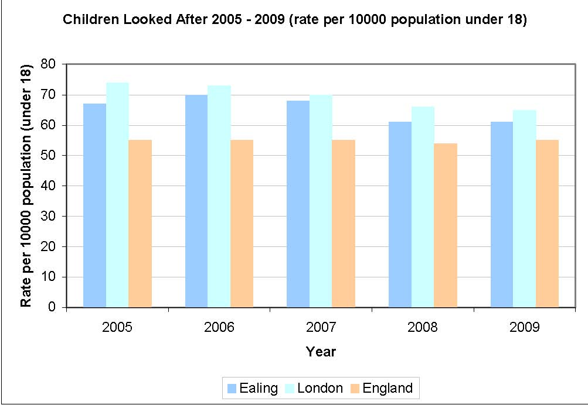
Source: Department for Education 2010

The number of children looked after in Ealing seems to be falling in general and mirrors the London trend. Over the same period the national trend has remained consistent and lower than the London and Ealing rate. The Ealing rate is nearly 9% lower in 2009 than in 2005 while the London rate is just over 12% lower over the period.

Table 7.32 Stability of placements- percentage of children looked after with three or more placements in a year
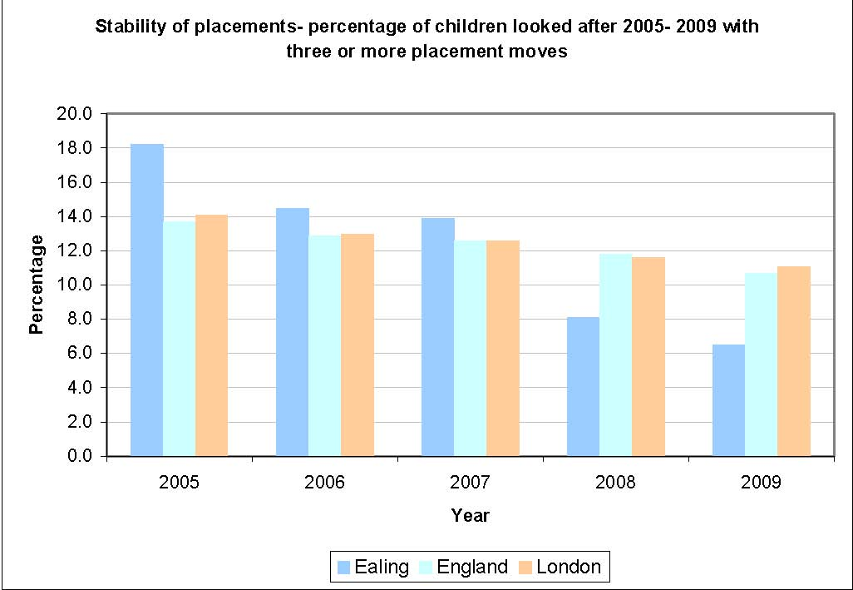
Source: Department for Education 2009

Stability as a whole leads to better outcomes for the child. A low percentage represents good performance and Ealing's performance has decreased year on year from a high of over 18% in 2005 to 6.5% in 2009. The trend both nationally and in London also shows a decrease in performance from 2005 to 2009. However the performance for both national and London closely mirrors one another and the drop in performance is not as significant as seen in Ealing.

Figure 7.33 Children who were the subject of a child protection plan at the end of year per 10,000 under 18 population
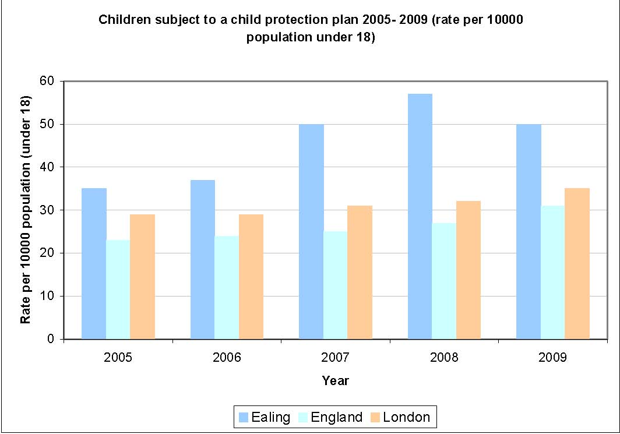
Source: Department for Education 2009

The number of children subject to a child protection (CP) plan has increased both in London and nationally. Ealing’s rate per 10,000 children subject to a child protection plan is significantly higher than both the London and national picture. This reflects Ealing’s diverse population, which has a high degree of vulnerability, with significant new arrivals and transient communities

Ealing has seen a year on year increase in numbers from 2005 to 2008. At the end of year 2009, the rate was 43% higher then it was in 2005. The national and London picture has shown a similar increase of 35% and 21% respectively when comparing 2009 figures against 2005. The rate in Ealing for 2009 dropped 12% compared to 2008 whereas the London and national trend showed an increase in the same period.

Figure 7.34 Children who became the subject of a child protection plan per 10,000 under 18 population
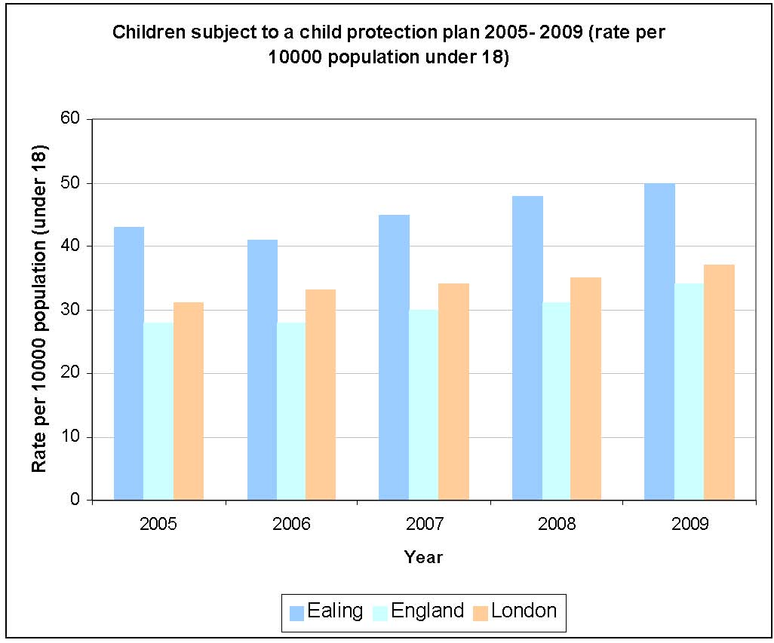
Source: Department for Education 2009
The number of children who became the subject of a child protection plan has increased in Ealing and this mirrors the London and national picture. The percentage increase in 2009 over 2005 for Ealing was 16%. This is lower then the national (21%) and London (19%) increases seen over the same period.

Figure 7.35 Percentage of children who became the subject of a child protection plan for a second or subsequent time
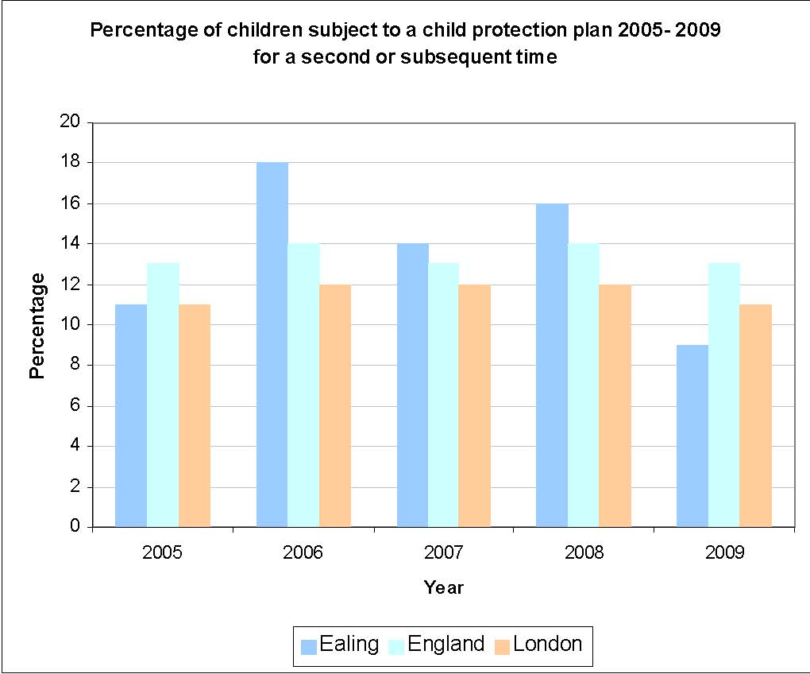
Source: Department for Education 2009
The percentage of re-registrations of children/young subject to a child protection plan is generally represented by a low percentage, however, some re-registrations are essential in responding to any changes in circumstances in a young person's life. However, high levels of re-registrations will suggest that interventions by the professionals for the child's welfare is not effective enough to bring about the required changes in the child's family situation.

The Ealing trend generally matches the picture seen nationally whilst the London trend has more or less remained the same in 2006, 2007 and 2008. In 2009, Ealing’s performance improved from 16% in 2008 to 9%. This was significantly lower than both the national and London average.
Domestic Violence

Figure 7.36 Domestic Violence Hotspot in Ealing, April 2009 to February 2010

Source: Ealing Community Safety Team 2010

There were a total of 1,644 incidents of domestic violence reported during this time frame. Northolt, Ealing Broadway and Southall Broadway are the three main hotspot areas for domestic violence within the borough. Levels of offending are lowest on a Thursday following a steady decline that starts on Monday. Increases begin again from Thursday before peaking on Saturdays/Sundays. Incidents after midnight on Saturday are counted within Sunday figures. There is an Initial increase between 12-13hrs with a Secondary increase noted at 1800hrs at which point levels then steadily increase throughout the evening and correlate with the night time economy with a peak at 2300 hours.

Table 7.37 Reports of Violence in the home by children in Year 4 and 6

Source: Ealing Community Safety Team 2010
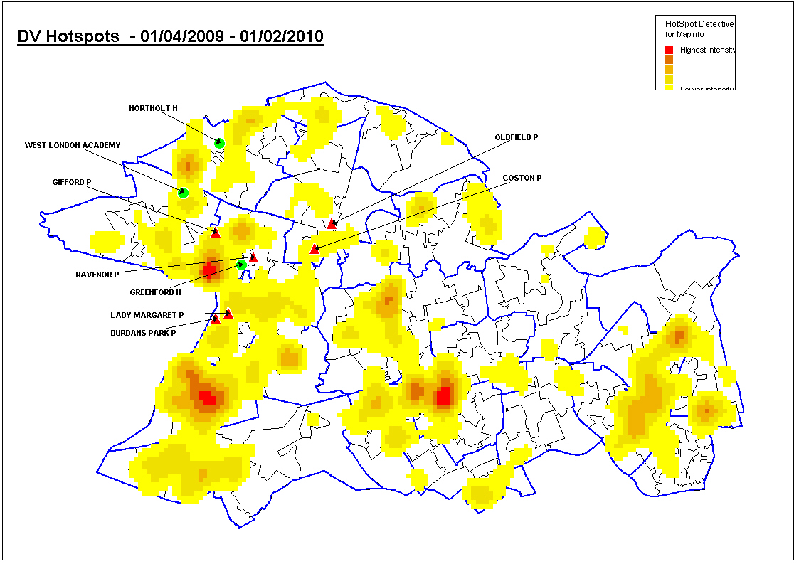
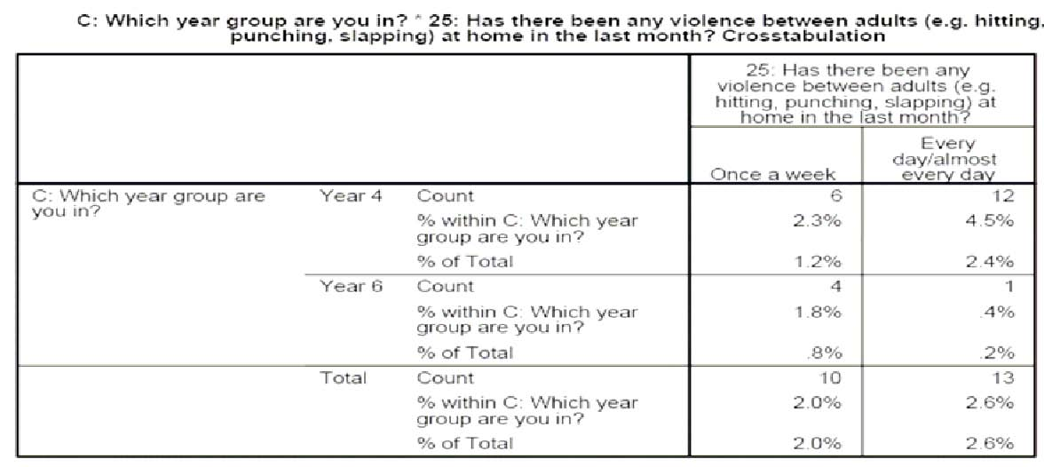
In responding to how frequent has there been violence between adults, 1.2% of those in year 4 stated once a week and 2.4% every day or almost every day and 0.8% of those in year 6 stated once a week and 0.2% every day or almost every day. Overall 2.0% in both years witnessed such occurrence once a week and 2.6% every day or almost every day.

Road Safety

The number of children and young people (under 16) killed or seriously injured in road traffic collisions in Ealing is currently increasing faster than in London or England. Factors contributing to this may be the relatively large number of children and young people in the borough, the volume of traffic and the size of the road network (Figure 7.38).

Figure 7.38 Percentage change in number of children killed or seriously injured during the calendar year compared to the previous year 1998 -2008
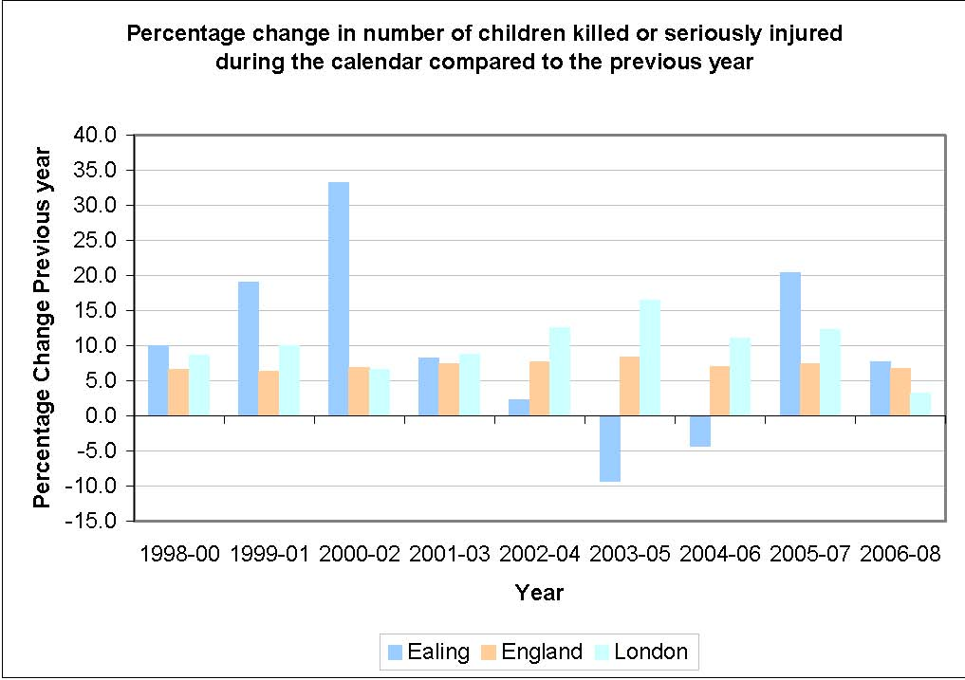
Source: Government Office for London, Department of Transport 2009

Ealing’s levels of children killed or injured on the borough’s road are lower than in 2000-02, they have been increasing since 2005 albeit slowing last year. Only 2003-05 and 2004-06 saw actual percentage falls in the number of children injured or killed.

EDUCATION

Special Needs Education

The numbers of pupils with Special Education Needs (SEN) in Ealing has risen significantly over the last few years which has increased demand for special needs provision for pupils with Statements of SEN.

This rise is set to continue and it is important that sufficient numbers of places and types of SEN provision is available to meet the full range of special educational needs.

As at January 2010 the numbers of pupils attending Ealing schools or early years settings or with a statement managed by Ealing was 1,627, a rise of 3.7% since 2007.

Looking on projections based on either rolling forward the current numbers in nursery (Method 1) or taking the average of the last five years (Method 2) indicate that numbers will continue to rise steadily over the next five years.

Table 7.39 Projected Number of Pupils with Special Education Needs 2011 to 2015
 | Method 1 | Method 2
2011 | 1,774 | 1,748
2012 | 1,941 | 1,849
2013 | 2,109 | 1,927
2014 | 2,295 | 2,002
2015 | 2,494 | 2,076

Key Stage One

Ealing’s performance in all areas of the Key Stage 1 is better now than in 2006. While there has been improvement over recent years, Ealing’s performance does remain below England and London levels. While the gap is generally between 2% and 3%, in science Ealing is currently behind London by 4% and England by 6%.

There is a correlation between educational attainment and levels of deprivation with more deprived areas tending to report lower levels of attainment. Improving attainment across the board and particularly in the borough’s most deprived wards would pay dividends in future years.

Table 7.40 Percentage of pupils achieving Key Stage 1 Teacher Assessment
level 2+ in Reading

Area | 2006 | 2007 | 2008 | 2009
Ealing | 79% | 79% | 81% | 81%
London | 82% | 82% | 83% | 83%
England | 84% | 84% | 84% | 84%

Source: Department for Education 2010

Table 7.41 Percentage of pupils achieving Key Stage 1 Teacher Assessment
level 2+ in Writing

Area | 2006 | 2007 | 2008 | 2009
Ealing | 72% | 73% | 73% | 76%
London | 79% | 78% | 78% | 79%
England | 81% | 80% | 80% | 81%

Source: Department for Education 2010

Table 7.42 Percentage of pupils achieving Key Stage 1 Teacher Assessment
level 2+ in Mathematics

Area | 2006 | 2007 | 2008 | 2009
Ealing | 84% | 86% | 87% | 86%
London | 89% | 89% | 89% | 88%
England | 90% | 90% | 90% | 89%

Source: Department for Education 2010

Table 7.43 - Percentage of pupils achieving Key Stage 1 Teacher Assessment
level 2+ in Science

Area | 2006 | 2007 | 2008 | 2009
Ealing | 81% | 80% | 81% | 83%
London | 87% | 86% | 86% | 87%
England | 89% | 89% | 89% | 89%

Source: Department for Education 2010

Key Stage Four

The proportion of pupils in Ealing attaining 5 or more GCSEs at grades A* to C rose in 2008/09 as did the proportion attaining 5 GCSEs at grades A* to G including English and Mathematics but were below the London average. They are higher than the England average however. Table 7.41 shows that nearly 99% of Ealing’s young people achieved at least one pass at GCSE in 2008/09, similar rates to England and London.

Table 7.44 Percentage of pupils achieving 5 or more GCSEs grades A*-C

Area | 2007/08 | 2008/09
Ealing | 68.4% | 70.8%
London | 62.5% | 71.2%
England |  | 70.0%

Source: Department for Education 2010

Table 7.45 Percentage of pupils achieving 5 or more GCSEs A*- G including English and Mathematics

Area | 2007/08 | 2008/09
Ealing | 52.1% | 54.0%
London | 47.5% | 53.9%
England |  | 49.8%

Source: Department for Education 2010

Table 7.46 Percentage of pupils achieving any passes at GCSE

Area | 2007/08 | 2008/09
Ealing | 99.4% | 98.7%
London | 98.3% | 98.8%
England |  | 98.9%

Source: Department for Education 2010

Attainment by Gender

There is a gap in attainment between boys and girls at Key Stage four the proportion of girls achieving 5 or more GCSEs at grades A*-C is significantly higher than the proportion of boys.

Table 7.47 Percentage of pupils achieving 5 or more GCSEs grades A*-C:
Gender breakdown

 |  | 2005/06 | 2006/07 | 2007/08 | 2008/09
Ealing | Boys | 58.5% | 57.6% | 63.2% | 67.2%
 | Girls | 65.1% | 66.4% | 73.7% | 74.6%
London | Boys | 53.6% | 56.7% | 60.6% | 67.5%
 | Girls | 63.0% | 65.0% | 69.4% | 75.0%
England | Boys | 54.6% | 57.7% | 60.9% | 65.8%
 | Girls | 64.0% | 66.4% | 69.9% | 74.4%

Source: Department for Education 2010

Attainment for boys and girls in Ealing is higher now than in 2005/06. However the attainment gap between genders is also higher, while in 2005/06, girls were out performing boys by 6.6% it now stands at 7.4%. Compared to London and England boys and girls attainment at this level is broadly similar. In terms of the attainment gender gap, the London gap is 7.5% and the national gap 8.6%, however unlike Ealing, these gaps are narrower now than in 2005/06.

Figure 7.48 Percentage of pupils achieving 5 or more GCSEs grades A* -C: Gender breakdown
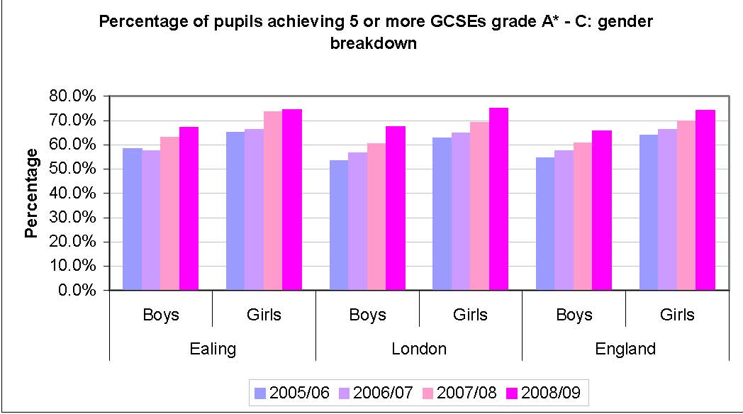
Source: Department for Education 2010

Attainment by Pupils from Minority Ethnic Groups

Figure 7.49 Percentage of pupils achieving 5 or more A*-C GCSEs by ethnic group

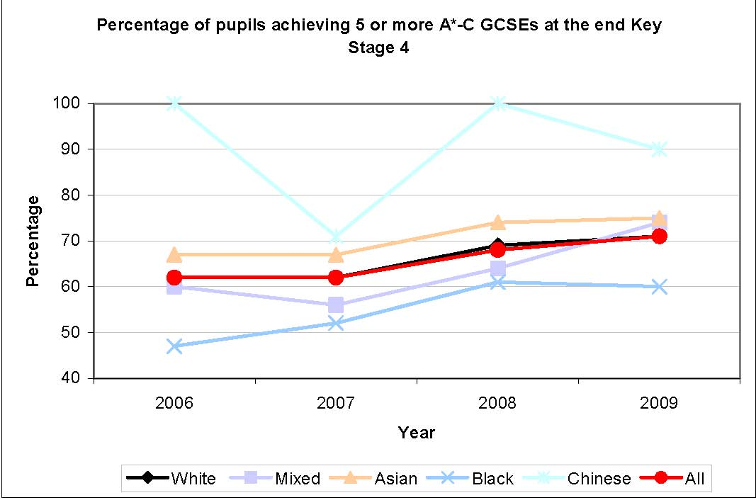
Source: Department for Education 2010
The average levels of educational attainment by different ethnic groups show considerable variation. Pupils from Chinese and Asian do much better than white pupils. The attainment level of black pupils is the lowest and, until recently, mixed background pupils was lower than that of white pupils and of all pupils.

Class Sizes

Table 7.50 Average Class Size taught by one teacher 2008

 | Primary | Secondary
Ealing | 27.5 | 21.7
London | 26.8 | 20.8
England | 26.2 | 20.9

Source: Department for Education 2009

At both primary and secondary school, Ealing average class size is slightly larger that the average class size in London and England.

Absence in Secondary Schools

Table 7.51 Percentage of Absences from Schools in Ealing

 |  | Authorised Absence |  | Unauthorised Absence |  | Total Absence
 | 2007/08 |  | 2008/09 | 2007/08 | 2008/09 | 2007/08 | 2008/09
Ealing | 6.05% |  | 5.54% | 1.07% | 1.16% | 7.13% | 6.70%
London | 5.50% |  | 5.44% | 1.54% | 1.52% | 7.04% | 6.96%
England | 5.86% |  | 5.79% | 1.41% | 1.44% | 7.27% | 7.24%

Source: Department for Education 2009

Absences are measured by the number of half days missed as a percentage of total school days. The total absences for Ealing in 2008/09 is below London and England levels. Broken down, in the same year we can see that unauthorised absences in Ealing fit this pattern but authorised absences are higher than the London average but lower than the national average. Overall total absences in Ealing are lower than in 2007/08.

Exclusions

Research has suggested that there is a direct link between being excluded from school and becoming involved in crime. A Youth Justice Board survey showed that excluded pupils were more than twice as likely to become involved in crime as other school children19. Therefore intervening early to tackle truancy and exclusion is vital to preventing youth crime.

There were 40 permanent exclusions in Ealing in 2007/08, more than in 2006/07 (26) but less than the 74 seen in 2004/05.

Table 7.52 Number of Permanent Exclusions in Secondary Schools

 | 2004/05 | 2005/06 | 2006/07 | 2007/08
Ealing | 74 | 65 | 26 | 40

Source: Department for Education 2010

Figure 7.53 Percentage of Secondary school pupils permanently excluded
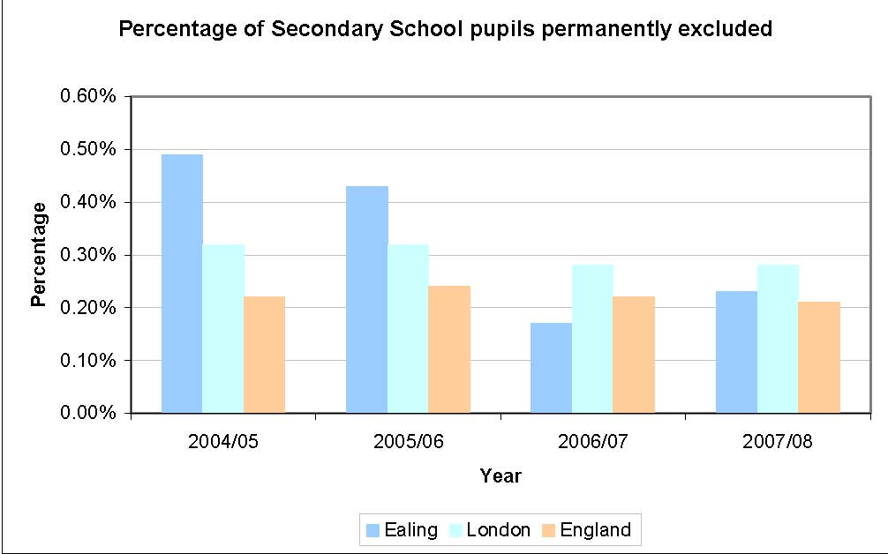
Source: Department for Education 2010

In previous years (2004/05 and 2005/06) Ealing’s permanent exclusion rate was significantly higher than that of London and England. Currently it stands at 0.23%, a fall of more than 50 % on the 2004/05 figure. It is slightly above the England figure but lower than London figure.

Table 7.54 Number of Fixed term Exclusions in Secondary Schools

 | 2004/05 | 2005/06 | 2006/07 | 2007/08
Ealing | 1,785 | 2,020 | 1,794 | 1,620

Source: Department for Education 2010

1,620 secondary school pupils were excluded on a fixed term basis in 2007/08. Comparing Ealing against London and England shows that Ealing excludes more pupils.

Figure 7.55 Percentage of Secondary school pupils excluded on a fixed term basis
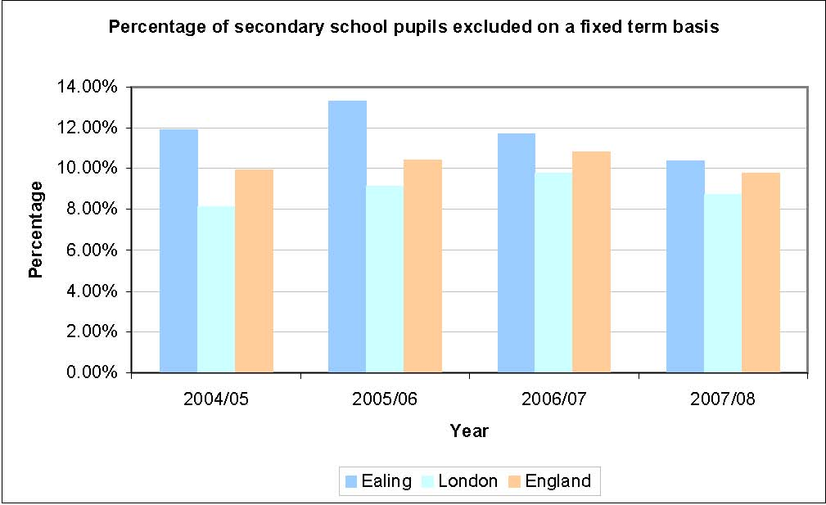
Source: Department for Education 2010

Since 2005/06 Ealing’s percentage of fixed term exclusions has been falling but remains higher than London and England averages.

Bullying

Ealing’s Health Related Behaviour Survey 2009 found that fear of bullying has increased among secondary pupils but decreased among primary pupils. 35% of primary, down 1% and 17% of secondary pupils up 3% feel afraid of going to school at least sometimes because of bulling; with 8% of primary and 3% of secondary pupils feeling afraid often or very often.

65% of primary, up 1% and 83% of secondary pupils down 3% were never afraid to go to school because of bullying.

Profile of Bullied Pupils

In primary school, girls were more likely to be often or very often afraid to go to school because of bullying (8.9%) than boys (6.6%). Northolt (8.8%) had the highest proportion of children who were afraid to go to school because of bullying, while “Other Black” and “Arab” children were the most likely to feel afraid.32

Racism

55% of primary and 51% of secondary pupils, according to Ealing’s Health Related Behaviour survey, felt that people with different background were valued in their school. 68% of secondary pupils thought their school was a place where people from different backgrounds got on well.

Overall, 13% of primary and 7% of secondary pupils thought they were being bullied or picked on because of their race, colour or religion. 2% of secondary pupils thought they were being picked on because of their sexuality, while 5% of primary and 2% of secondary pupils thought they were being picked on for having a disability.32

POVERTY

Table 7.56 Eligibility for Free School Meals

 | 2006 | 2007 | 2008 | 2009
Ealing | 25.3% | 25.6% | 26.3% | 24.4%
London | 23.2% | 22.4% | 22.5% | 22.6%
England | 13.6% | 13.1% | 13.1% | 13.4%

Source: Department for Education 2010

Nearly a quarter of Ealing’s secondary school pupils are eligible for free school meals. This is higher than the London percentage and nearly double that of the national. Currently there are 4,221 secondary school pupils eligible for free school meals.

Table 7.57 Number of Secondary School Pupils Eligible for Free School Meal

 | 2006 | 2007 | 2008 | 2009
Ealing | 3,848 | 3,930 | 4,460 | 4,221

Source: Department for Education 2010

Figure 7.58 Income Deprivation Affecting Children Index 2007

This index, illustrated in the map below, shows the distribution of Income Deprivation
affecting children within Ealing, there are pockets in Ealing which are amongst the
20% most deprived nationally.

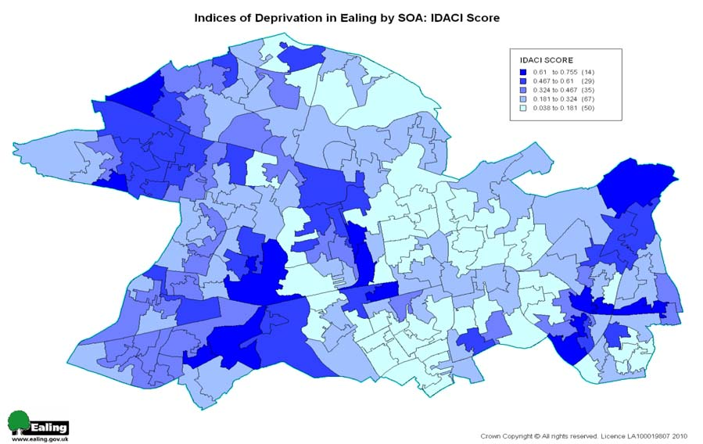 Source: Department of Communities and Local Government
EMPLOYMENT & TRAINING

Nationally the proportion of 16 to 18 year olds not in employment, education or training (NEET) remained broadly level over the last decade. The government target is for a 2% reduction between 2004 and 2010.

The proportion of young people who are not in employment, education or training
(NEET) varies during the year. The level usually peaks in the summer, when the figures are swelled by young people leaving school and college, and reduces thereafter.

Ealing’s rate has been falling since 2005/06 and now stands at 4.9%.

Table 7.59 Percentage of young people NEET in Ealing

 | 2005/06 | 2006/07 | 2007/08 | 2008/09 | 2009/10
Ealing | 7.1% | 7% | 5.9% | 5.4% | 4.9%

Source: Ealing Connexions Service 2010

CHILDREN AND YOUNG PEOPLE PROFILE

Table 7.60 Children and Young People Profile, Ealing

Domain | Number | Indicator |  | Ealing
Be Healthy | 1 | Infant Deaths
Be Healthy |  | 2 | All Cause mortality (age 1-17)
Be Healthy |  | 3 | Breastfeeding initiation
Be Healthy |  | 4 | Obese children (age 4-5)
Be Healthy |  | 5 | Obese children (age 10-11)
Be Healthy |  | 6 | Participation in at least 2 hours per week of sport
Be Healthy |  | 7 | Tooth Decay (age 5)
Be Healthy |  | 8 | Under 18 conceptions
Be Healthy |  | 9 | Under 18 conceptions ending abortion
Stay Safe | 10 | Children who have been Bullied
Stay Safe |  | 11 | Hospital stay following injury (under 18)
Stay Safe |  | 12 | MMR Immunisation (2 years)
Stay Safe |  | 13 | Children in care immunisations
Stay Safe |  | 14 | Road traffic accidents
Enjoy and Achieve | 15 | Primary school exclusions
Enjoy and Achieve |  | 16 | Secondary school exclusions
Make a Positive Contribution | 17 | Alcohol specific hospital stays (under 18)
Make a Positive Contribution |  | 18 | Hospital stays for drug misuse (age 15-24)
Make a Positive Contribution |  | 19 | First time entrants to YJS
Make a Positive Contribution |  | 20 | Reoffending rates
Make a Positive Contribution |  | 21 | NEET
Achieving Economic Well Being | 22 | Homeless families
Achieving Economic Well Being |  | 23 | Children living in poverty

Source: London Health Observatory 2010
Key
Significantly worse than England Average
Not significantly different England Average
Significantly better than England Average
Not Comparable

Update on progress on priorities since 2010

3.1 Progress made on children’s health

3.2 Safe Priorities for 2010/11 – Progress Updated needed

- ESCB - To improve outcomes for children and young people through review and challenge
- ESCB - To improve outcomes for children and young people by strengthening audit, quality assurance and management oversight arrangements
- ESCB - To improve outcomes for children and young people by strengthening skills and knowledge
- ESCB - To improve outcomes for children and young people by strengthening key processes
- Implement the local Safeguarding Improvement Plan
- Ensure compliance with regulation in preparation for Ofsted announced inspection
- Ensure lessons learnt from SCRs are embedded to improve practice
- Continue to address recruitment and retention issues
- Prioritise and increase efficiencies linked to economic factors
- Implementing the revised Childrens Trust guidance
- Implementing the New National Independent Safeguarding Authority (ISA) vetting and barring scheme
- Improve clarity for services in understanding the value and place for CAF in assessing need and coordinating services and measuring outcomes
- Continue to develop and implement the Lead Professional role in the context of CAF
- Launch the new multi agency Domestic Violence procedures
- Continue to strengthen joint working re safeguarding across the YOS and social care provision
- Develop the implementation of the Disadvantaged Subsidy Scheme under Access4All through extended school partnerships
3.3 Progress made in Education
Education Priorities 2010/11 – Progress Update needed

- BSF programme achieves financial close in September 2010.
- Implementing BSF proposals for children and young people with social, emotional and behavioural needs.
- Addressing Primary school places sufficiency
- Improving pupil attainment across all key stages
- Implementing specific measures to narrow the gap between the attainment of the general population and that of vulnerable underachieving groups
- Implementing short break provision for children with additional needs
- Extending free entitlement for three and four year olds, initially in areas of deprivation, rolling out across the rest of the Borough from September 2010.
- Publishing the next full Childcare Sufficiency Assessment for Ealing by March 2011.
- Completing the Big Lottery Fund Play Programme by August 2010.
- Continuing identification, tracking and ensuring access to education of CME
- Continuing training and work with schools in this area to review and ensure best practice
- Continue to offer a service to the 10 schools whose parents have the lowest rate of success in gaining places at their first preference school (on time applicants, first round of offers)
- Developing the Behaviour and Attendance Network model to build capacity of partnership initiatives.
- Mapping the availability of alternative education provision, encouraging the market and streamlining the contracting process.
- Building on the recommendations of the final review of the ‘Back on Track’ driven developments in provision and responding to the changes to delivery of support services, which will take effect in 2011 with the cessation of the National Strategies.
- Futuversity 2010 planned for Summer 2010
- Deliver the 2010 Play Strategy to ensure every child has access to high quality, fun and challenging play opportunity,
- Deliver the Summer 2010 activities programme

3.4 Priorities on Making a positive contribution 2010/11– Update needed
Re-prioritising activities in anticipation of national and local budget reductions
- Reviewing funding beyond 2011 to continue a range of grant funded projects, particularly PAYP and Summer Uni/Futureversity
- Marketing and promoting delivery of a range of packages of youth provision within schools
- Developing integrated “One Stop Shop” within Young Adult Centre and planning for co-location of services within W13
- Expanding the range and quality of methods of communication of services and provision available to young people and ensure meeting their needs
- Ensuring the service meets changing needs of young people and raises their aspirations and achievements
- Working in partnership within YOS to reduce number of young people engaged in gangs and carrying weapons
- Continuing to reduce the level of young people not in education, employment and training (NEETs) and target those young people with highest needs, eg. young offenders, care leavers, teenage parents, young people with disabilities, young people from BME communities and other over represented groups
- Implementing Information, Advice and Guidance (IAG) strategy in line with guidance for local authorities on IAG responsibilities
- Continuing to improve on national PIs and meet a challenging LAA stretch target in relation to NEETs levels of engagement. Also to provide improved consistency in the quality of service delivered to young people across the borough, working to meet gaps and reach a greater number of young people
- Maintaining levels of usage of children’s centres.
- Securing new funding streams for play projects.
- Early identification, person centred plans starting at year 9 reviews, age 14.
- Identified transition social workers in the separate teams- explore the possibility of co-locating these posts for one day a week to improve communication and sharing of information.
- Availability of wider post 16 provisions to meet the full range of needs; young people need continuing opportunities to learn and an appropriate peer group.
- Effective and timely person centred planning, and some good leisure opportunities.
- Families getting support to make use of direct payments or individual budgets.
- Review of the transition protocol, Development of a multi-agency transition pathway
- Engage housing in strategic transition planning
3.4.1 ESCAN

3.5 Priorities on Achieving Economic Wellbeing Plans for 2010-11 progress update needed

- Implement the 14-19 Strategy
- Close the KS4 achievement gaps for all under-performing groups. In Ealing the lowest performing of these groups are white boys and girls FSM, black boys and girls FSM, Travellers, LAC,
- Ensure Ealing’s young people are able to access the local and regional job market opportunities available
- Increase employment opportunities for vulnerable young people including care leavers and young offenders through the care2work programme and local partnership with key employers such as BAA at Heathrow
- Continue to develop the ME peer education programme for care leavers
- Planning to achieve No NEETs by 2013
- Implementation of BSF programme and Ealing Strategy for Change
- Increasing access to affordable child care
- Implement the Poverty strategy
- Develop 14-19 joint engineering diploma bid with Hillingdon.

3.5.1 - ESCAN A number of key areas for action - Update needed

- Development, review and sign up to the transition protocol
- Person-centred approach to be used
- Increased access to a wide range of Post-16 options across education, training and paid employment
- Assist more young people with disabilities to access higher education and provide more positive role models to raise aspirations
- Parent Forums development to contribute to the development of transition processes
- Support parents to access affordable, inclusive childcare to enable them to resume employment and achieve economic wellbeing.

