Instructions for Submitting a response via Atamis:
Log on to atamis - Welcome
You will need to register with basic information – name, organisation details and contact email address. Once registered please log in using your user name and password.
Go to Find Opportunities – locate Borough of Sanctuary Community Fund opportunity.
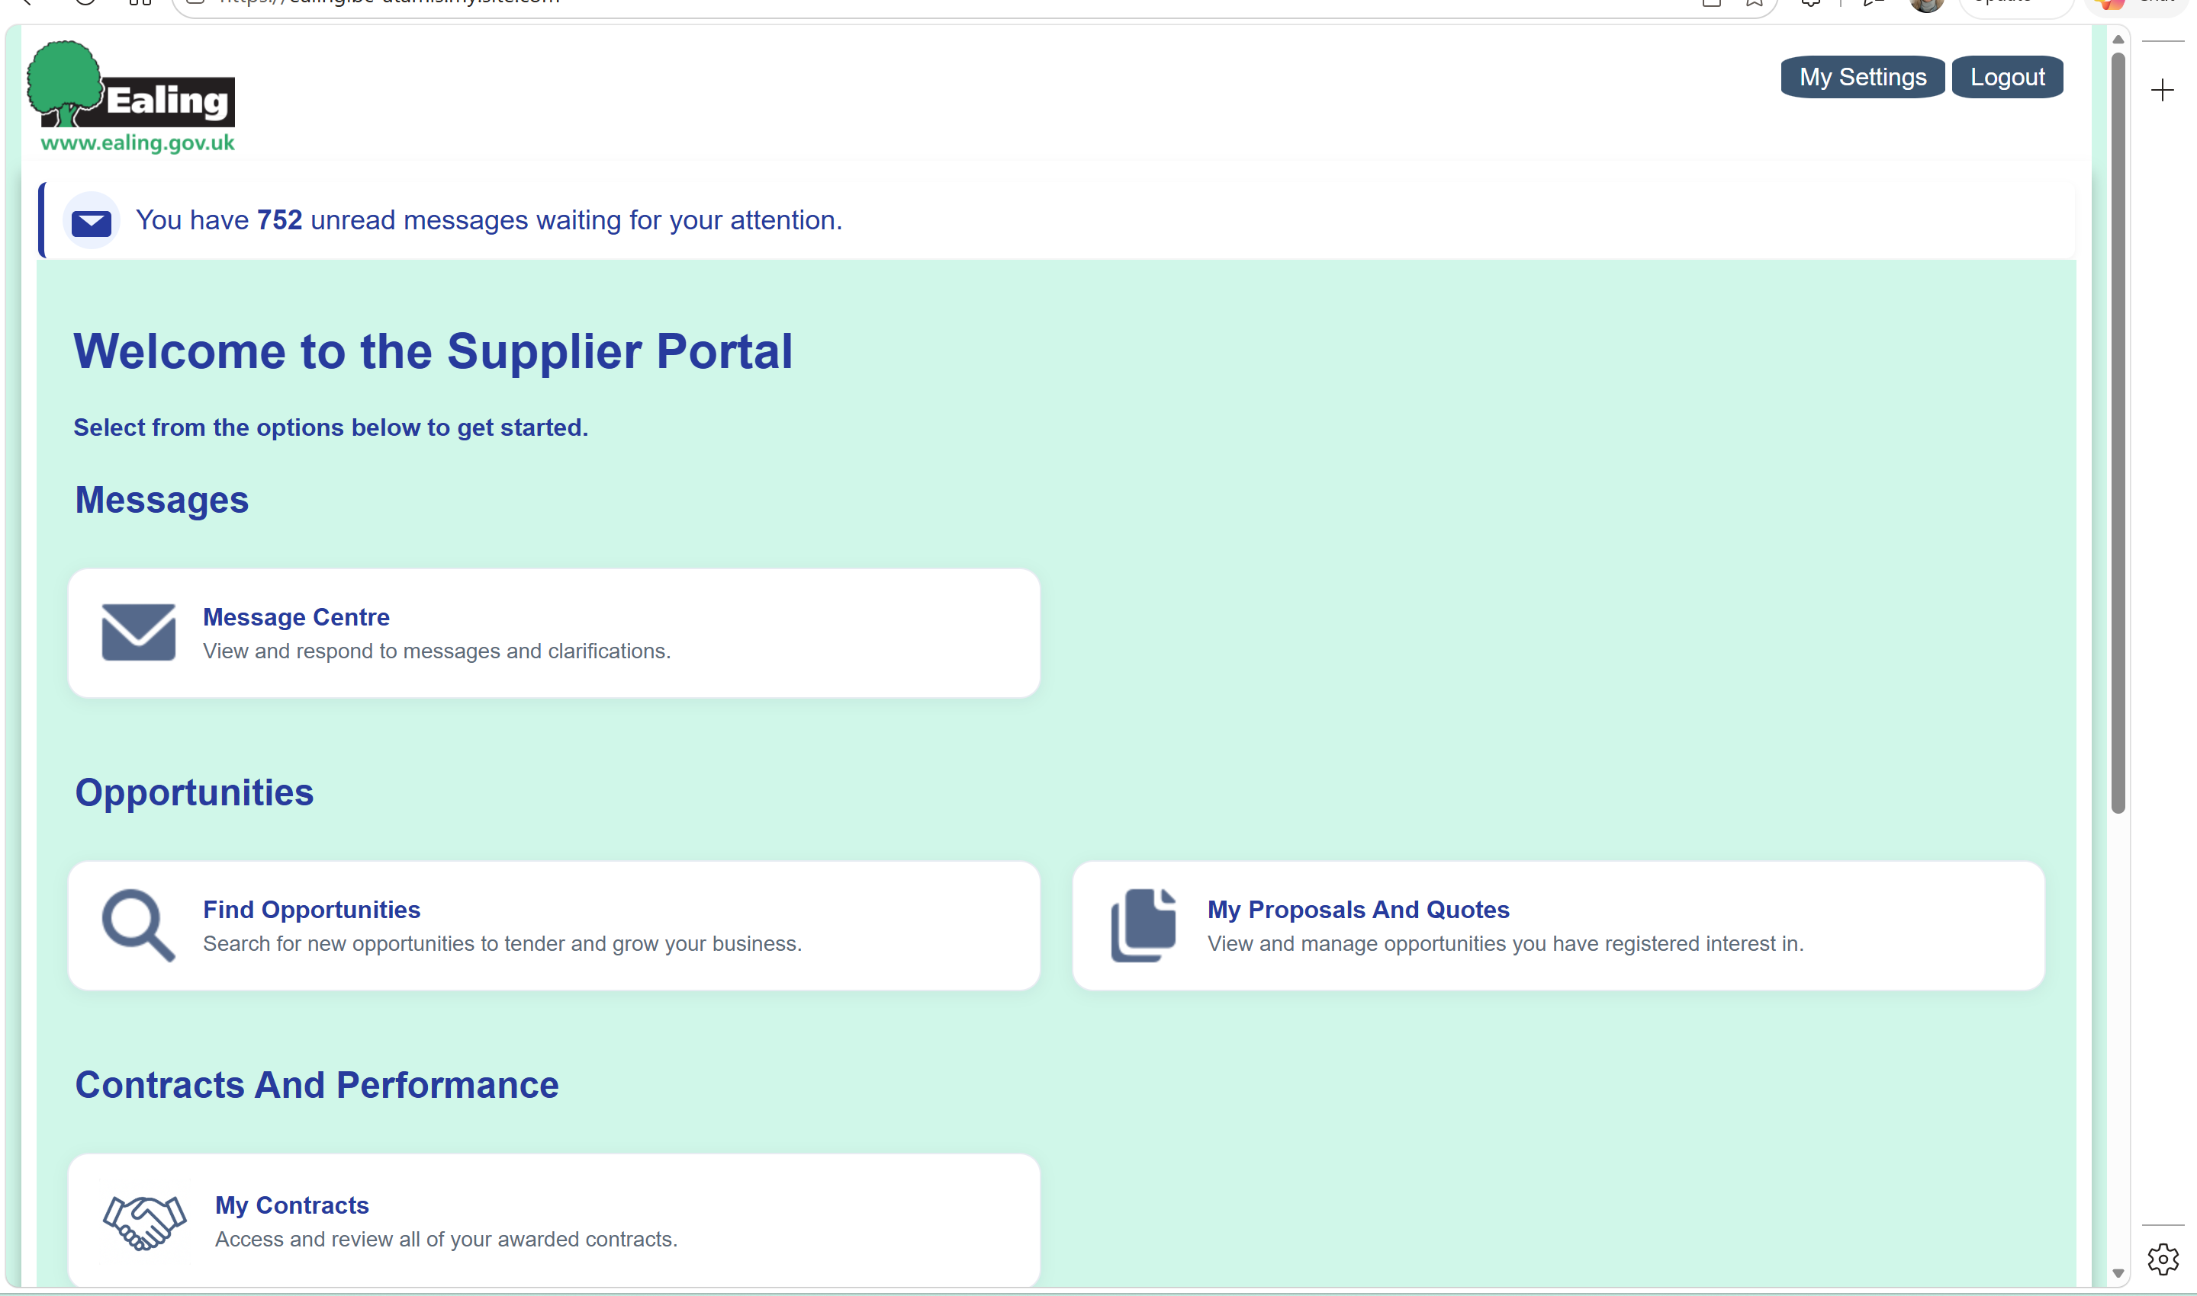`
REGISTER your interest in that Opportunity by clicking the button .
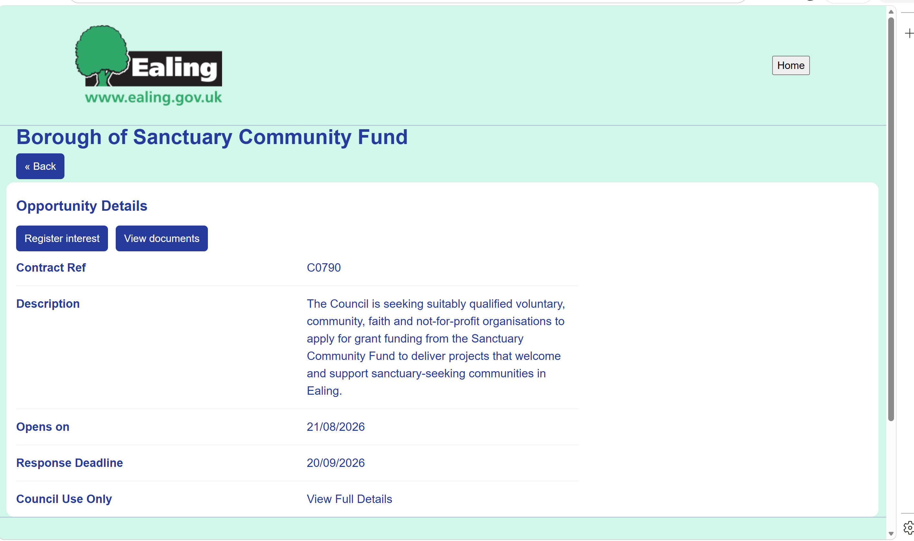
Once you have submitted an interest the opportunity will be in your My proposals and Quotes section. You need to go to HOME, then click on “click here” under My Proposals and Quotes.
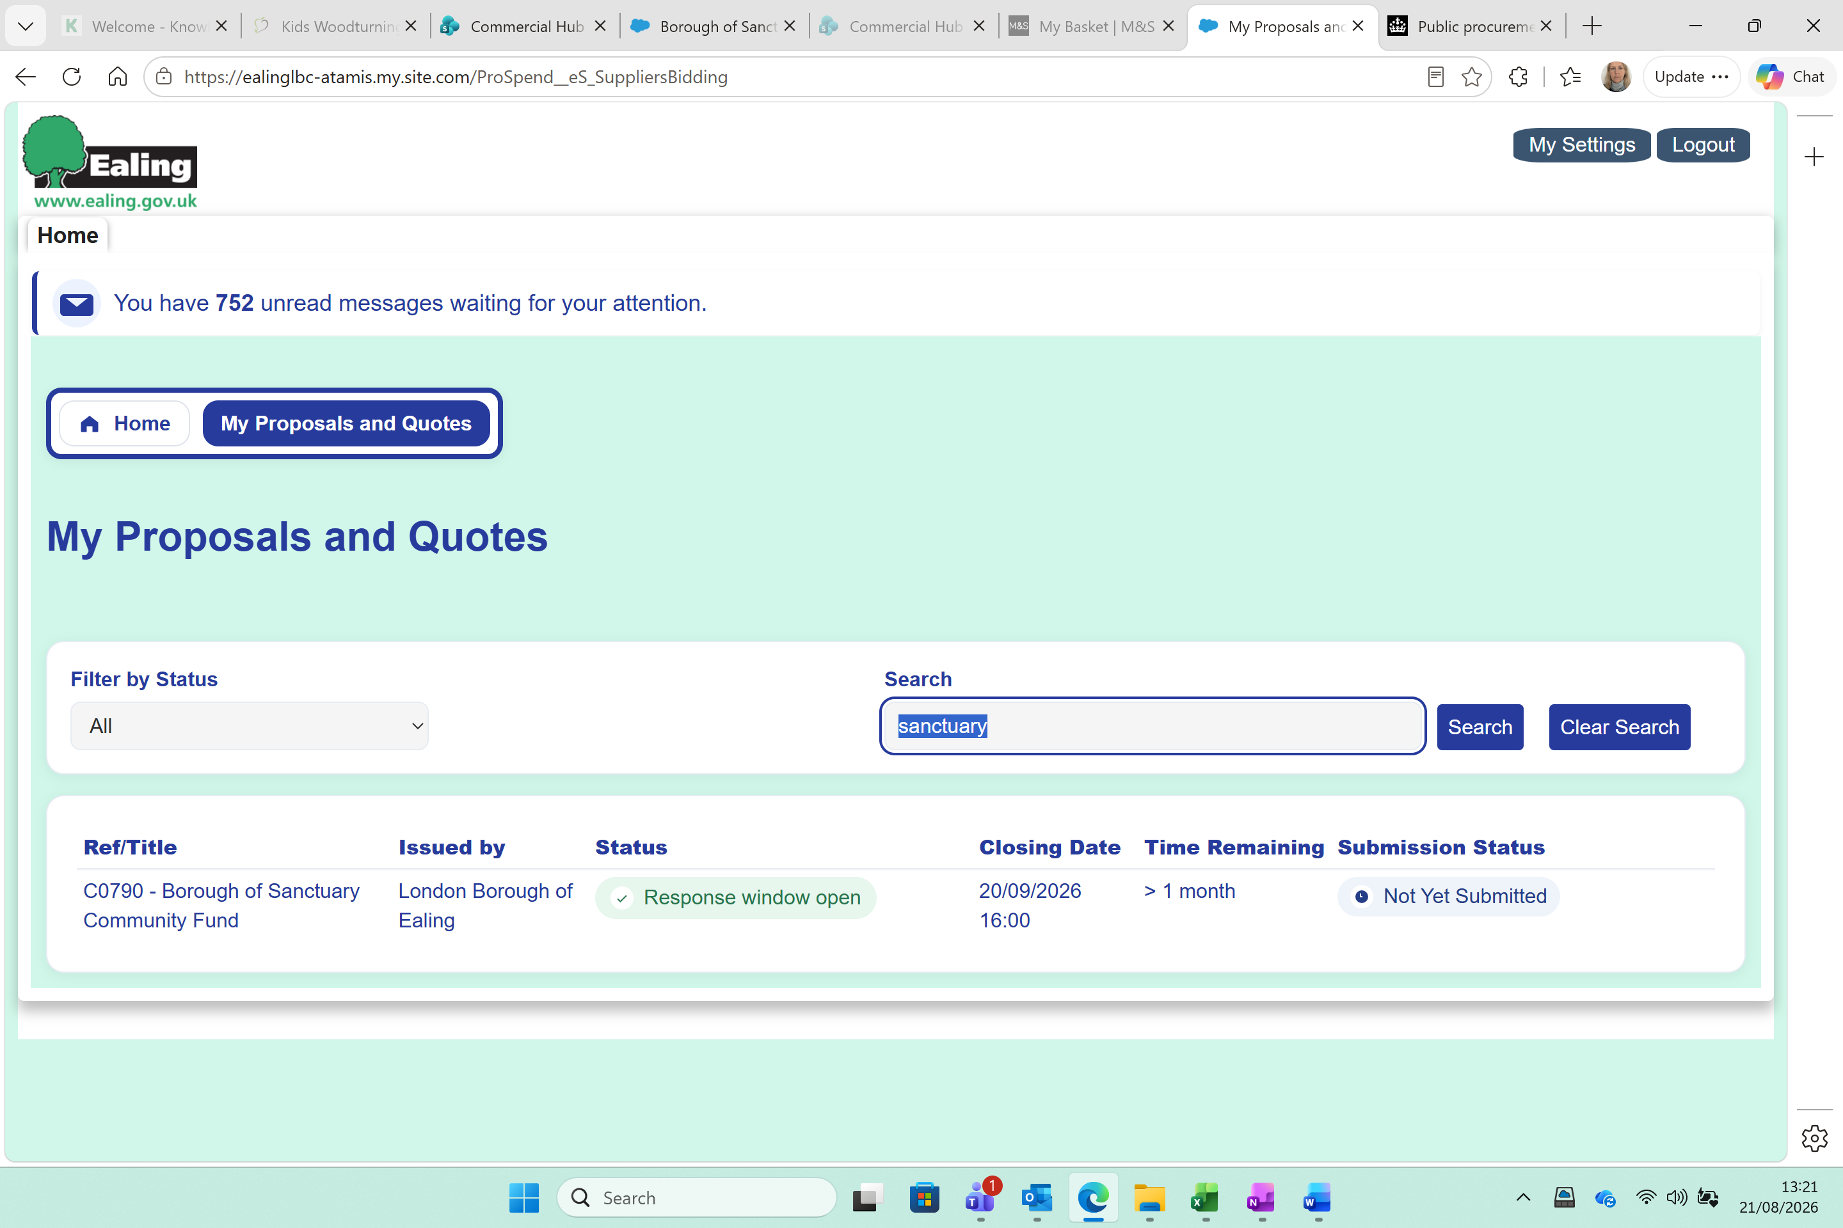
Click on the title of the Opportunity, and you will have the following options. You first need to go into documentation, using the blue button.
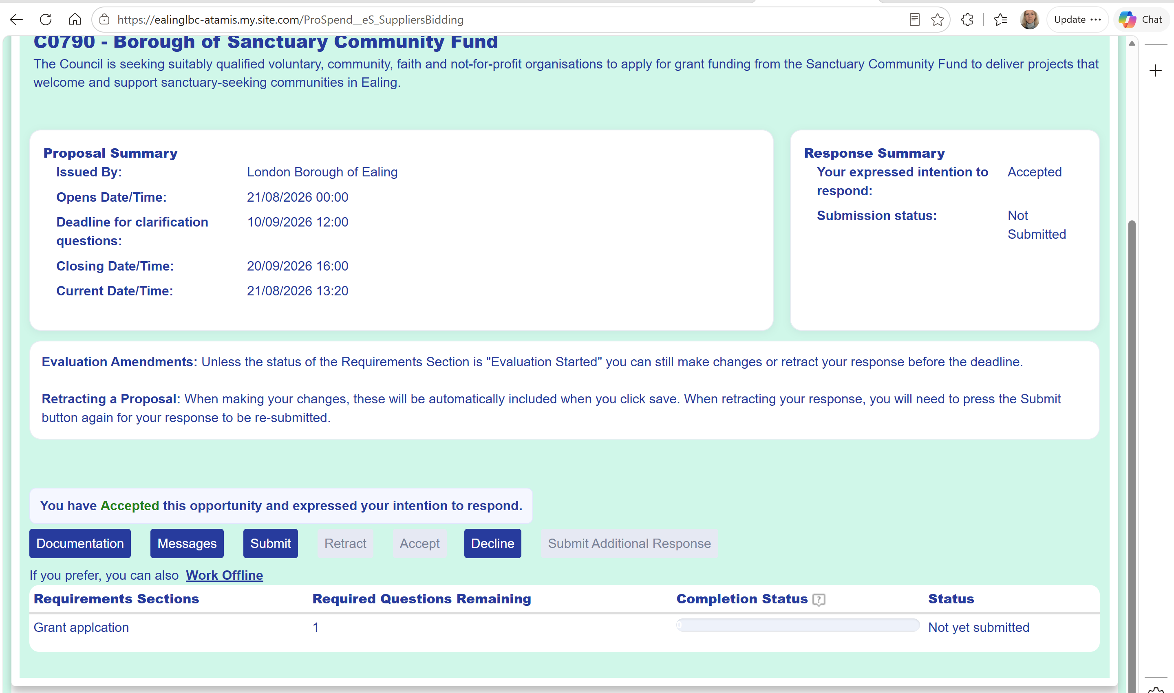
You will need to download the documents so that you can fill in/complete/ amend etc. These are word documents you will need to read and complete. With the word documents you will need to save on your computer in “editing” version of MS word before editing/filling in.
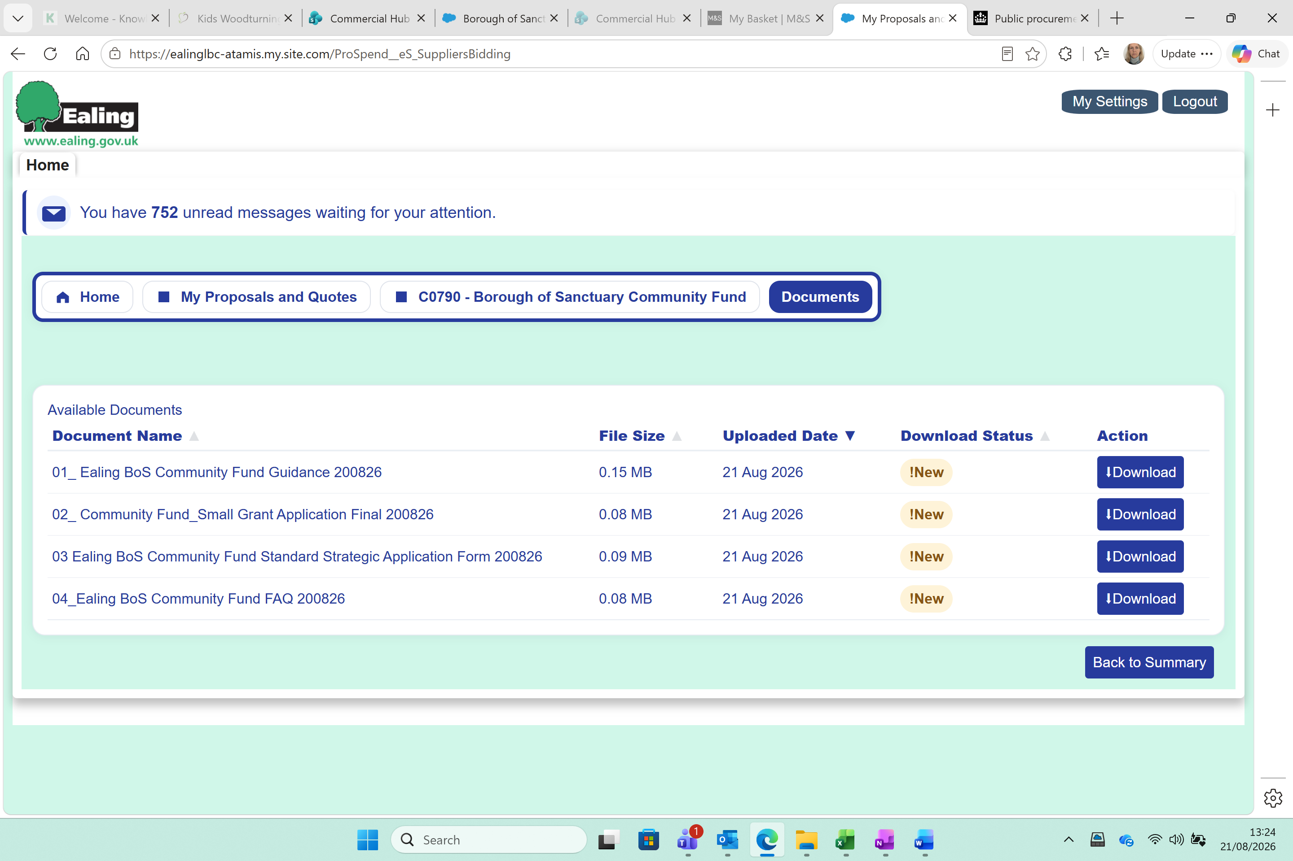
Once you have completed this you need to go to the Summary screen using the blue button at the bottom (Back to Summary) and click on Grant application (underlined).
You will then see this screen below, click on attach file button. This will ask you to upload a file from your computer, and will enable you to upload your attachments.
