|  |  |  |  |  |  |  |  |  |
| --- | --- | --- | --- | --- | --- | --- | --- | --- |
| **EVENT BOOKING REQUEST FORM**  **Please return completed form to :**  **Hanwell Community Centre, Westcott Crescent, Hanwell, London, W7 1PD**  **Tel: 020 8575 7019** [**hanwellcc@ealing.gov.uk**](mailto:hanwellcc@ealing.gov.uk) | | | | | | | | |
| **Date(s) of event** | |  | | | | | | |
| **Primary Room / Area Requested** | |  | | | **Additional Room(s) / Area Requested** | | |  |
| **Time of arrival**  **(set up to be included)** | |  | | | **Time of Departure (following clear-up)** | | |  |
| **Time guests arrive on site** | |  | | | | | | |
| **Type of event & purpose (wedding, children’s party, dinner dance etc.)** | |  | | | | | | |
| **Full Names of all applicants** | |  | | | | | | |
|  | | | | | | |
| Address & postcode | |  | | | | | | |
| **Email address:** | |  | | | | | | |
| **Contact number:** | |  | | | | | | |
| **Invoice address if different from above address** | |  | | | | | | |
| **Contact Name for invoice** | |  | | | | | | |
| **Telephone:** | |  | | | | | | |
| **Invoice Email address:** | |  | | | | | | |
| Expected number of guests | |  | | Price (to be confirmed by centre staff) | |  | | |
| How did you hear about us | |  | | | | | | |
| **Do you have any suppliers and if so please provide details below:** | | | | | | | | |
| Caterers | |  | | | | | | |
| Music / AV etc. | |  | | | | | | |
| Florist / Decorators/Other | |  | | | | | | |
| **Signature** |  | | **Date of Application** | | | |  | |
| **Please note that :**  1. We do not provide linen / covers for tables – if you require this please make arrangements prior to your event. We have a limited number of table arrangements for hire - Please ask our staff for details  2. A refundable cash deposit is also required for **parties and events** when making the booking. | | | | | | | | |

If booking an Event in a meeting room, please specify the room layout.

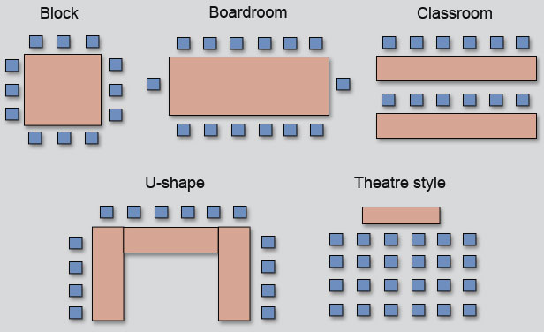

We can also provide catering. Please email [info@withlovefrommamaandme.co.uk](mailto:info@withlovefrommamaandme.co.uk) or call the centre on the above number.