LSP 18th April 2011

Progress Update: High Need Families Project

Project Overview

This project will focus on:

- Identifying our highest need service users
- Mapping and reviewing how they currently receive services
- Considering opportunities for more joined up, effective and efficient service delivery in the future
- Planning and actioning steps to make these improvements happen

Progress

Stakeholder engagement and co-ordination of a wide range of interventions

In order to engage key stakeholders at the very onset of the project and to try and begin to pull together all the disparate sources of data we collect on children and families, P&P have been meeting with a range of services and agencies as set out in the table below.

Key stakeholders meetings undertaken | Key stakeholders – meetings planned
Children's social services | Schools services
Adults social services | Benefit services
Police | VCS organisations
DAAT | Probation
Housing including housing associations | Youth services
Community safety | Health visitors
Youth offending service | Maternity Services
Substance and Alcohol Misuse | GPs
Domestic Violence/Abuse | Hospitals
Ealing Hammersmith and West London College
Anti-social behaviour teams
Finance

The information from these meetings is being used to inform the developing scope of the work, the focus of research, and the shape of the project group to be established once sufficient information has been collected to consider in detail. This is all with a view to shaping future services.

P&P is also ensuring links are being made between the Reducing Multiple Disadvantage Project with funding awarded to DAAT and the Cabinet Office’s Resolving Multiple Disadvantage Project, using these projects as vehicles to share our learning, raise the positive profile of work occurring in Ealing, to build networks, and gain insight into good practice elsewhere. This is something that we think is unique to the Ealing approach.

Research

P&P is leading and co-ordinating research, particularly that being undertaken in Children’s Services by an assistant psychologist, into the most effective types of intervention. This research has involved traditional desk based research, conversations with authorities undertaking similar intervention approaches and attendance and networking at events.

The aim of the research is to understand more about what works in tackling the issues faced by our families in highest need, recommending the most effective types of intervention for Ealing using this information, and developing key models for intervention to fulfil these opportunities.

This initial research stage will inform the next stage of delivery. From research undertaken so far there seems to be three potential models of delivery which will be further explored to inform future service delivery recommendations. These models are:

- Model 1: New practitioner-based delivery team e.g. as in Westminster
- Model 2: Extending a pre-existing and tested model of working e.g. Family Intervention Project
- Model 3: Systems change e.g. new ways of working between adult and children's services

A visit has also been undertaken to Westminster to learn more about their Family Recovery Programme and links are being made with Lewisham’s Think Family Approach to intervention. Work continues to identify good practice elsewhere to feed into the overview of alternative models of delivery that may be possible.

Mapping need

Data is being received and reviewed from service areas and partners to develop a picture of need in the borough. So far data has been received from:

- Housing
- Domestic violence
- Anti-social behaviour
- Data obtained through the adults and children’s social work health checks

Further information is being collected in conjunction with the LSP Data project, and we will also be taking forward work with the London Partnership for reducing Multiple Disadvantage, and free consultancy (GVA) using a diagnostic tool to identify areas of current excellence and areas for future development. This work will take place in April. We continue to develop other systems to enable us to map need, service delivery, and cost.

The information collected to date presents us will a general picture of need in the borough emerging to date. However, it must be noted that this data will only give us an overall picture of need in the borough it will not enable us to identify individual families. This is discussed in more detail later in this paper

Example of the type of data received so far

- Children

A total of 4574 children (this equates to 7.6% of the 0-15 year old population in Ealing) were referred to Ealing’s children’s social care teams in 2009/10. This compares to 5620 children in 2008/09. Most referrals are received from the police.

The total number of children subject to a Children Protection Plan in 2009/10 was 379. In 2009/10 there were 401 Looked After Children in Ealing.

The re-referral rate for 2009/10 was 24.2%.

- Adults

A total number of 46, 945 adults were referred to adults social work teams in 2009/10. Of these, 41, 046 were new referrals. From these referrals a total number of 10,020 adults actually accessed services.

There was a 5% increase in the overall number of safeguarding adult referrals received in 2009/10 (658 in 2009/10 compared with 600 in 2008/09).

- Anti-Social Behaviour

In the last two years the ASB caseworkers within the Community Safety Team have dealt with complaints regarding;

- Domestic Violence
- Drugs (misuse in public areas)
- Harassment
- Street Drinking
- Begging
- Prostitution
- Inconsiderate Parking
- Noise Nuisance (loud music, revving engines, business noise etc)
- Groups of Youths
- Flytipping
- Littering
- Urinating in Public
- Dogs
- Neighbour Disputes
- Car Repairs
- Off-Road Motorcycles (mini-moto’s quadbikes etc)
- Verbal Abuse
- Hate Crime (Racial & Homophobic)
- Playing Football in Public Areas
- Criminal Damage
- Graffiti
- Squatters
- Abandoned Vehicles
- Threatening Behaviour (by individuals & groups)

The total number of ASB cases received into the community safety team during 2009/10 totalled 421. Of these 421 incidents, 265 were complete and 156 are still being investigated in addition to the 117 new cases received into the team since the start of the financial year (data covers 1st April 2010 to 9th June 2010). In order to add some context, if comparisons are made between the two time frames, during 2009 (between April and 9th June) 63 cases were reported to the team, this therefore indicates increasing reporting between 2009 and 2010 of 54% (54 more cases).

Case Analysis

The chart below details the top 12 cases received into the Community Safety Team during 2009/10. In total, these cases account for 76% of all incidents reported to the team.

Geographical Spread of Incidents

The map below highlights key areas where cases are received by ward.

Those 3 wards with the highest number of cases reported to the ASB team are:

- East Acton – 37 cases received (8.8%)
- Acton Central – 35 cases received (8.3%)
- Lady Margaret – 32 cases received (7.6%)

Norwood Green had the lowest level of incidents with only 1.9% of all cases dealt with originating from here.

- Domestic Violence

In relation to violent crime Ealing’s figures for 2008/09 show that domestic violence accounted for 29% of all crime. 1622 allegations of domestic violence were made between 01/04/2009 and 01/02/2010, of these 537 occurred within Ealing Homes stock. Approximately one third of all allegations borough wide occurred within the estates.

Domestic Violence Hotspots

There are three main hotspot locations. These are Northolt, Southall, and Ealing. This is illustrated on the map below.

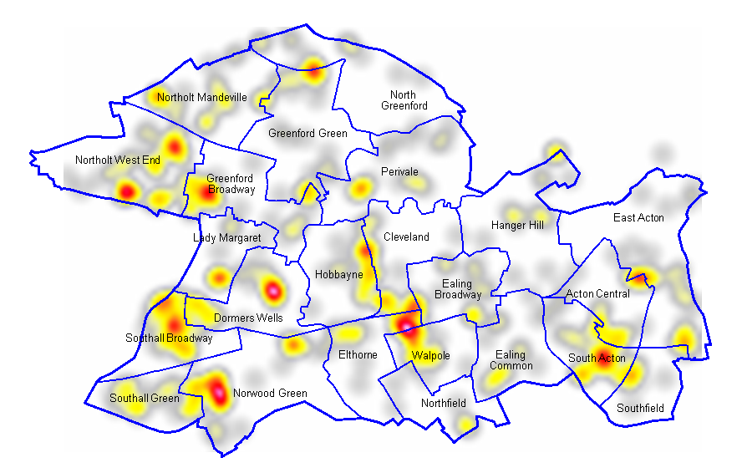

Identifying high need families

Successful delivery of the project will require us as a partnership to have much better, and joined-up, evidence about the numbers and need profiles of these children and families so that a flow of appropriate referrals into programmes delivered through the right partnerships can be assured from the outset.

Such evidence will also enable us to identify which services to decommission in order to focus resources on proven interventions at an early enough stage and to the right children and families.

To do this we need commitment from key council services and partner agencies to share data. The proposed way of doing this is through a data sharing agreement.

Data sharing agreement

It is recommended that key council services and partner agencies sign an agreement to release some officer time to identify their ‘frequent flyers’ based on criteria agreed by the LSP and DMG, and to share this data with P&P who will collate and analyse the data and develop a matrix of need. An example matrix of need can be found in the table below.

Example matrix
 | Family A | Family B | Family C | Family D

Domains
Domestic violence | x | x |  | x
Debt |  | x
Children involved in gangs/knife crime/youth violence | x |  | x
Children subject to ASBO |  |  | x
Teenage pregnancies |  | x
Permanent exclusions | x |  |  | x

From this matrix the project group will develop a flexible set of criteria based on family need and develop options to intervene more effectively into the lives of these children and families.

Next Steps

Project Group

After the data sharing stage the project group will meet to map need in the borough and consider the research to date on intervention opportunities. The focus of the group will be to consider the stories emerging from our mapping of needs as viewed by different agencies, and identify opportunities for efficiencies and better joined up working informed by this.

Further to this the project will focus on areas for future change and development to meet need more effectively and efficiently, building the relationships, implementation plans and action groups to make this happen.

A virtual project group will also be set up which will include all members of the project group and other key individuals who want to keep kept informed and who want to continue to contribute to project developments but who may not have the time to commit to attending project group meetings. A knowledge hub or community of practice will be facilitated by P&P and all information regarding the project will be saved here. The aspiration is that the development of this knowledge hub will be linked with the wider developments around increased use of technology and data sharing and will eventually develop into an online repository for the high need families project.

Actions required from the LSP

- To note progress made on the project so far
- To consider and sign off the data sharing agreement
- To consider and sign-off future plans for the setting up of the project group

Mid-2099 Population estimates, ONS

