Peter Gow
High Speed Two (HS2) Limited
The Podium
1 Eversholt Street, London, NW1 2DN

[by email]
Ealing Council Cabinet Office
Perceval House
14/16 Uxbridge Road
London W5 2HL

3rd April 2024

Dear Peter,
Following the urgent meeting that we called with you on 15th March to discuss your surprise announcement about the extended closure of Old Oak Common Lane, we are writing to formally express our deep concern over the proposed four or five year closure of this key road link and the impact any closure will have on our residents. While we appreciate the additional benefits that rail connections such as the Elizabeth Line can bring for Ealing residents, we know our residents have also experienced years of disruption, inconvenience, noise and air pollution and we are concerned that your most recent announcement will only exacerbate that disruption and is already causing a great deal of uncertainty and distress locally.
Given the location of Old Oak Common station and the placement of the Mandeville Road Headhouse in Northolt, Ealing Council, is a key partner in the delivery of HS2. We were therefore very surprised to hear about the proposed long-term closure of Old Oak Common Lane, particularly as this was not raised with us when we and Peter George, Strategic Director for Economy and Sustainability at Ealing Council, met with senior officers from HS2 on 2nd February. We are deeply disappointed that this information was not shared with us at the meeting, undermining HS2’s professed commitment to engaging with partners.
We have consistently raised with you the level of disruption that residents in North Acton and East Acton have experienced for years as a direct result of HS2 construction works at Old Oak Common Station. Residents have described their experience as a “living hell” as they live with near constant noise, poor air quality and vibrations as a result of HS2 works. There has been an impact to the health, quality of life and wellbeing of residents, particularly those living in Wells House Road, Midland Terrace and Victoria Road, which has been compounded by years of delays and a lack of engagement from HS2 regarding the damage and distress imposed by the project to date.

It is for this reason that Ealing Council has been in continued conversation with HS2 representatives to push for a more substantial programme of resident engagement and mitigation measures from HS2 for residents in Acton, as we are also doing for residents affected by the construction of the air vent in Northolt.
However, the present impact of HS2 will be made substantially worse when your proposed programme of phased or sustained closures of Old Oak Common Lane begins. The closure will have a severe impact on residents’ transport options, their ability to access essential services such as Queen Charlotte Hospital and local schools, their proximity to shops and their ability to move or relocate. Whilst it has been suggested that the closure will be for four or five years, residents have absolutely no confidence that this will be the case given the history of delays throughout the HS2 project.
In order to give residents certainty on plans for the local area HS2 must now urgently share details of the final configuration of closures in writing and provide confirmation now if any more closures are to be considered. If this option is to be seriously considered, it is crucial that HS2 meet with residents affected by the proposals and formulate a mitigation plan that is acceptable to residents and stakeholders. Given the wide-ranging impact of the closures, this mitigation plan should be developed with input from stakeholders such as TfL, Ealing Council, Hammersmith and Fulham Council and Brent Council.

At a minimum any mitigation plan should include how the length of time of any closures will be minimised, how residents will be supported to reach local services, whether by free, regular dedicated shuttlebus or taxi, how residents seeking to move do not face “blight”, and how residents will be compensated for the daily inconvenience they will face.

We also note that at the time of your announcement of the potential closure, you had not yet confirmed with TFL whether the road lowering was still required. It is astounding that you would create distress locally without confirming the need for this
work, so it is imperative that you now confirm this with TFL before progressing further with your plans.

Ealing Council is committed to supporting low carbon public transport and we recognise that the Old Oak Common station has the potential to be transformative for the borough. However, our priority is to ensure that HS2 can build a lasting legacy for the borough, and that local disturbances are mitigated as much as possible. For HS2 to be a success for the residents of Ealing, it needs to leave a positive long-term legacy, not just in terms of new transport infrastructure, but also in terms of improving the lives and prospects of our residents. It is therefore critical that the long-term

benefits of HS2 are not outweighed by the present impact from HS2 works that residents experience daily.

We look forward to receiving a response from you in due course.

Yours sincerely,

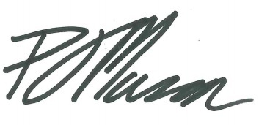

Councillor Peter Mason
Leader of Ealing Council

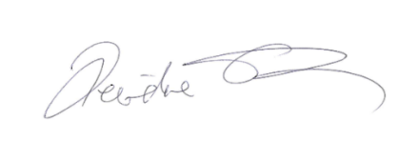

Councillor Deirdre Costigan
Deputy Leader of Ealing Council and Cabinet Member for Climate Action

