Rt Hon James Cleverly MP
Cabinet Office
Perceval House
14/16 Uxbridge Road
London W5 2HL

2 Marsham Street
London
SW1 4DF

(by email)

19th January 2023
Dear Home Secretary,

As Leader of Ealing council and cabinet member for tackling inequality and crime, we are writing to express our concern, in the strongest possible terms, regarding current Home Office proposals to amend the guidance relating to Safe Access Zones at abortion clinics.

Ealing council is proud to have led the country in protecting the ability of women to access healthcare safely and without risk of harassment or intimidation, as evidenced by our continued use of a public space protection order to settle these matters. We enclose the technical response offered to the consultation, which clearly sets out the detrimental impact of the new guidance.

Overall, the proposed guidance ignores operational realities, demonstrates little insight or understanding of the activities the legislation was introduced to address, fails to grasp the nuances of those activities and behaviours, and introduces additional ambiguities which would make Safe Access Zones almost impossible to enforce without a concurrent Public Spaces Protection Order.

We believe this undermines the Public Order Act 2023 and unnecessarily revisits human rights arguments which have already been settled by the courts.

The proposed guidance ignores the safety and wellbeing of women and seeks to undermine an Act of Parliament. We understand that this guidance was brought forward by the former Home Secretary and would urge you to personally review it and the government to reconsider.

Yours sincerely,

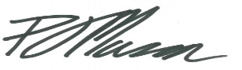 | 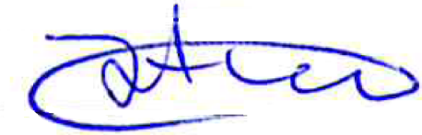
Cllr Peter Mason  Leader | Cllr Jasbir Anand  Cabinet member for tackling inequality and crime

